HIRAD Project Memorandum

SUBJECT: Wind Speed and Rain Rate “Quick-look” Retrievals for Hurricane Earl
From: UCF
Spencer Farrar, Saleem Sahawneh, Jim Johnson, W. Linwood Jones
Date: May 1, 2013

References: 1. HS3 Project Grant No. NNX11AF02G, Year 2 Progress Report
2. HIRAD Project Memorandum, Hurricane Earl Calibrated Brightness
Temperatures, dated 07-30-2012

Purpose: To provide preliminary geophysical retrievals from calibrated HIRAD brightness temperatures during GRIP in Hurricane Earl on Sept. 1, 2010 EST.

Data Sets: HIRAD flight observations were taken over Hurricane Earl on 1 flight from Sept. 1, 21:39:30 GMT, to Sept. 2,03:40:37 GMT. Eight flight legs were flown over the storm during this time period and 4 of them have been emphasized in these preliminary image products. These are designated as Legs 1, 3, 4, and 6, are identified in the figure below, and listed as 4 separate data files as follows:

yr=2010;mo=9;dy=1;

leg{1}=[(yr,mo,dy,23,24,11) (yr,mo,dy,23,41,16)];
leg{3}=[(yr,mo,dy,23,52,35) (yr,mo,dy+1,0,17,39)];
leg{4}=[(yr,mo,dy+1,00,33,12) (yr,mo,dy+1,01,02,46)];
leg{6}=[(yr,mo,dy+1,01,13,46) (yr,mo,dy+1,01,36,22)];

The wind speed, WS, and surface rain rate, RR, retrievals that make up these images are based on the brightness temperature data in Reference 2 above. This WS and RR data is contained in 4 separate formatted ascii files. Each flight leg consists of a modified HIRAD swath of 66 measurement cells, equally spaced in scan angle (2 degree steps), from + 65 deg. to – 65 deg. These are all mapped to the surface at corresponding latitude and longitude.

The storm centric latitudes and longitudes are based on the difference between the absolute latitude and longitude and the location of the eye of storm at a given point in time. This location of the eye of the storm is subtracted from the absolute latitudes and longitudes. The selected time of the leg is defined as mean time of the leg, i.e. the average of the start and end time.

Files:

1. grip_hirad_20100901_Earl_leg1WSRR.txt
2. grip_hirad_20100901_Earl_leg3WSRR.txt
3. grip_hirad_20100902_Earl_leg4WSRR.txt
4. grip_hirad_20100902_Earl_leg6WSRR.txt

Format:

There are eight columns in each data file. These columns are:

1) Scan number
2) Pixel number
3) Absolute longitude
4) Absolute latitude
5) Storm centric longitude
6) Storm centric latitude
7) Wind speed (m/s)
8) Rain rate (mm/hr)

Methods: A “Quick-look” retrieval approach was used for these preliminary retrievals. Two empirical algorithms were used, one for WS and one for Integrated Rain Rate (IRR). Both were derived empirically by regression of modeled geophysical data for Hurricane Frances 2004. Each algorithm is given below,

WS = a₁ + a₂×ExT_{b}
IRR = b₁ + b₂×ExT_{b}+ b₃×ExT_{b}²

where ExT_{b} is the difference between the observed T_{b} and the corresponding modeled smooth surface brightness temperature with no wind and no rain. Using ExT_{b} emphasizes wind and rain effects and minimizes the strong incidence angle effect over the swath. The WS algorithm was implemented at 5 GHz only and the RR algorithm was implemented at 6.6 GHz only. IRR is converted to RR and is contained within this data set. Units of WS and RR are m/s and mm/hr, respectively.

Data Location:

The data and this summary are in a folder labeled Earl_2010_WS_RR located on the grip ftp site at ftp:// infield.nsstc.nasa.gov/incoming/grip_hirad/

HIRAD Flight Legs in Hurricane Earl

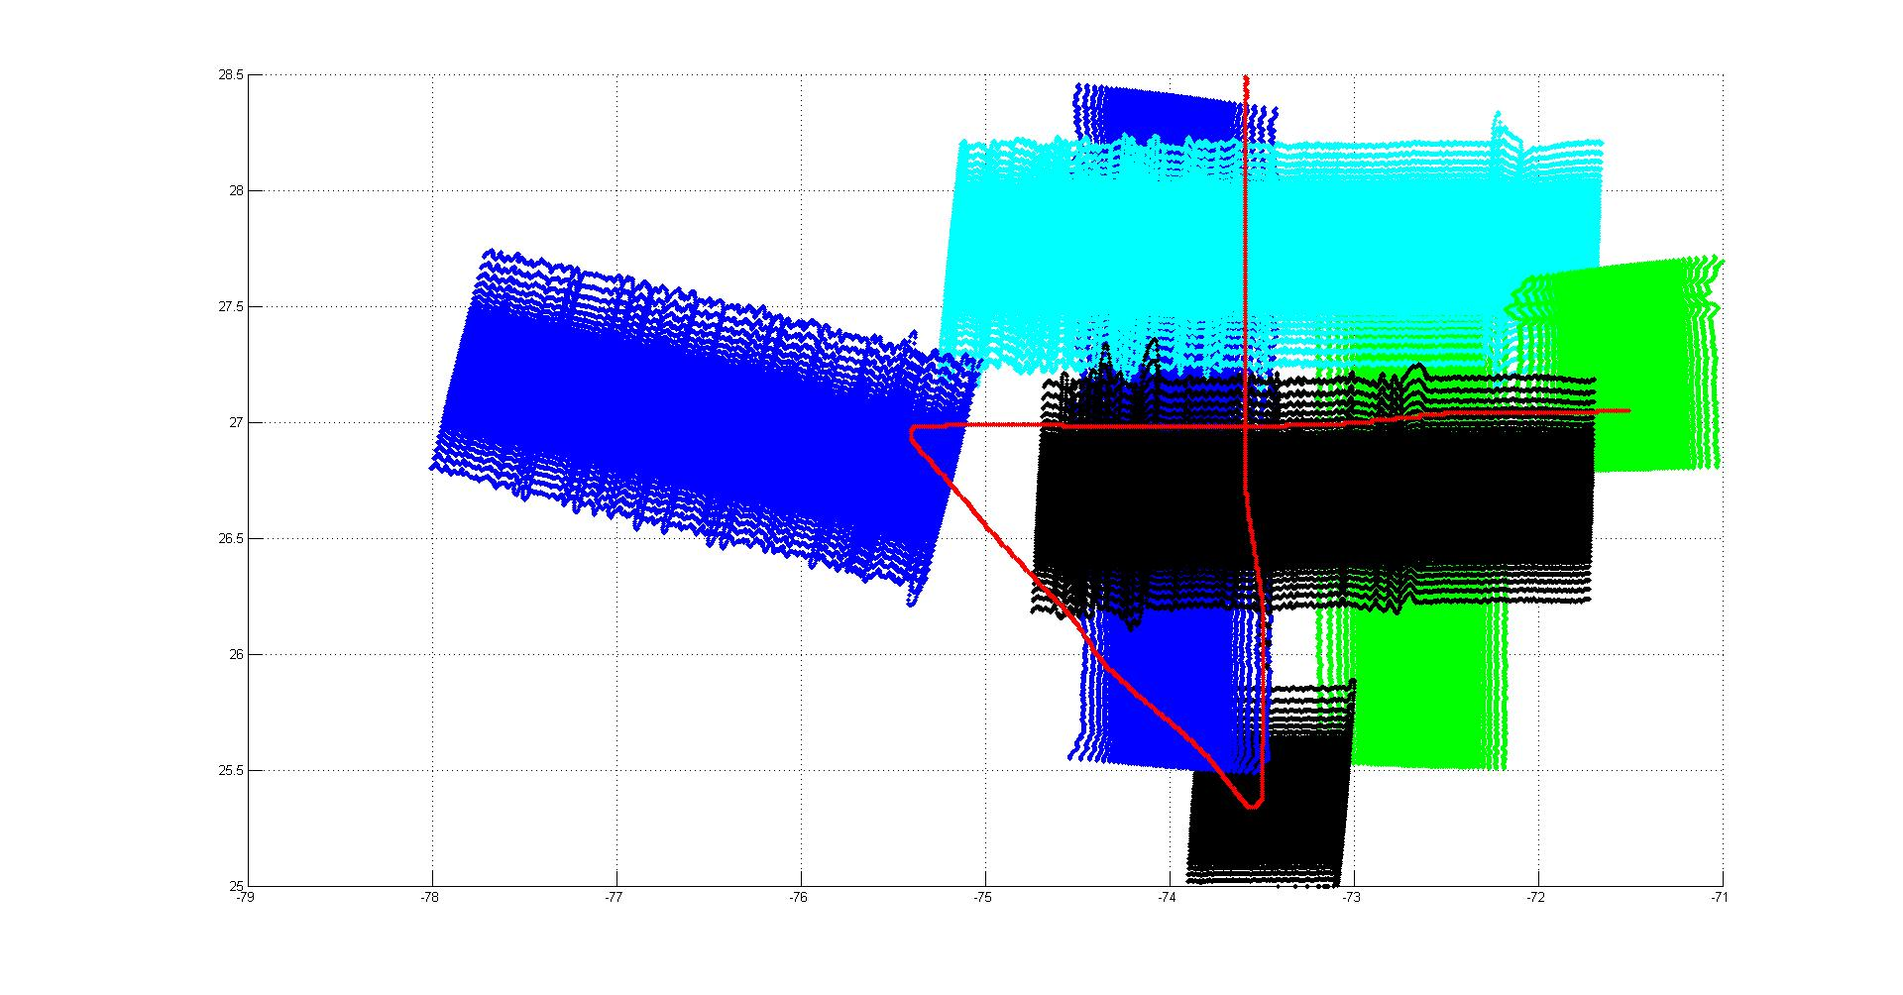
Leg 1
Leg 4
Leg 3
SFMR Observations
Leg 6

Leg 4
Leg 3
Leg 1

