Today’s forecast called for a SW-NE line of thunderstorms to form about 21-22 UTC just east of an OKC-Tulsa line. This prompted the first day of enhanced soundings from the DOE network, and a plan for the ER-2 to plan for 90 minutes of research near OKC as part of their ferry flight from California to Offutt AFB near Omaha. Based on the forecast, we requested the ER-2 to arrive over Norman OK at 22 UTC, and alerted the UND Citation to be ready to underfly the ER-2 track in the downstream anvil.

The forecast verified almost perfectly, with a growing line of cumulus visible at 21 UTC, and thunderstorms forming on the line, first from Tulsa and NE, then progressively farther south. The ER-2 arrived in the area at 2150 and was overflying a strong storm with frequent lightning along the line at 2156. It made 3 consecutive passes directly over the strong cells in the line (SW-NE, NE-SW, SW-NE), then offset 14 nm to the east to overfly the portion of the anvil that the Citation was to fly. Unfortunately, the Citation was held on the ground by ATC for almost one hour (too many commercial aircraft trying to avoid the line), finally taking off at about 2234 UTC. By that time, it had to fly quite far to the south to avoid a very strong storm near Purcell, so by the time it reached the anvil streaming to the east off the major line of storms, there was only time for one pass fairly close to the ER-2. After the 3 back-and-forth passes over the line, the ER-2 made about 2-3 complete racetracks, with one leg over the line, and the second leg offset over the anvil. The ER-2 and Citation both left the research area at about 2355 UTC, the ER-2 passing over a strong cell in the line enroute to Offutt, and the Citation had to travel almost to Lawton to avoid strong cells SW of OKC.

Following are a selection of screen captures showing satellite, radar, and lightning, and aircraft tracks, covering some of the on-station times of 2150-2355.

Ed Zipser and Steve Rutledge, Mission Scientists for April 22.

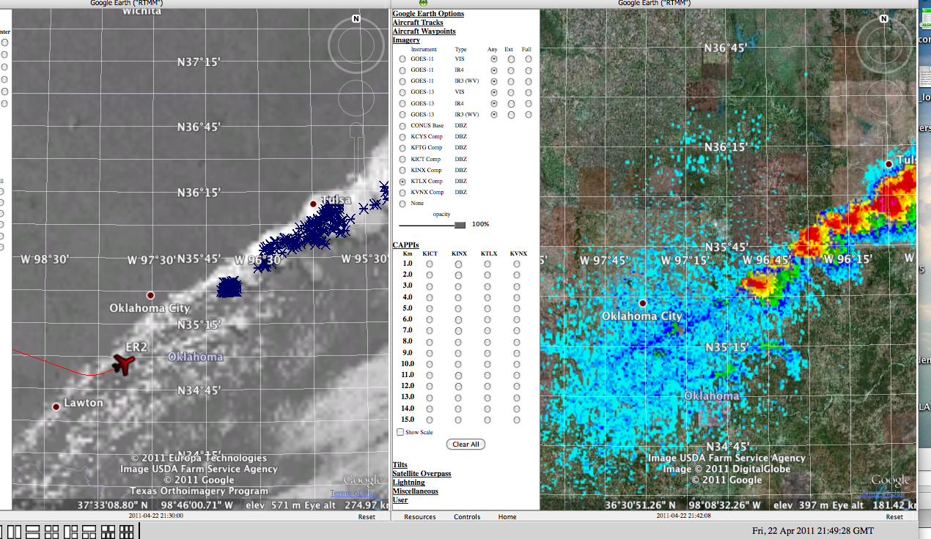
2149 UTC ER-2 starting first pass

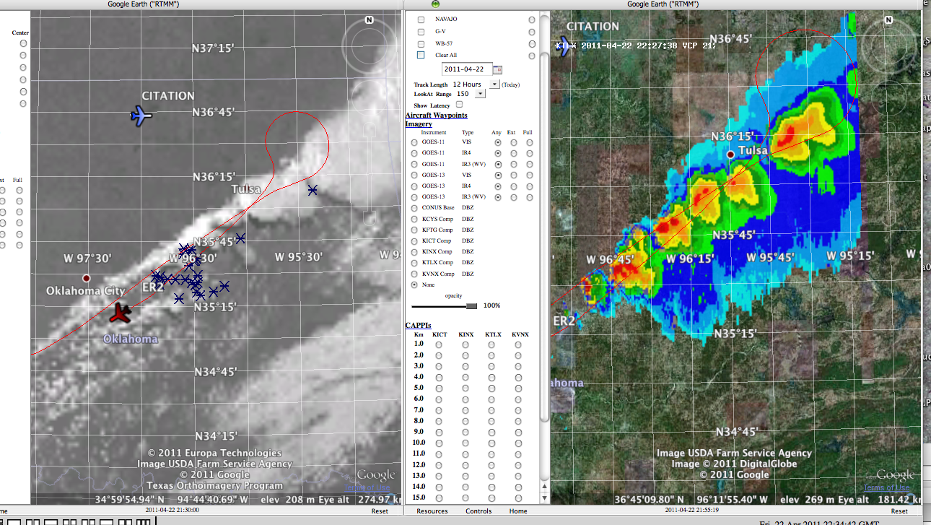
2234 UTC ER-2 completing second pass, NE-SW, Citation still on the ground at PNC
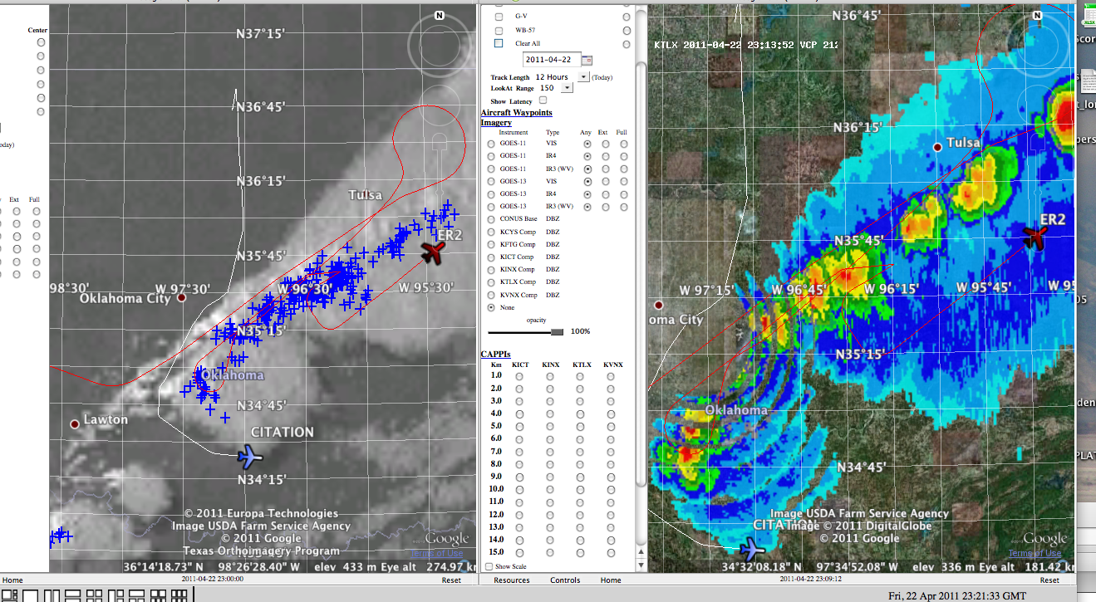
2321 UTC First ER-2 pass over the anvil, Citation going around storm SE of OKC to join

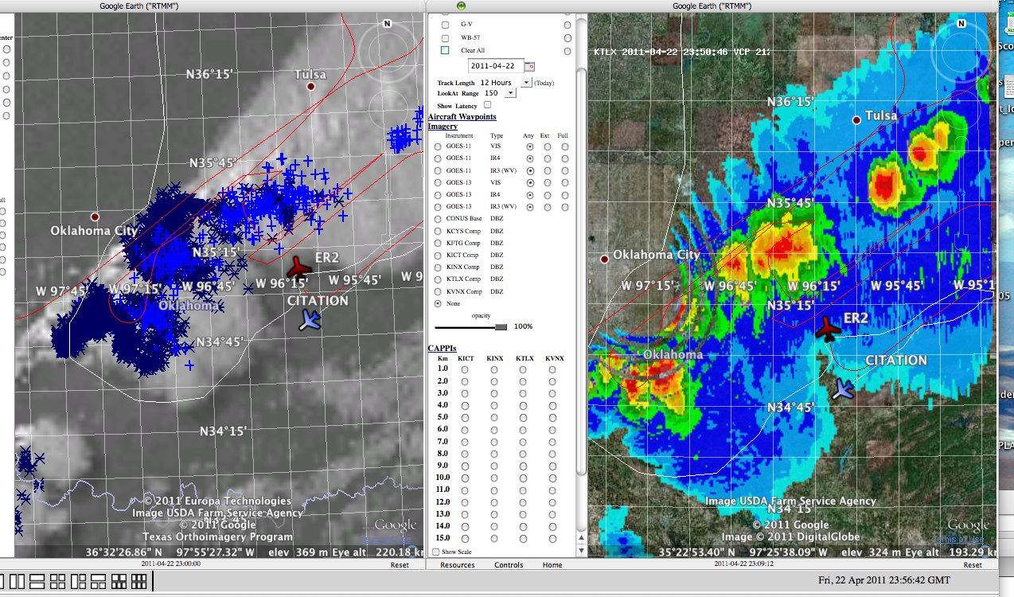
2356 UTC ER-2 leaving for Offutt via storm; Citation looking for a safe route to PNC

