Mission Scientist Report for August 17, 2010
Mission Scientists: Scott Braun and Greg McFarquhar
DC8 Platform Scientists: Ed Zipser and Jeff Halverson
August 17, 2010
Mission Objective: To obtain microphysical data in rainbands associated with the remnants of TD5, to train dropsonde and APR-2 personnel, and provide additional test data for DAWN.
The DC8 took off from FLL at 15 UTC and proceeded to a location just southeast of New Orleans. It then headed west along ~28°45’ to just southeast of Houston, passing through moderate precipitation. The leg was flown at FL400-FL410 and dropsonde releases were made along the leg. During this leg, a target for the microphysical module (a descending spiral) in stratiform precipitation was identified. On the return eastbound leg, a short constant altitude leg was flown to collect data with the APR. Thereafter, the spiral commenced near 93°W, with the aircraft descending at 1000 fpm down to 11,000 feet and collecting good microphysics and APR-2 data. Once the downward spiral was completed, the DC8 ascended to FL410 and did another constant altitude leg above the spiral location to collect data with APR2. During the course of these maneuvers, there was steady dissipation of the stratiform rain region which initially had rain echoes as high as 30 dBZ. An image from the end of the eastbound pass is shown below.
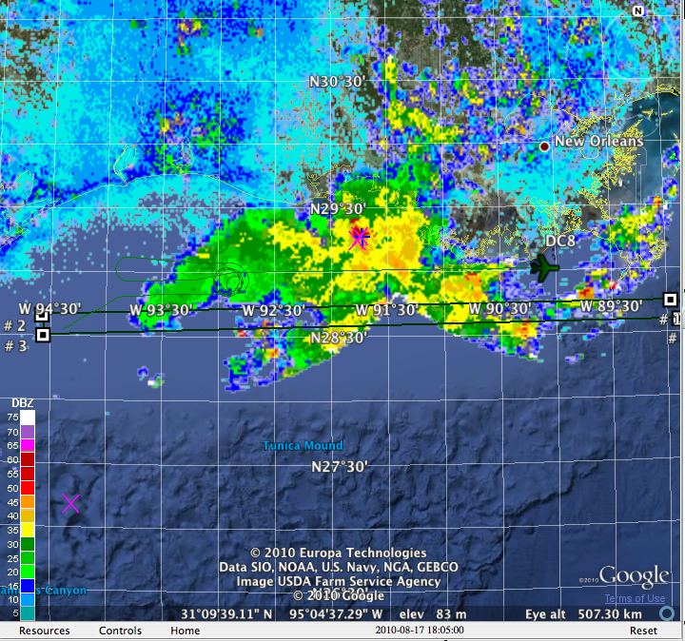
Eight dropsondes were released during the initial transit, the westbound leg, and the spiral. Most soundings were good. The eighth, in the spiral, showed some data drop outs during descent. The dropsonde D files were successfully transmitted to the ground and processed using ASPEN software. The wind lidar worked well when the laser worked well, but when temperature changed beyond certain limits (when it got too cold), it needed to be shut down. They will try to solve this problem by channeling warm air to the instrument if possible. No de-integration until this approach is tested in the next flight.
Plans for August 18-20, 2010
DC-8 (Time in EDT)
Wednesday Aug 18
Hard Down Day - No Aircraft Access
Thursday Aug 19
No-Fly Day
Friday Aug 20
Possible Flight Day (Time TBD) into PGI27 in the western Caribbean. Although most models appear to having the system staying well south in the Caribbean, there were some opinions during the forecasting telecon that it could move northward toward the Gulf of Mexico. The decision was made to put the aircraft on alert in this case.
- - - - - - - - - - - - - - - - - - - - - - - - - - - - - - - - - - -
Global Hawk (Times in PDT)
Wednesday Aug 18
No-Fly Day
Thursday Aug 19
No-Fly Day
Friday Aug 20
No-Fly Day
- - - - - - - - - - - - - - - - - - - - - - - - - - - - - - - - - - -
WB-57 (Times in CDT)
Participation in GRIP flight starts Aug 25

