Platform Scientist Report for August 24, 2010
DC8 Platform Scientists: Jeff Halverson and John Molinari
FLL Mission Scientist: Scott Braun
August 24, 2010
Mission Objective: (1) To provide a broad-scale survey of the pre-genesis environment in the Gulf of Mexico along an elongated, weak frontal boundary; (2) execute a cloud microphysics module coincident with a TRMM overpass ; (3) provide additional data for DAWN and APR2; and (4) perform dropsonde validation of AIRS in cloud-free regions.
.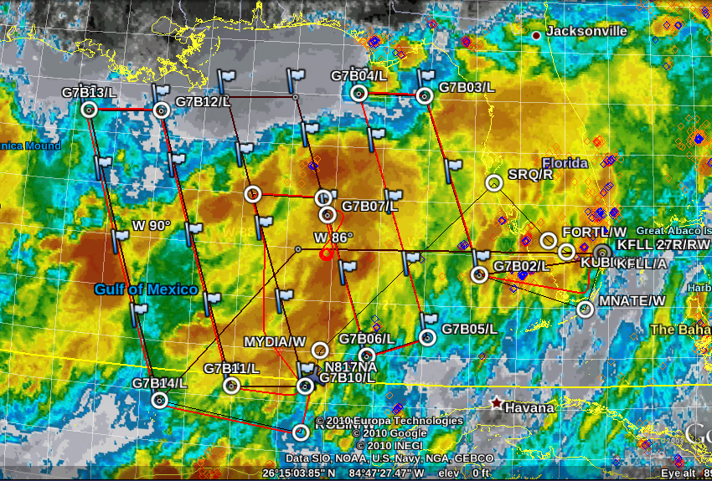
A lawnmower survey pattern was designed to survey a weak surface trough/frontal zone oriented W-SW to E-NE across GOMEX. The lawnmower pattern was oriented to sample gradients perpendicular to the trough axis with five dropsondes per leg. From 72-48 hours prior to the mission, several models had hinted at genesis along this zone. Deep moist convection (DMC) was ongoing along the trough axis. The axis featured weak cyclonic shear at the surface along which several convective clusters developed and remained nearly stationary. New convective growth with electrification was occurring along the northern edge of the zone, with north-northeasterly upper level flow advecting stratiform cloud and anvil debris toward the south. At the surface, moist southwesterly flow impinged into the zone. The deep layer shear appeared strongest along the eastern end of the zone and 850 mb vorticity assumed the form of a weak, elongated filament along the entire zone. An upper-level dry-air intrusion was observed to approach the zone from the north on the morning of the mission.
The DC8 took off at 14 Z from FLL for a mission of 7.25 hours duration. About 30 minutes after departure, the data network on the DC8 became completely inoperative. After about an hour of diagnosing and troubleshooting, a patch workaround re-established limited data feed to the mission scientists. The first six drop releases were missed because AVAPS could not initialize sondes without in situ data from REVEAL. We were successfully able to patch AVAPS into the work-around data feed and drops resumed as planned. Additionally, the PIP instrument (in the microphysics suite) suffered a probable laser failure early in the mission, eliminating the possibility of sampling large particles.
Much of the mission was spent within cloud and above precipitating regions. The DC8 initially cruised at FL310 then stepped up to FL390 by mission’s end as fuel was burned. The microphysics probes collected a large amount of data, mainly small particles in anvil and stratiform regions. APR collected a large volume of data including very intense convective cores, but their interpretation will be handicapped by loss of PIP. A short spiral in a growing convective region was performed mid-way along the pattern, co-incident in time with a 16 Z TRMM overpass. The descending portion of the spiral was flown at -1000 fpm while the ascent was flown at 300-400 fpm (limited by the aircraft’s ability to climb). Microphysics and APR collected good data on this spiral, with APR reporting rain rates of ~ 100 mm/hr. Lightning strikes were noted in the vicinity of the spiral on the RTMM.
Twenty-four dropsondes were released in the pattern and all returned good data. Extremely dry air was noted aloft along the northern edge of the trough/convective region, consistent with the dry air intrusion observed on satellite. While the operating environment was not ideal for either DAWN or LASE, both instruments collected good data and this mission set an endurance record for DAWN (previously the instrument was only able to collect 2 consecutive hours of data; on this mission, they collected 7 consecutive hours). LARGE reported very few aerosols throughout its sampling. MMS also performed well.

