Platform Scientist Report for August 30, 2010
DC8 Platform Scientists: Scott Braun and Jon Zawislac
FLL Mission Scientists: Jeff Halverson and John Molinari
August 30, 2010
Mission Objective: This mission was the second of two involving a suitcase flight to Saint Croix to conduct missions into Hurricane Earl, with the goal of investigating rapid intensification. Specific objectives were to conduct a set of three non-rotated figure 4 patterns in the core of Earl. Weather permitting, we were to land in St. Croix to be in position to retrieve the ground crew left behind the day before and to conduct an additional mission on the 31st.
.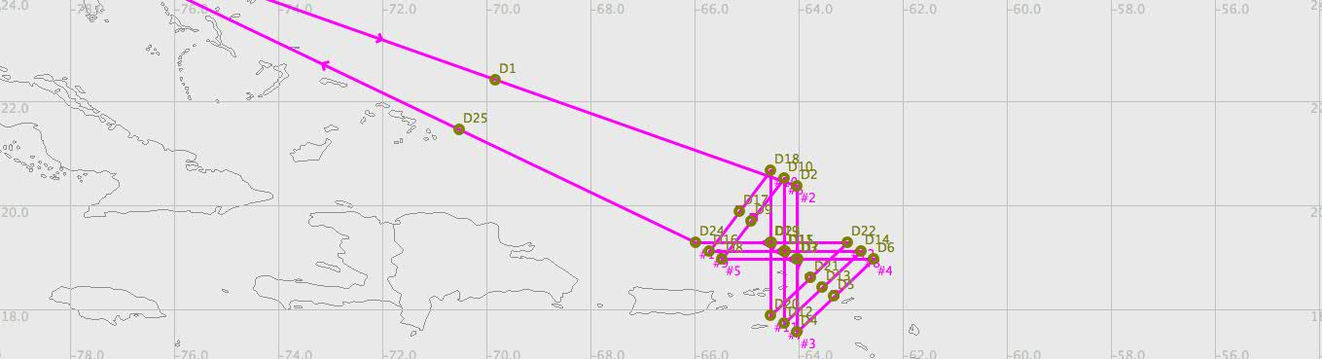

The DC8 took off from FLL at 1613 UTC heading to the northern side of Earl to begin the set of figure 4s. The storm’s intensity at 15 UTC was 105 knots and 960 mb. Unlike the day before, the eyewall was readily seen in the DC8 pilot’s radar, allowing for straightforward targeting of the center. During the first pass through the eye, visible satellite data suggested a mostly clear eye.
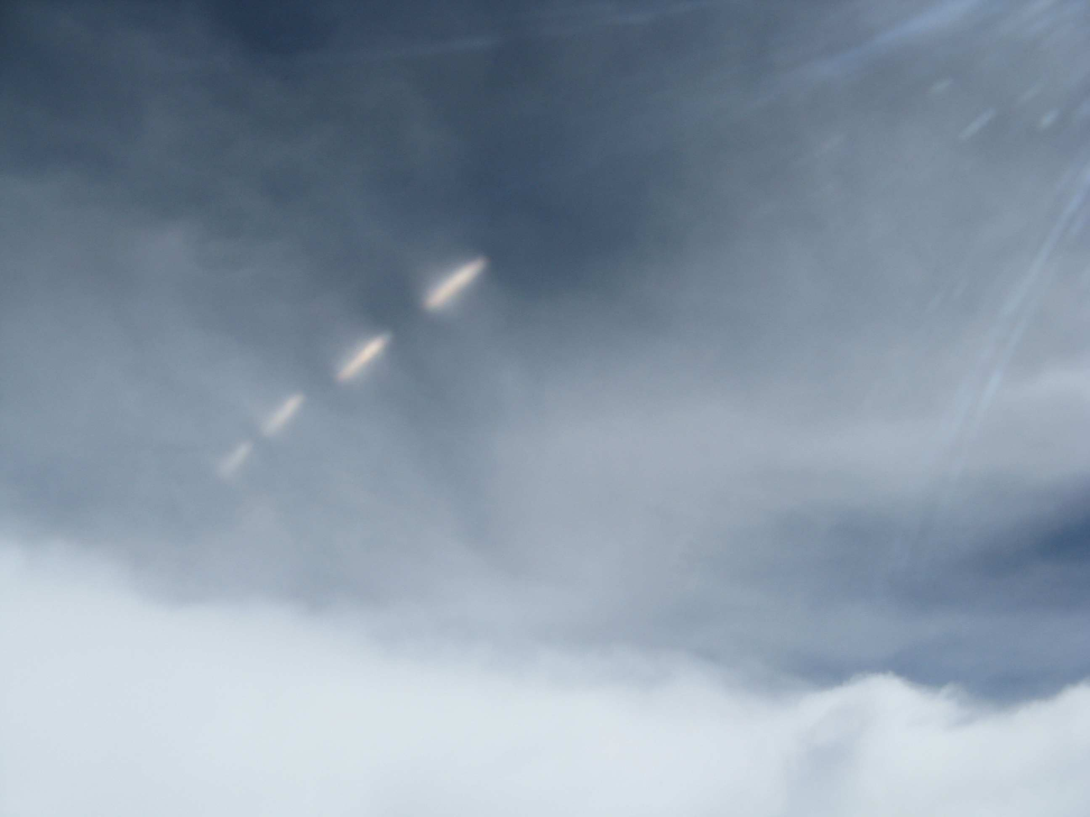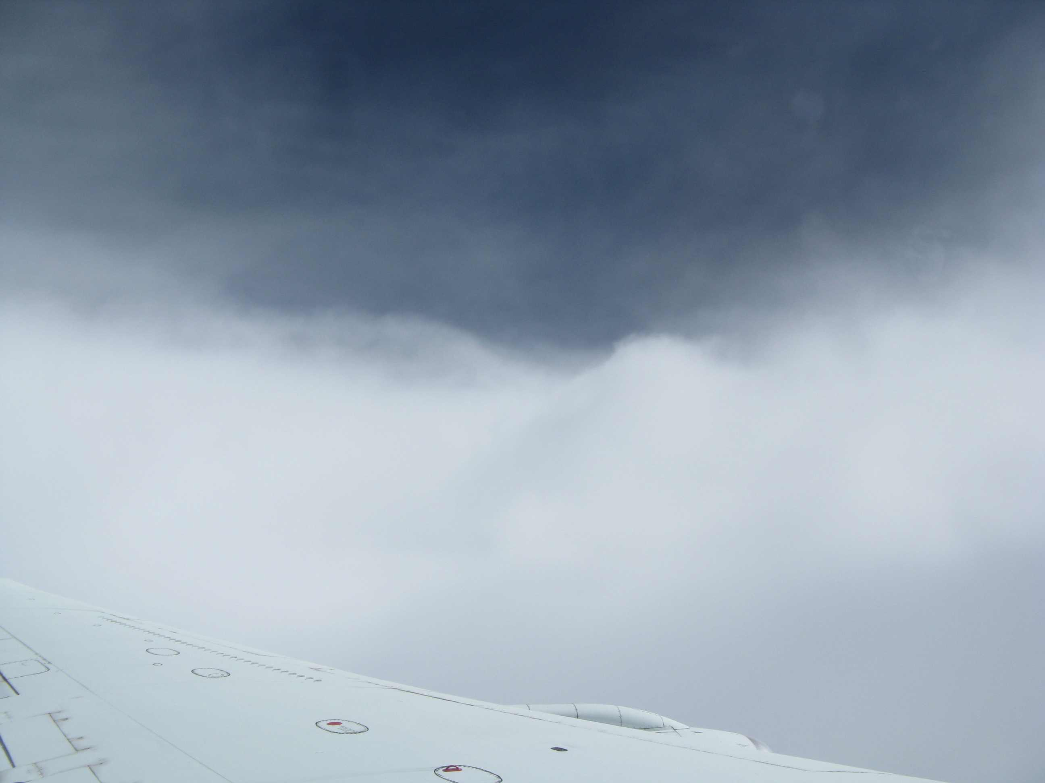
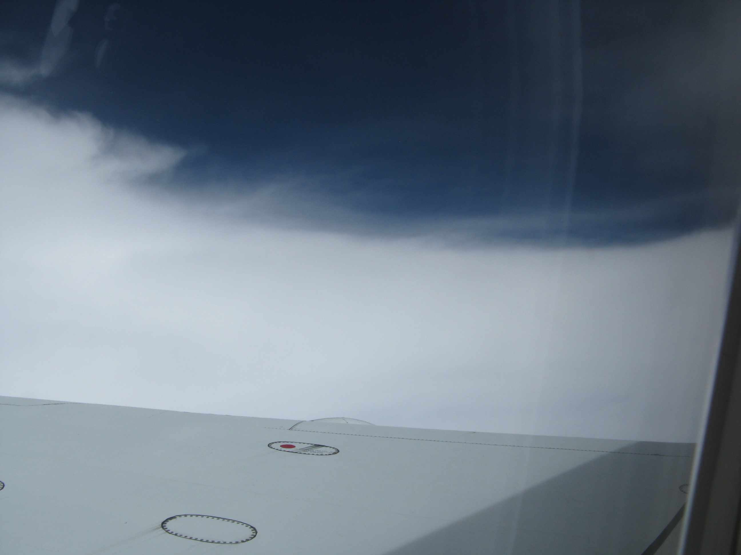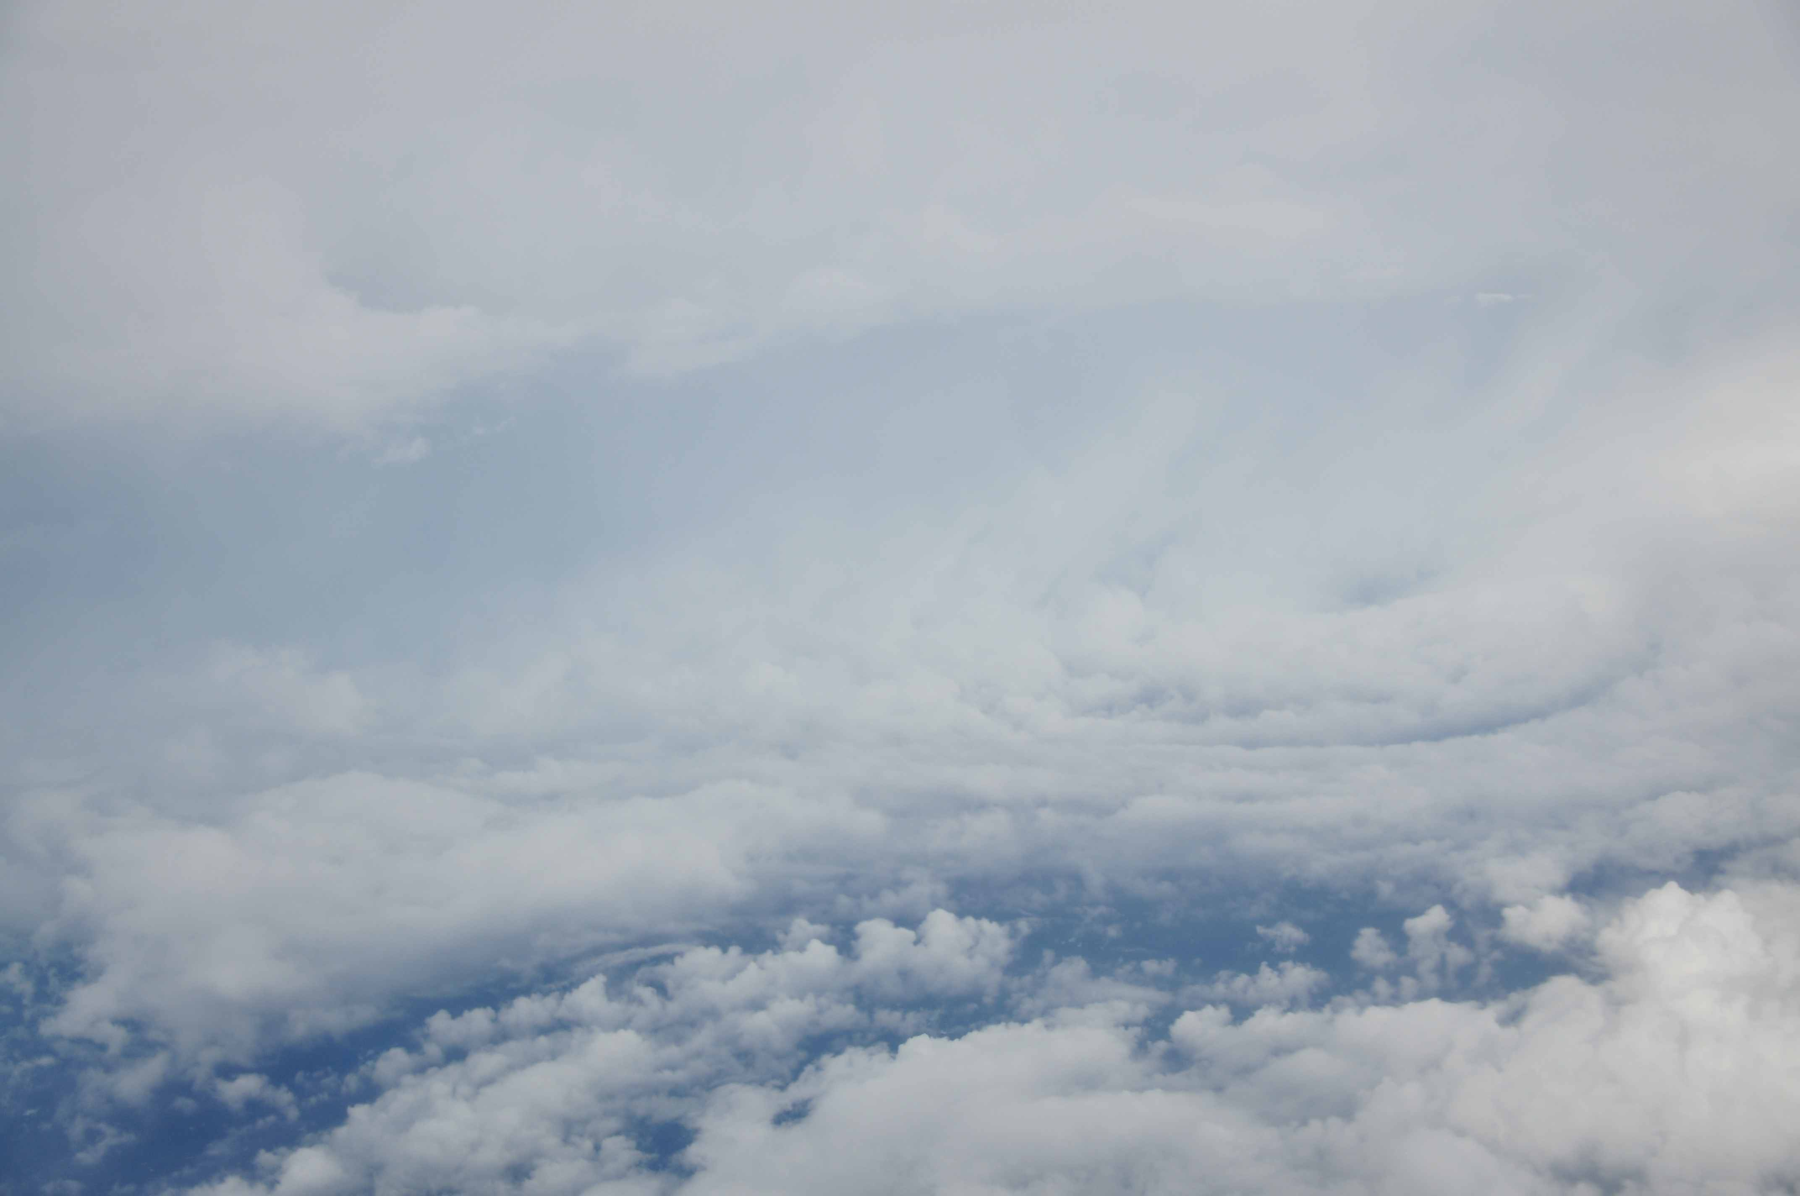

From the DC8, we observed a thin layer of cirrus above the eye (upper left image), which dissipated by later passes (upper right, then lower left), likely due to increasing subsidence. At low levels, mesoscale low-cloud swirls were seen within the eye, with two vortices occasionally visible from the DC8 (lower right). All three non-rotated figure 4 patterns were completed, each time penetrating the eye (total of 6 eye penetrations) using the aircraft radar for guidance. Pilots provided information about when to drop sondes, with several of the eye sondes falling in regions of weak winds. One of the eye drops failed, so on two later occasions, two sondes were dropped in the eye in quick succession. After completing three figure 4 patterns, we landed in St. Croix with approximately 20 kt surface winds. The pilots needed to do a hard landing to improve braking on the wet runway. The crew was picked up and the aircraft returned to Fort Lauderdale 2.5 hours later. The intensity of the storm had increased to about 115 knots and 939 mb by 23 UTC.
LASE collected great data on aerosols and humidity in the eye during each pass. An example is included below.
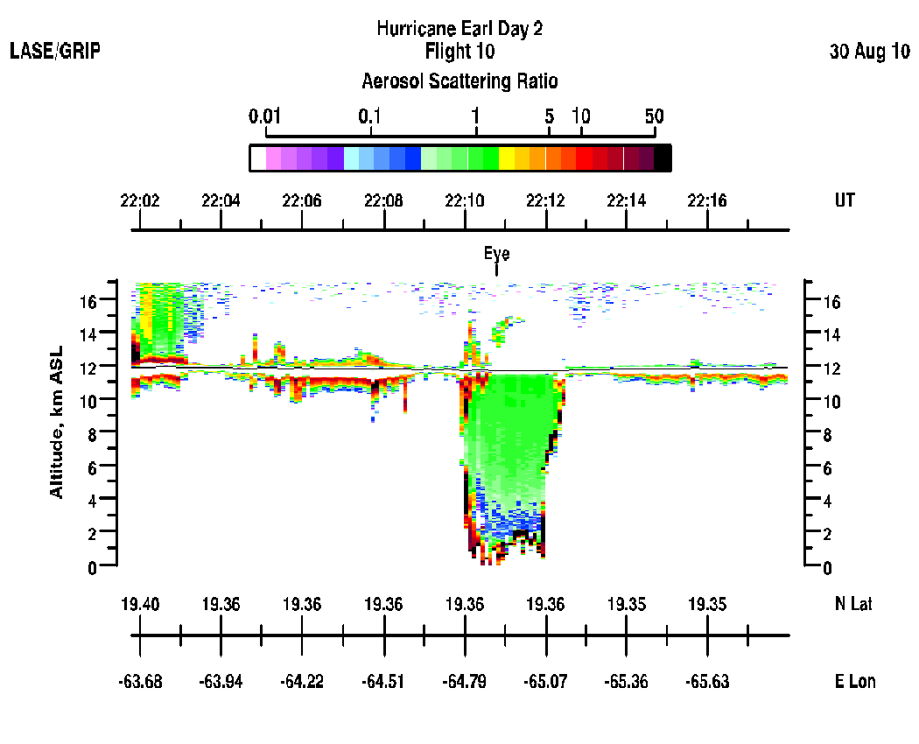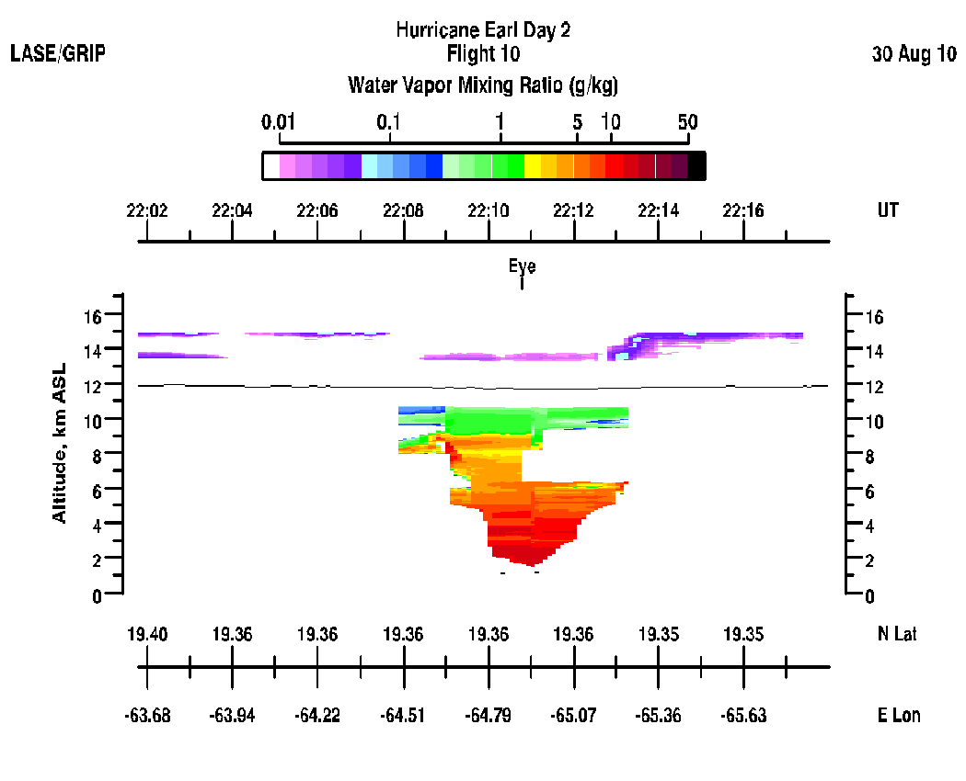
The APR2 radar during a southbound eye pass at 2120 UTC showed very intense convection in the eyewall, often asymmetrically distributed around the eye with the heaviest rain often on the eastern and northern sides of the storm. This particular example suggests a southward tilt to the eye and eyewalls.
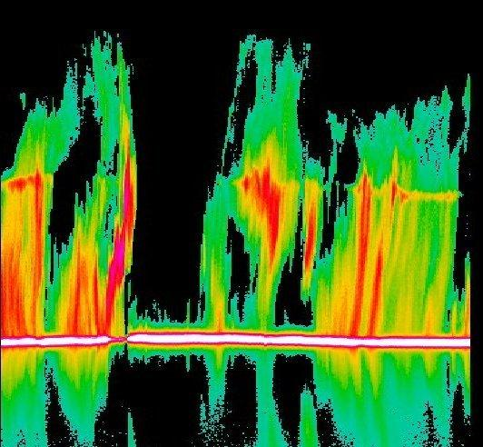

The PIP remained non-functional during the mission.
Twenty-eight dropsondes were released in the pattern and all but four returned good data.

