1 May 2011

Mission Scientists: Ed Zipser, Dan Cecil, and Pavlos Kollias

Citation spirals above Central Facility in aggregates and mixed-phase precip

Stratiform rain area surprised us, arriving / establishing itself earlier than expected Sunday morning. We decided to have the Citation fly spirals above the Central Facility, collecting microphysics. Initially we had virga at CF, with low melting layers further south where it had been raining. Strong temperature inversion, and two melting levels. Citation launched at 1630 UTC, NPOL switched to Scan 3 (six RHIs for a tight sector encompassing the ~3 km wide Citation spiral). First spiral began at 1637 from 4000’. Citation confirmed two freezing levels, with ice around 4000’ and the higher freezing level around 10000’. Freezing rain mixed with sleet reported between 4000’-6000’ and completed spiral down to 3200’ at 1726. Sleet was observed at the surface at the CF at 1730. Second spiral ascent completed at 1747 at 21000’. As echos eroded from CF, we moved the spiral center to 36.57 N, 97.32 W (midway between CF and NPOL) during the second descent. Third ascent ended at 1823 with Citation breaking out of cloud at 14000’.

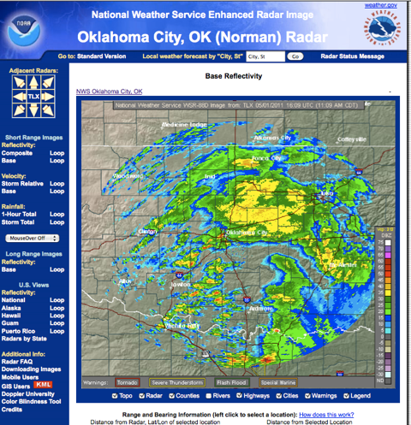
Twin Lakes 88D Radar image at 1609 UTC that encouraged us to ask the Citation to take off and start spirals over the Central Facility.
Took off about 1630 UTC.
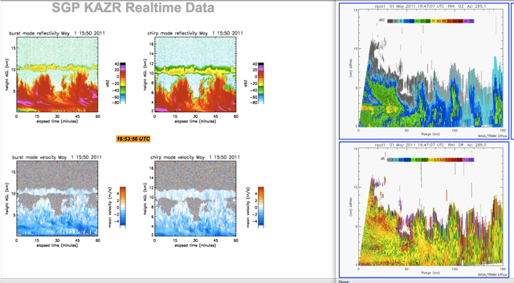
KAZR radar (vertical pointing) and NPOL RHI (CF is at X=28 km) at about 1650 UTC. Citation in spiral.

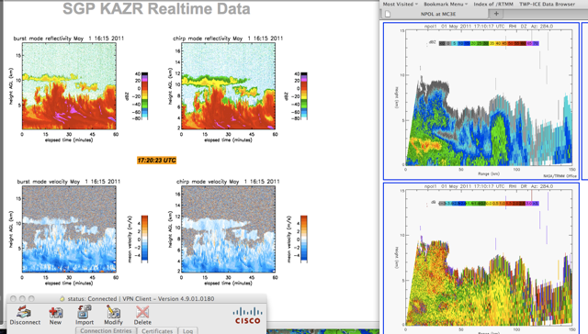
KAZR radar (vertical pointing) and NPOL RHI (CF is at X=28 km) at about 1715 UTC. Citation in spiral.

