DRAFT 2 DRAFT 2 DRAFT 2 DRAFT 2

23 June 2006
Second Draft of DC8 Flight Plans for NAMMA 2006
By EJZ on behalf of NAMMA Science Team

1. Assumptions

DC8 ferries from North Dakota to Sal, Cape Verdes (hereafter CV) on August 15
First Research Flight on August 18
Last Research Flight on Sept. 13
DC8 ferries from CV back to North Dakota on Sept. 15.
95-100 research hours available during the 27 days between 8/18 – 9/13 inclusive

Typical maximum flight duration 8 hours, max altitude about FL 400 (actual 12 km)
2 consecutive days of 8-hour missions possible; possibly 3 days for one high priority event

Typical westward movement of easterly waves or tropical depressions 5-6 degrees longitude/day

Highest priority for DC8 flights in waves is for waves located between 16 W and 36 W

2. Priority Missions (based on NAMMA AO and PI abstracts)

EEW: Evolution of Easterly Waves, requiring multiple missions for a specific disturbance
PP: Precipitation Processes, especially comparative observations in continental vs. maritime regimes, and/or in clean vs. dusty environments
SAL: Composition and vertical structure of the Saharan Air Layer, especially in dust outbreaks
CS/C: Underflights of A-Train, especially CloudSat/Calipso

3. Proposed Allocation of Missions/Flights (Note: Not mutually exclusive- combinations likely)

EW: 4 desired (12 flights) 4 minimum (8 flights)
PP: 5 desired (5 flights) 3 minimum (3 flights)
SAL: 5 desired (5 flights) 3 minimum (3 flights)
CS/C: No dedicated missions. 5 segments desired 3 minimum. Note: Segments about 10 minutes each for cloud observations, 30-40 minutes if primary target is aerosols in the SAL)

Comments/Justification:

EEW: About 4-6 waves can be expected during the 27-day operating period for the DC8, some stronger than others. Wave evolution requires flights on successive days for continuity. The highest priority goes to waves with intensification potential in east/central Atlantic. Our NOAA partners are prepared to follow a DC8 mission with G4 missions (west of 35-40 W) and P3 missions (west of 42-45 W), both based in Barbados (59 W). Typically the DC8 is expected to fly 2 successive days followed by one no-fly day. Therefore, possible scenarios are for waves centered at [13, 19, 25, 31 W]; [16, 22, 28, 34 W]; 18, 24, 30, 36 W) on consecutive days, so 3 flights are possible but contingent on good forecasts, suitable waves/weather, no aircraft problems, etc. Therefore, it would be optimistic to imagine that each attempt to do the EW mission would result in 3 flight days, but the “desired” 12 flights would be spread over 4 days.
More realistic would be to assume that the system would weaken greatly, or the flight sequence would not be carried out for a variety of reasons. It seems a high priority to plan to attempt this sequence 4 times in order to succeed 2-3 times.

For EW-related missions, highest priority should attach to opportunities to work within 150 km range of NPOL and especially the TOGA radar. Climatology is for very few such events near TOGA (most frequent rainfall and convective systems are well south of TOGA) so we don’t want to miss these when they occur. This would be the best opportunity for data relevant to convective bursts and evolution of mesoscale convective vortices in a strong wave/depression. We also must be alert to the status of the G4 and P3 in Barbados (they are subject to recall for tropical threats to the U.S.) and place higher priority on continuity in the central Atlantic when they are available.

Lower priority attaches to working over Africa east of 15-16 W (quantitative range of NPOL) for two reasons. One, without NPOL support, severe storms over land pose an operational hazard. Two, without dropsondes over land (still TBD) scientific justification weakens, and the low-mid-level wind field will be partially obtainable by the rawinsondes, pibal network, and driftsondes.

For all these reasons, the initial recommendation would be target waves with vorticity centers as follows:
For systems with likely precipitation systems north of 13 N: 15-19 W, 21-25 W, 33-39 W.
For systems with precip expected to be south of 13 N: 13-19 W, 25-31 W, 31-37 W. (Note: The Guinea coast is about 10 N 13 W, so if a strong system is expected to exit the coast there, it may be desirable to sample it shortly after it emerges.)
(Note that precip is far more likely near NPOL than near TOGA for any wave and often between waves; e.g. squall lines.)
Note: There are many different flight tracks possible, and if desired more examples can be provided. They all share the objective of dropping sondes covering the N-S and E-W extent of the wave, to include any embedded vortex, the AEJ, and crossing into the SAL. If most of these objectives can be covered in 5-7 hours, modules for PP or SAL objectives can be inserted. If a CS/C orbit is within the pattern, a segment for an underflight can be programmed into the pattern.
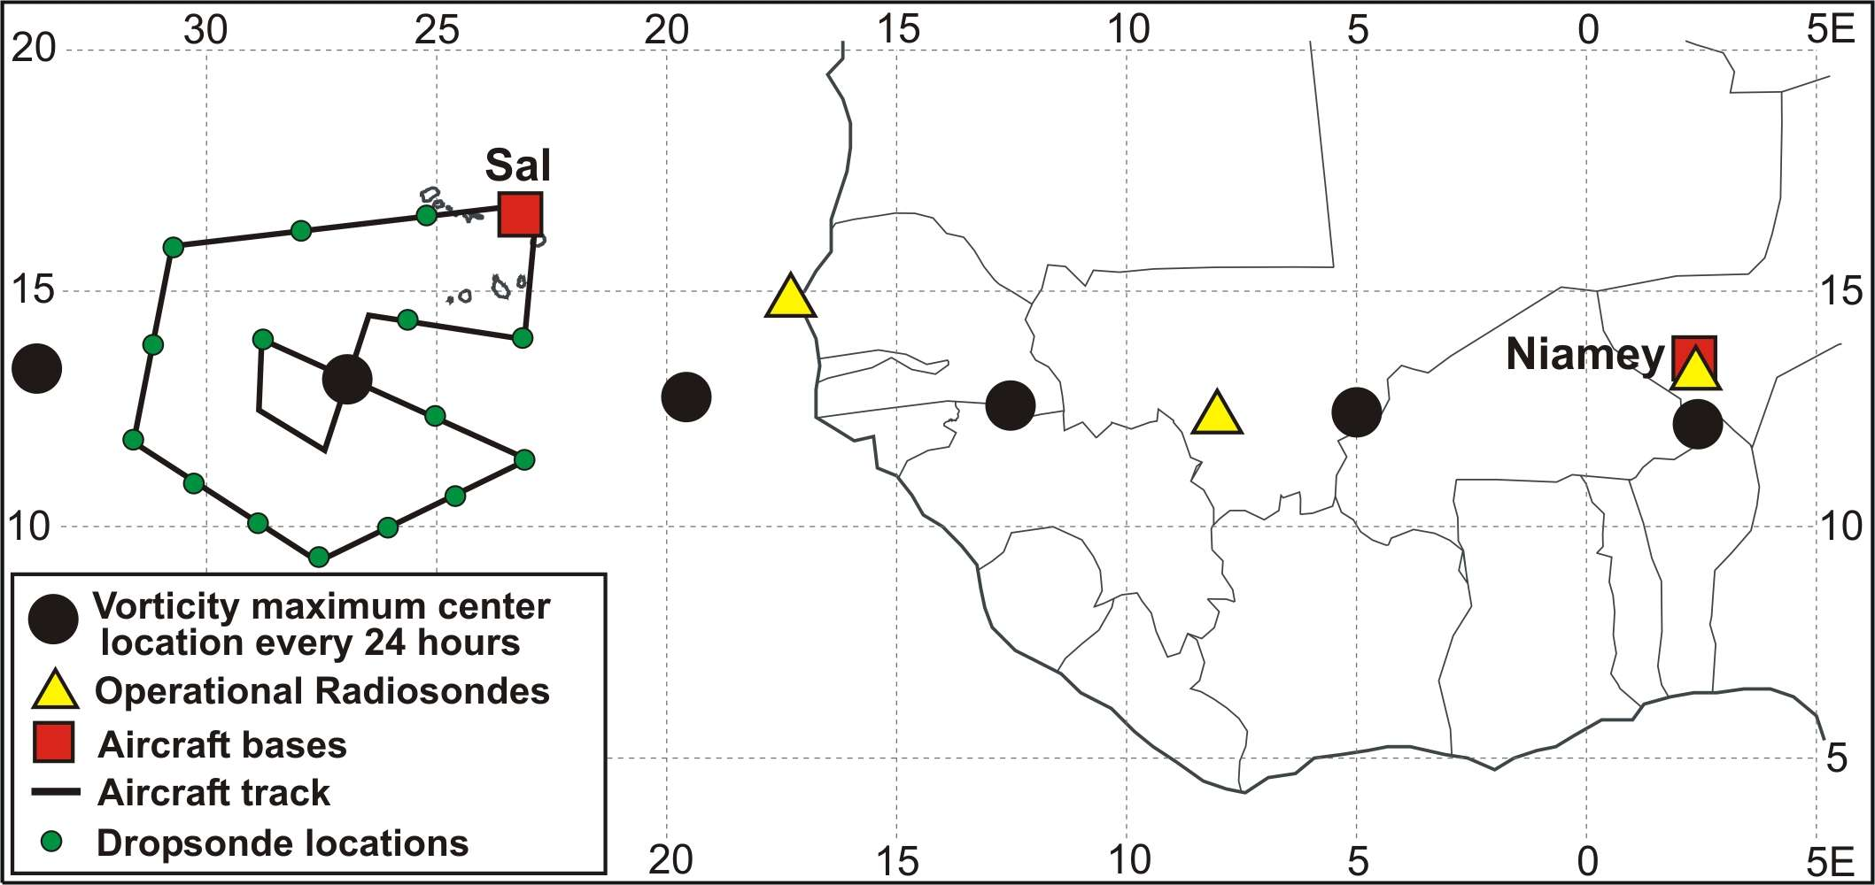
Figure courtesy of Mike Douglas illustrating one possible flight pattern for an EW mission. Obviously, if the AEJ was north of Sal, the pattern would be extended northward. If there is evidence of a vortex, a possible option is for an in situ module at lower levels as illustrated. If there is convective weather near the TOGA radar, more time would be spent in that vicinity. Altitudes would be mostly 35-40Kft to get best science output from dropsondes.

Combining Mission Modules with EEW missions: For any EEW mission with less than 1 hour ferry (EW between 16-31 W), it is quite possible that several hours will be available for targeted modules that meet many of the PP or SAL missions. In the case of SAL, most of the EEW flight plans would naturally go far enough north to be over the SAL for several hours. (If not we’re not doing our job.) Whether this is coincident with a dust outbreak will vary for each situation.

Specific suggestions for modules follow the descriptions for dedicated missions. Further discussions are needed on strategies for combining modules and dedicated missions.

PP: These missions require enough altitude changes that they are not compatible with most of the EW missions. Whether in clean or filthy air, continental or maritime air, the objective of these missions will be to sample aerosol in the boundary layer (BL) and cloud layers outside of cloud, and particle type and size distributions inside of clouds. At least one set of penetrations should be made a short distance above cloud base to assess PSD and therefore CCN at low levels. These missions should consist of at least two types:
PP-1) Cumulus clouds of varying depths up to cumulonimbus, but visually distinct so that they may be safely penetrated with easy and quick escape routes. The aircraft should penetrate at a variety of levels up to and including anvil level, if present.
PP-2) Mixture of isolated and organized cumulonimbus with some anvils, perhaps large enough to include stratiform precipitation regions. There is also interest in doing a spiral descent through the melting layer in a region of extensive stratiform precipitation. Preference will be given to PP-2 missions within range of NPOL or TOGA radar for safety and for the best science.

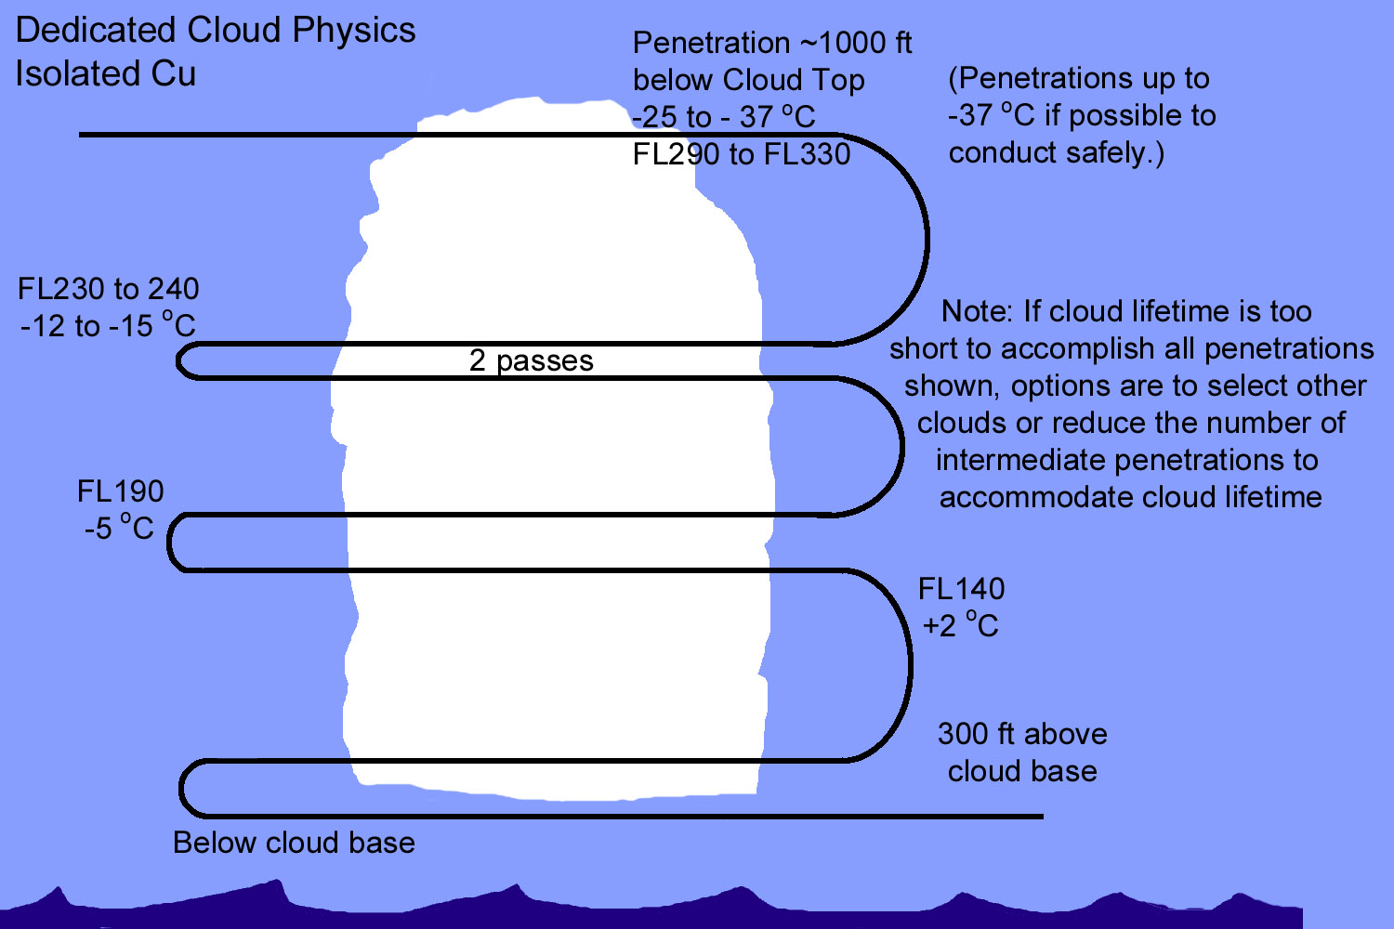
Dedicated PP-1 mission- vertical levels desired.
EZ Comment: Similar altitude coverage would be good for PP-2 but sketch would then include anvils and regions of stratiform precipitation. (radar guidance needed- see anvil module)
SAL: While some of the goals of this mission type may be accomplished as part of the EW missions, especially those close to CV, it is necessary to have some dedicated missions or modules where penetration and direct aerosol sampling of the dust layer is accomplished. One may envision some runs above the SAL, preferentially crossing its southwestern boundary to determine structure and gradients, followed by direct sampling within the dust layer and perhaps into the BL as well. (Dust layer is expected to be between 1.5 and 4.5 km, more or less.)
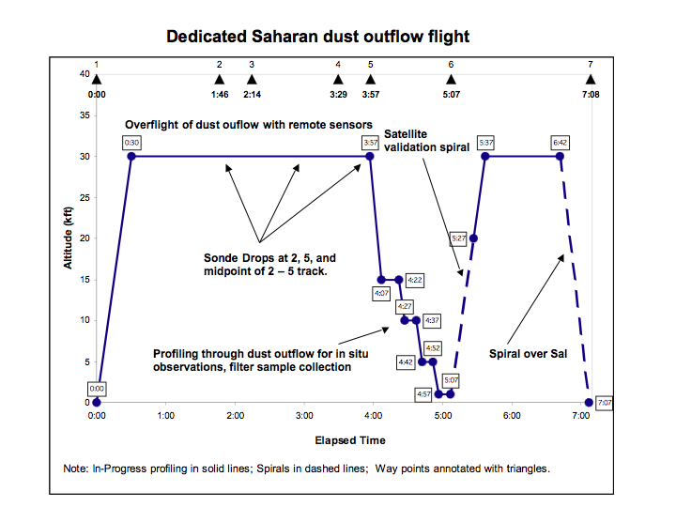

EZ query: If situation permits, could this flight be designed for 5-6 hours?
See additional SAL modules below.

CS/C: The opportunity for Cal/Val and intercomparison between DC8 in situ and remote sensing measurements and CloudSat/Calipso measurements should not be missed. The main constraints will be the necessity to fly down the nadir track with precision, as the swath width is only 1-2 km. We will need excellent ephemeris data and some input from interested PIs to determine priority days for this mission segment and desired cloud fields to sample. Flight segment is recommended as 10 minutes if clouds are main target; 30-40 minutes if aerosol.

ADDITIONAL MODULES CONTRIBUTED BY SCIENCE TEAM MEMBERS:

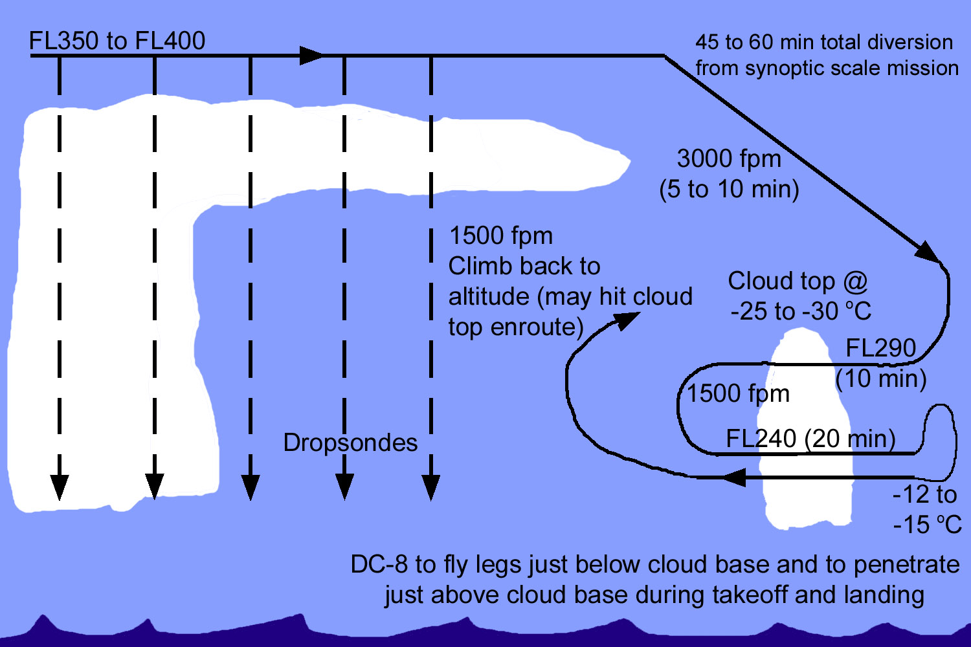
PP module: 1-hour deviation from EEW mission to penetrate isolated convective clouds

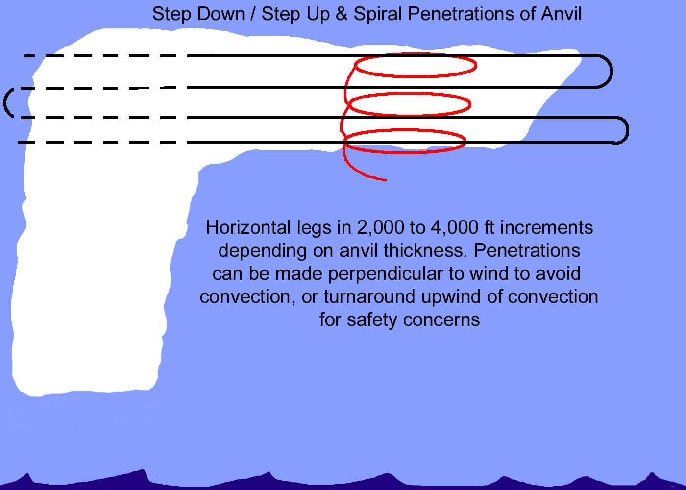
PP module: Anvil penetrations and spirals. EZ comment: Obviously, this could be anything from a 1-hour module up. If spiral extends through melting band, assumes stratiform precip.
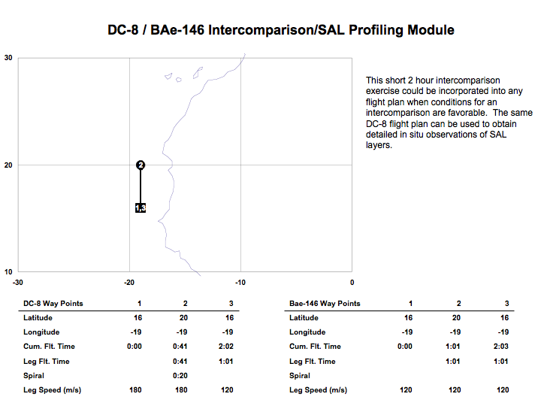

(See next page for flight profiles for each aircraft. Ellie Highwood note: Research speed of BAe146 is 100 m/s so some adjustments pending.)


