Description of the High Altitude MMIC Sounding Radiometer (HAMSR) Level 1B data format
5/6/2011

Overview

The High Altitude MMIC Sounding Radiometer (HAMSR) is a 25 channel cross-track scanning microwave sounder with channels near the 60 and 118 GHz oxygen lines and the 183 GHz water vapor line. A detailed description of the instrument and a characterization of its performance are found in Brown et al. 2011. The Level1B product contains time-ordered and geo-located brightness temperatures for the Earth scan for each of the 25 HAMSR channels. The HAMSR Level1B data files are in netCDF format. The processing from Level1 (raw instrument telemetry) to Level1B involves conversion of the raw counts to brightness temperature using the two blackbody calibration targets that are viewed through the main reflector each scan. The Level1B data are produced at the sensor resolution and no along-track or cross-track averaging is performed. The HAMSR beamwidth is 5.7º (1.8km resolution from the Global Hawk) and the Earth scene is sampled every 0.84º in the alongtrack direction and 1.7º in the along-track direction, meaning the data are over-sampled significantly. The Earth scan consists of observations from +/- 60º about nadir, though users are cautioned about using edge-of-scan data (greater than 45º) for applications requiring high accuracy since edge of scan errors scan approach 2K. See Brown et al. 2011 for more details.

Level1B Contents

The contents of the Level1B files are shown in the following table. The variables in the netCDF file are also fully attributed and self describing. The nominal channel dimension is 25 and the nominal cross-track dimension is 127 pixels. The along-track dimension varies from flight-to-flight. The netCDF header dump for an example file is given in another section below.
Variable Name | Variable Description | Variable Dimensions
HAMSR time | seconds since 2000-01-01 00:00:00.0 | along track
pixel latitude | Latitude for each HAMSR pixel [-90:90] | cross track x along track
pixel longitude | Longitude for each HAMSR pixel [-180:180] | cross track x along track
altitude | Aircraft altitude from GPS in meters | along track
brightness temperature | Calibrated Brightness Temperature for the Earth scene. Default value is -1. | channel x cross track x along track
pixel Earth incidence angle | Earth incidence angle for each HAMSR pixel [0:89.9] | cross track x along track
aircraft latitude | Aircraft Latitude [-90:90] | along track
aircraft longitude | Aircraft Longitude [-180:180] | along track
aircraft roll | Aircraft Roll [-180:180] | along track
aircraft pitch | Aircraft Pitch [-180:180] | along track
aircraft heading | Aircraft Heading [-180:180] | along track
Brightness temperature Quality Flag for the entire scan | 0 – good  1 – data may be noisier than normal, exclude for high-accuracy applications  2 – not recommended for use | along track

HAMSR Channel Set

HAMSR has 25 channels divided among three bands; 50-60 GHz, 113-118 GHz and 166-193 GHz. The channel centroid frequency, convolution bandwidth and sideband weighting ratio for each channel are shown in Figure 1. These values were computed from measured passband data of the instrument. The values given in Table 1 are for each channel and for the upper and lower sidebands separately for the double-sideband channels. The side-band weighting ratio is the ratio of the power received in one sideband to the total power received for that channel (e.g. from both sidebands). The detailed passband shapes are shown in Figure 1 below.
Table 1. HAMSR frequency response: Centroid frequency, bandwidth and upper/lower sideband weighting.
Channel | f_{c} – LSB [GHz] | BW – LSB [MHz] | W₁ | f_{c} – USB [GHz] | BW – USB [MHz] | W₂
1 | 50.30 | 185.34 | - | - | - | -
2 | 51.81 | 456.26 | - | - | - | -
3 | 52.82 | 444.60 | - | - | - | -
4 | 53.46 | 151.29 | 0.58 | 53.69 | 155.73 | 0.42
5 | 54.41 | 446.50 | - | - | - | -
6 | 54.94 | 442.91 | - | - | - | -
7 | 55.46 | 374.80 | - | - | - | -
8 | 55.99 | 279.05 | 0.90 | 56.61 | 235.84 | 0.10
9 | 113.27 | 1062.11 | - | - | - | -
10 | 115.19 | 1060.03 | - | - | - | -
11 | 116.18 | 506.09 | - | - | - | -
12 | 116.70 | 504.33 | - | - | - | -
13 | 117.13 | 432.13 | - | - | - | -
14 | 117.54 | 418.95 | - | - | - | -
15 | 117.93 | 459.60 | 0.54 | 119.56 | 424.56 | 0.46
16 | 118.30 | 319.84 | 0.54 | 119.19 | 302.38 | 0.46
17 | 118.50 | 117.19 | 0.47 | 118.98 | 140.74 | 0.53
18 | 118.61 | 100.86 | 0.42 | 118.86 | 105.95 | 0.58
19 | 166.95 | 3812.82 | - | - | - | -
20 | 173.22 | 3298.97 | 0.54 | 192.88 | 2926.96 | 0.46
21 | 176.26 | 2409.16 | 0.34 | 190.23 | 2472.45 | 0.66
22 | 178.74 | 2133.24 | 0.23 | 187.95 | 2162.90 | 0.77
23 | 180.39 | 1093.10 | 0.29 | 186.32 | 1119.17 | 0.71
24 | 181.44 | 1157.75 | 0.36 | 185.09 | 1109.80 | 0.64
25 | 182.30 | 536.28 | 0.27 | 184.31 | 539.22 | 0.73

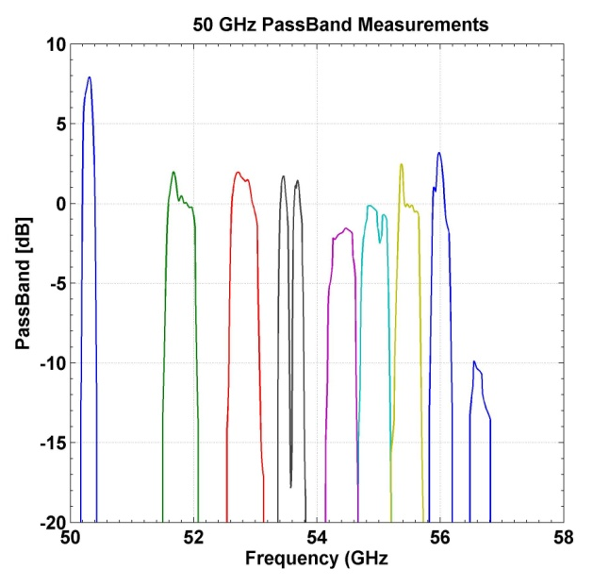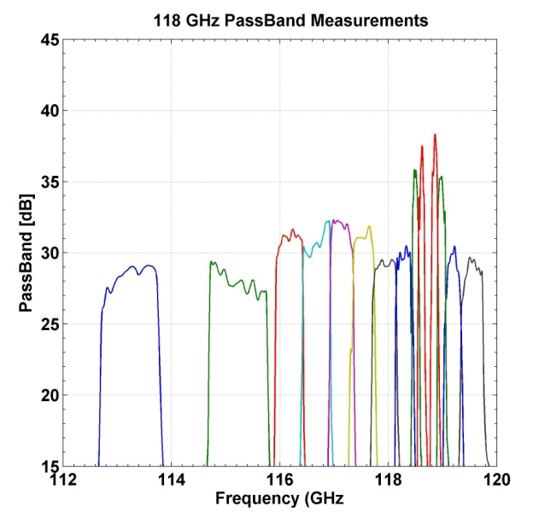
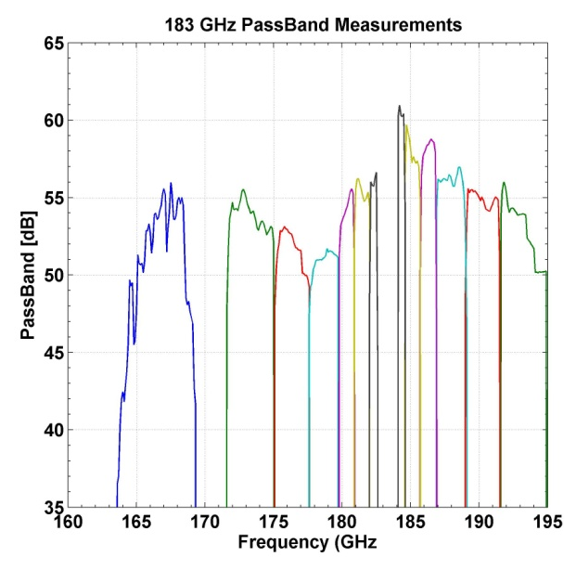
Figure 1. 50 GHz (top left), 118 GHz (top right) and 183 GHz (bottom) HAMSR passband measurements.

HAMSR Level 1B NetCDF Header Dump
netcdf HAMSR_L1B_20100916T061217_20100917T070940_v01 {
dimensions:
channel = 25 ;
cross_track = 127 ;
along_track = 37987 ;
variables:
double time(along_track) ;
time:units = "seconds" ;
time:comment = "seconds since 2000-01-01 00:00:00.0" ;
time:long_name = "Measurement time" ;
time:scale_factor = 1. ;
int lat(along_track, cross_track) ;
lat:units = "degrees_north" ;
lat:comment = "Pixel Latitude [-90:90]" ;
lat:default value = 91. ;
lat:long_name = "Pixel Latitude" ;
lat:scale_factor = 0.001 ;
int lon(along_track, cross_track) ;
lon:units = "degrees_east" ;
lon:comment = "Pixel Longitude [-180:180]" ;
lon:default value = 361. ;
lon:long_name = "Pixel Longitude" ;
lon:scale_factor = 0.001 ;
int altitude(along_track) ;
altitude:units = "m" ;
altitude:comment = "Aircraft altitude from GPS in meters" ;
altitude:long_name = "Altitude" ;
altitude:scale_factor = 0.1 ;
int TB(along_track, cross_track, channel) ;
TB:units = "K" ;
TB:comment = "Calibrated Brightness Temperature" ;
TB:default value = -1. ;
TB:long_name = "Brightness Temperature" ;
TB:scale_factor = 0.001 ;
short EIA(along_track, cross_track) ;
EIA:units = "degrees" ;
EIA:comment = "Pixel Incidence Angle [-90:90]" ;
EIA:long_name = "Pixel Incidence Angle" ;
EIA:scale_factor = 0.01 ;
int AClon(along_track) ;
AClon:units = "degrees_north" ;
AClon:comment = "Airplane Latitude [-90:90]" ;
AClon:long_name = "Airplane Latitude" ;
AClon:scale_factor = 0.001 ;
int AClat(along_track) ;
AClat:units = "degrees_east" ;
AClat:comment = "Airplane Longitude [-180:180]" ;
AClat:long_name = "Airplane Longitude" ;
AClat:scale_factor = 0.001 ;
short ACroll(along_track) ;
ACroll:units = "degrees" ;
ACroll:comment = "Airplane Roll [-90:90]" ;
ACroll:long_name = "Airplane Roll" ;
ACroll:scale_factor = 0.01 ;
short ACpitch(along_track) ;
ACpitch:units = "degrees" ;
ACpitch:comment = "Airplane Pitch [-90:90]" ;
ACpitch:long_name = "Airplane Pitch" ;
ACpitch:scale_factor = 0.01 ;
short ACheading(along_track) ;
ACheading:units = "degrees" ;
ACheading:comment = "Airplane Heading [-180:180]" ;
ACheading:long_name = "Airplane Heading" ;
ACheading:scale_factor = 0.01 ;
short Qflag(along_track, channel) ;
Qflag:units = "unitless" ;
Qflag:comment = "Quality Flag, 0-Fine, 1-Marginal, 2-Unusable" ;
Qflag:long_name = "Quality Flag" ;
Qflag:scale_factor = 1. ;
}

References
Brown, S. T.; Lambrigtsen, B.; Denning, R. F.; Gaier, T.; Kangaslahti, P.; Lim, B. H.; Tanabe, J. M.; Tanner, A. B.; , "The High-Altitude MMIC Sounding Radiometer for the Global Hawk Unmanned Aerial Vehicle: Instrument Description and Performance," IEEE Transactions on Geoscience and Remote Sensing, in press; doi: 10.1109/TGRS.2011.2125973

