One-Degree Monthly Microwave Total Precipitable Water
Version 7r01 RSS Product Documentation
Product Overview:
The One-Degree Monthly Microwave Total Precipitable Water (TPW) product (also referred to as column-integrated water vapor) is constructed by merging together carefully intercalibrated microwave water vapor values derived from a series of satellite microwave radiometer instruments that include SSM/I, SSMIS, AMSR-E, WindSat, and AMSR2 data. Monthly means, 12 month climatologies, cumulative trend maps and latitude-time plots are packaged in a single file at RSS. GHRC retrieves the updated file every month and repackages it as a series of monthly mean files, a separate climatology file, and a cumulative map file. These netCDF files are available from the GHRC data archive.

RSS Data Production Team:
Product Lead: Carl Mears, Remote Sensing Systems
Product Team Members: Deborah K Smith, Kyle Hilburn, Lucrezia Ricciardulli

Roles of Team Members:
Development and Testing: Carl Mears, Deborah Smith, Kyle Hilburn, Lucrezia Ricciardulli
Product Design: Carl Mears, Deborah Smith, Kyle Hilburn, Lucrezia Ricciardulli
Product Validation: Carl Mears, Deborah Smith
Product Production: Carl Mears, Deborah Smith
Product Distribution: Deborah Smith, Marty Brewer
Help Desk: Marty Brewer

Contact Information for Data Team:
Remote Sensing Systems
www.remss.com
support@remss.com
707­-545-­2904

Sponsor: NASA

Product Design:
CF variable name, units: | prw (atmosphere_mass_content_of_water_vapor), kg m-2
Spatial resolution: | 1.0 x 1.0 degree latitude/longitude
Temporal resolution and extent: | monthly averages, Jan 1988 - present (increases monthly)
Coverage: | global oceans, no ice, not near land
The One-Degree Monthly Microwave TPW product is constructed using satellite microwave data. Carefully intercalibrated microwave total precipitable water vapor values derived from a series of satellite microwave radiometer instruments are merged to create a product suitable for model validation and other uses. Details of the RSS data product are available online at http://www.remss.com/measurements/atmospheric-water-vapor/tpw-1-deg-product.

The netCDF files at GHRC contain identical data and metadata but have been reformatted into individual files. GHRC data format is described at
https://ghrc.nsstc.nasa.gov/pub/tpw/doc/rss1tpwnv7r01_dataset.pdf

Version History:
Version 7r00 released January 2012 original data release
Version 7r01 released January 2016 added AMSR2 and used updated correction factors

The files are updated monthly with new data for the previous month. The version will change when any of the following events occur: 1) a new version of RSS radiometer data are available for all sensors used (such as V8), 2) a new climatology is produced (happens every 10 years), 3) a new sensor is added (such as GMI) or new correction factors are applied. In all cases, the entire data set will be reprocessed and a new revision number given. The first number in the version (the 7 in v07r01) applies to the algorithm used for the microwave sensor data, so if new version 8 data are used as input, the name of this product will change to V08r00).

Data Product Processing and Algorithm:
The satellite microwave radiometer total column atmospheric water vapor also known as total precipitable water (TPW) values are used as inputs to this product. The data are from 6 SSM/I on DMSP satellites (F08, F10, F11, F13, F14 and F15), 2 SSMIS on DMSP satellites (F16 and F17), AMSR-E on Aqua, AMSR2 on GCOM-1, and the WindSat polarimetric radiometer on the NPP Coriolis satellite [Gaiser et al, 2004; Hollinger et al., 1990; Kawanishi et al., 2003; Kunkee et al., 2008]. Each of these polar-orbiting sensors measures the Earth radiance at multiple frequencies and polarizations in the microwave spectrum. RSS obtains homogenous brightness temperatures using careful intercalibration and a consistently applied data processing scheme [see Wentz, 2013]. On-orbit calibration is accomplished with observation of cold (cosmic background radiation) and hot (on-board warm source) targets. These measurements are needed to maintain consistency of values over time.
The transformation of satellite measured brightness temperatures to geophysical measurements is accomplished by using a consistent algorithm and a well-developed and tested radiative transfer model to simulate satellite measured brightness temperatures and derive a regression algorithm [Meissner and Wentz, 2004; 2009; 2012; Wentz and Spencer, 1998]. The currently used RSS algorithm is referred to as Version-7 and is consistently applied to each of the sensors [Hilburn et al., 2010]. Uniformity of process and intercalibration between sensors on the brightness temperature level ensures the TPW values coming from each platform can successfully be merged to produce a high-quality climatological product.
The satellite-measured atmospheric water vapor values represent the depth in millimeters the atmospheric water vapor would be, if condensed at the surface, for a column of atmosphere above a given grid cell. The CF-compliant unit for this measurement is kg m-2, which is equivalent (using the density of water) to 1 mm depth. TPW values range from 0 to 75 kg m-2. By measuring microwave radiance near the water vapor emission line at 23.8 GHz, and at other frequencies where the atmosphere is more transparent, the TPW can be retrieved with high accuracy [Wentz, 1997; Wentz et al., 2007]. This works best over the radiometrically dark ocean surface, and thus high-quality measurements are available only over the world’s oceans. TPW retrieval is prevented only in regions with heavy rain and near land or sea ice.
The near-polar orbiting satellite microwave sensors provide daily coverage consisting of approximately 15 orbits per day which are plotted as ascending and descending swaths on a gridded map. For each sensor, the swaths and resulting gaps between swaths vary in width. When averaged over a month, the swath gaps can result in geographic sampling that varies. With the exception of areas bordering land and sea ice, the global oceans are well represented throughout the month. The Version-7 ocean water vapor values from the individual SSM/I, SSMIS, AMSR2, AMSR-E, and WindSat sensors are freely available from RSS at ftp.remss.com. Further documentation on the RSS microwave radiometer products is available from www.remss.com/missions/ssmi, www.remss.com/missions/amsre, and www.remss.com/missions/windsat.
This merged TPW product is made using a two-step construction process. First, monthly 1-deg maps are made from individual satellite TPW values, keeping track of the number of observations per grid cell, the number of ice observations, and the mean day of month. In the second stage of processing, quality control measures are applied and a small bias adjustment (<0.1 m/s) is applied to each satellite. The values of these adjustments were found by comparing the retrievals from each satellite to measurements made by the Tropical Rainfall Measuring Mission (TRMM) Microwave Radiometer, which has been in continuous operation from 1997 to early 2015. This part of the process is described in more detail below. We then combine TPW values from all sensors using simple averaging. The resulting TPW product is constructed using the following requirements: We only calculate a mean TPW value for a specific 1-deg grid cell if the cell contains more than 160 observations during the month, if ice is present for less than 30 of the observations in that cell, and if the calculated mean day of the month (derived by averaging the time of the data falling within the cell) is within 6 days of the center day of the month.
We then compute the monthly gridded climatology by averaging together spatially-smoothed gridded maps for each month of the year over the 20 year period, 1988-2007. Each monthly map for each satellite is smoothed using a 3 degree by 3 degree boxcar smooth prior to computing the climatology. This serves to fill in small regions with missing data, and reduce sampling noise in the climatology. The monthly gridded anomalies are then computed by subtracting the climatology values for each location and month.
This product is updated monthly and will continue for as long as satellite microwave radiometers are in operation.

Validation and Uncertainty Estimate:
All measurements contain some degree of measurement error. Much of the uncertainty in a monthly mean TPW product is due to spatial-temporal sampling errors, uncertainty in intersatellite calibration, and systematic errors in the retrieval algorithm. Systematic errors in the retrieval algorithm can be important in regions where the typical atmospheric profile is markedly different than the profiles used to train the retrieval algorithm, but only lead to small errors in the mean state, and do not contribute substantially to errors in long-term changes in TPW. The contribution of measurement noise, which can be important for a single retrieval, is greatly reduced by averaging large numbers of measurements into each monthly grid point.
We know that the strong spectral signature of water vapor makes it a robust parameter to retrieve from microwave radiometer radiances and our previous comparisons of satellite TPW values with those from small-island radiosonde measurements of water vapor demonstrate RMS errors of approximately 1.2 kg m-2 [Wentz, 1997]. A more recent paper describes the comparison of RSS TPW values with ground-based GNSS values has been accepted for publication by the Journal of Geophysical Research [Mears et al., 2015]. Here we found that satellite radiometer measurements are biased about 0.4 mm high compared to the GNSS measurements, which is within the roughly 0.5 mm absolute accuracy thought to characterize the GNSS vapor values. The standard deviation of the difference between satellite and GNSS measurements ranged from between 1.60 and 1.94 kgm-2 depending on the satellite used. Since this difference includes the errors in the GPS measurements as well as error due to spatial and temporal mismatch, we expect that the error in the satellite measurements is considerably less than these values. Twelve GPS stations had overlap time periods long enough to evaluate difference trends, yielding 59 satellite-station pairs when paired with different satellites. More than half (39 of 59) did not show a significant trend. The twenty pairs with significant trends did not show trends of predominantly one sign, suggesting that neither system is plagued by a system-wide drift in TPW. This result lends confidence to the long-term trends in the merged dataset.
We have also compared the data from the individual satellites with retrievals from the TMI instrument. TMI is a microwave imaging radiometer that included the capabilities of the SSM/I instrument, but orbits in a different orbit sampling only Earth’s tropical regions. Because this orbit evolves rapidly in local measurement time, TMI measurements often occur that are closely collocated in both time and location with all of the other satellites (except F08 and F10, which ceased operation before the TRMM launch). The results of these comparisons are shown in Fig. 3 below. Most of the time, the TMI measurements show very little drift relative to the measurements from the other satellites, adding more confidence to the stability each of the components of the merged vapor dataset. There are periods of anomalous measurements for the F14, F15, and F16 satellites (shown in red). Since other TMI/radiometer comparison do not show these problems for measurements made at the same time, we conclude that the problems are due to the F14, F15, and F16 satellites, and these periods are excluded from the merged vapor product.
Several presentations are available online that describe the construction process of the RSS data set:
Smith, Deborah K., Mears, Carl A., Hilburn, Kyle A., Ricciardulli, Lucrezia, and Wentz, Frank J., 2012, Contribution of data set construction methodology to data set uncertainties, presented at 2012 AGU Fall Meeting, San Francisco, CA.,
Smith, Deborah K., Mears, Carl, Hilburn, Kyle A., and Ricciardulli, Lucrezia, 2013, A 25-year satellite microwave mean total precipitable water data set for use in climate study, presented at 2013 EUMETSAT Meteorological Satellite Conference, Vienna, Austria.

Important Considerations for Data Set Use:
Temporal Sampling Bias:
There are two types of temporal sampling biases to take into consideration:
- The sun synchronous orbit of any polar-orbiting instrument yields retrievals at specific local times. Figure 1 shows the ascending node time for each instrument and the change in this value over time. Though TPW has little diurnal variability over the oceans, what exists fails to be resolved or well measured from only 2 points of the diurnal cycle, a morning and evening time window. Merging of multiple instruments improves the sampling only slightly, typically widening the am/pm window. The AMSR-E and AMSR2 measure at 1:30 AM and 1:30 PM (local time), significantly different from the other sensors. No explicit diurnal correction is applied to account for any diurnal differences in TPW between AMSR-E and the other sensors.
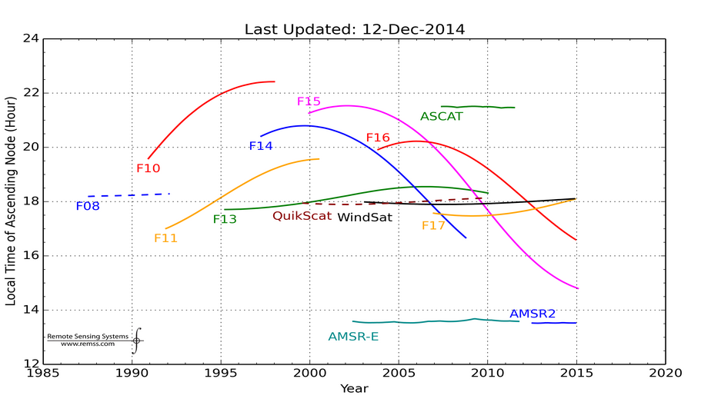
Figure 1: Local ascending crossing times for each microwave radiometer showing the change over the lifetime of the sensor. The SSM/I and SSMIS sensors are distinguished using the name of the DMSP satellite. F08 to F15 have the SSM/I and F16 and F17 have SSMIS. This plot is continually updated and available at www.remss.com/support/crossing-times. Though the plot represents all imaging radiometer data processed by RSS, only the SSM/I, SSMIS and WindSat data are used in this merged product.

- In creating this merged product, there were 3 satellite-months that did not meet the data production requirements: the average time of the calculated monthly mean fall must fall within 6 days of the center of the month. This was not the case for the following satellites/months: F08 in Jan 1988, F08 in Oct 1990 and F10 in Dec 1991 when the sensors operating at that time had data outages. In each case, the month values were needed for consistency of the time series so an exception is made and the data are included despite the poor sampling. These exceptions are early within the time-series and bias be avoided by starting analysis in 1992.

Inhomogeneous Sampling:
The quality of the TPW product is dependent on the number of data that are averaged into each grid cell. Sampling by polar-orbiting microwave sensors is not homogeneous. For a given day of measurement, polar-orbiting sensors measure some regions with greater coverage and some regions without any coverage. In the Arctic, there are an extremely high number of observations due to overlapping measurement swaths by multiple sensors. In areas where the first and last orbits for a day overlap, a greater sampling exists. Other regions have fewer values in the mean.
Land and ice proximity reduces data sampling as radiometers suffer from side lobe interference that prevents obtaining values near land. Due to variations in sensor resolution, look angle, geographic conditions and spatial footprints, some pixels near land have more observations than others. This results in varying numbers of observations for a given grid cell and poorer quality averages near coastlines and along ice edges.
We account for sampling differences when constructing the product by requiring a minimum number of values for a mean to be calculated in any grid cell. We tested a variety of minimum observation requirements. We found that only along the coastlines and ice edges did the number of values drop below a threshold and poor quality data enter into the product. We experimented to see how different thresholds affected the resulting trends and determined little difference once a minimum threshold of 160 counts per cell per month was met. This is therefore the requirement used in constructing the merged product.

Ice Effect:
Ice is likely to exist more at one end of a month than another (with the exception of floating icebergs) and ice removal is necessary to obtain a quality product. A mean-day-of-month quality calculation is used to remove ice edge grid cells where the amount of ice increases or decreases throughout the month during seasonal changes. To handle icebergs which move between grid cells, we use the number of ice observations within a grid cell during the month to exclude when too much ice exists (number of ice observations must be <= 30). Even though these requirements are applied, it is still possible that some small ice effects remain.

Rain Effects:
Light rain has little effect on TPW values measured by microwave radiometers. The removal of values measured in rainy conditions can have adverse effects on the product. Comparison of SSM/I F13 vapor values to GPS vapor in rain-free and rainy conditions convinced us that little difference can be attributed to rain. We also found that the use of an extended rain flag creates a geographic sampling problem by removing data from primarily rainy, high vapor tropical areas which results in lower mean vapor values and higher global trends. For this reason, we excluded heavy rain-affected data (in that our microwave instrument processing does not derive a TPW value in the presence of heavy rain), but we did not use any form of extended rain flag to remove nearby rain-affected data.

Accounting for Small Differences between Sensors:
Even after significant effort to intercalibrate the satellites at the brightness temperature level, small vapor biases exist that are typically less than 0.1 mm for the various satellites. These are characterized and removed via comparison to the TMI V7 sensor water vapor values (Wentz, 2015). The TMI values are not included in making this product. Figure 2 shows the monthly-mean time series of the differences (satellite minus TMI) between collocated measurements made by each of the satellites used in the merged product and TMI. To be considered to be collocated, the observations must be in the same 0.25 degree grid cell, and separated in observation time by less than 30 minutes. The DMSP F14, F15, and F16 sensors all exhibited periods of anomalous performance (shown in red) that are excluded from further processing. Ignoring these red regions, the mean differences shown here are used to adjust the values for each of the satellites prior to merging. The exception is AMSR-E, which behaves slightly differently in the presence of light rain, which causes a slight regionally-dependent bias relative to the other instruments. This, combined with the tropical-only sampling of the TMI instrument leads to a small difference in global-mean difference for AMSRE vs. the other satellites. To account for this we subtract an additional 0.1 mm so that the global mean values are consistent. The biases applied to each satellite are shown in Table 1 below.
To test the success of these adjustments, in Figure 3 we plot the global mean vapor for each satellite relative to the mean vapor from all satellites combined. Any bias or drift in a single satellite would be seen as an offset or slope in these time series. No large biases or drifts can be seen. There is a slight upward drift in the F17 vapor values. We will continue to monitor this issue to see if it continues on the same trend line or not.

Table 1. Adjustments Applied to Sensor Data Prior to Merging
Satellite | Adjustment (m/s)
F08 | 0.000
F10 | 0.000
F11 | 0.057
F13 | 0.076
F14 | 0.011
F15 | 0.039
F16 | 0.016
F17 | 0.002
AMSR-E | -0.147
WindSat | -0.008
AMSR2 | -0.041
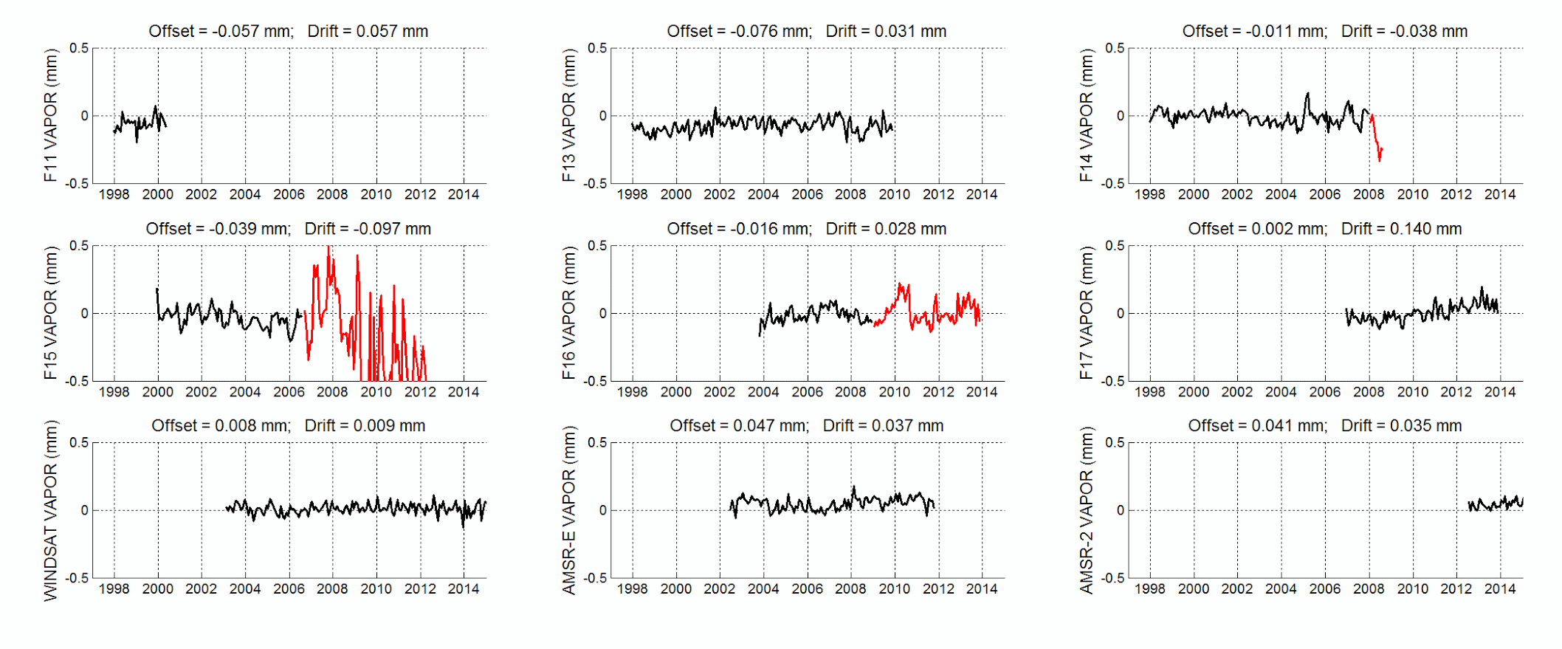
Figure 2. Time series of monthly-mean differences (satellite minus TMI) of collocated measurements between TMI and each of the satellites used in the merged vapor product. TMI is not used in the merged product. The F14, F15, and F16 satellites show periods of anomalous performance, shown in red. Data from these periods are not used in the merged product.
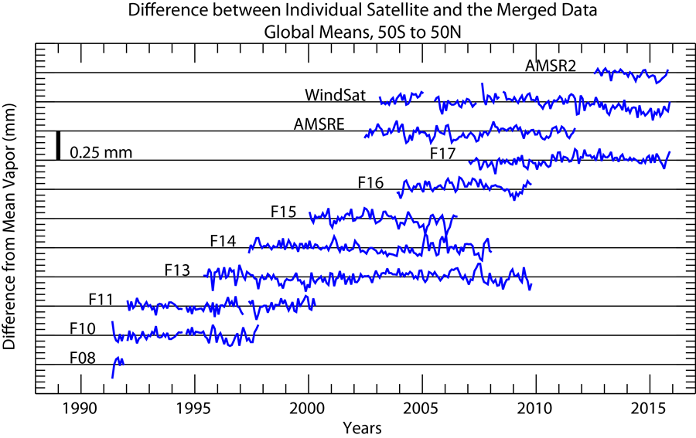
Figure 3. Monthly global mean time series for each satellite relative to the mean of all satellites operating at the given time. Each small tick mark on the y-axis corresponds to 0.1 mm. The early part of the F08 mission is not shown, because the plot is only meaningful when 2 or more satellites are operating at the same time.

Requirements for Ancillary Data Sets:
The RSS microwave radiometer data processing has minimal requirements for ancillary data sets. Since wind direction, in relationship to satellite look angle can impact the emissivity; wind direction is needed for the retrieval algorithm. Wind direction from NCEP Global Data Assimilation System (GDAS) analysis [Derber et al., 1991] is used. Any error in wind direction specification has little effect on subsequent TPW retrieval errors

References
Derber, J.C., D.F. Parrish, and S.J. Lord, 1991: The New Global Operational Analysis System at the National Meteorological Center. Weather Forecasting, 6, 538–547.
Gaiser, P. W., et al. (2004), The WindSat spaceborne polarimetric microwave radiometer: Sensor description and early orbit performance, IEEE Transactions on Geoscience and Remote Sensing, 42(11), 2347-2361.
Hilburn, K. A., F. J. Wentz, C. A. Mears, T. Meissner, and D. K. Smith (2010), Description of Remote Sensing Systems version-7 geophysical retrievals, in 17th Conference on Satellite Meteorology and Oceanography and 17th Conference on Air-Sea Interaction, Annapolis, MD.
Hollinger, J., J. L. Peirce, and G. Poe (1990), SSM/I instrument evaluation, IEEE Transactions on Geoscience and Remote Sensing, 28(5), 781-790.
Kawanishi, T., T. Sezai, Y. Ito, K. Imaoka, T. Takeshima, Y. Ishido, A. Shibata, M. Miura, H. Inahata, and R. W. Spencer (2003), The Advanced Microwave Scanning Radiometer for the Earth Observing Systems (AMSR-E), NASDA's contribution to the EOS for global energy and water cycle studies, IEEE Transactions on Geoscience and Remote Sensing, 41(2), 184-194.
Kunkee, D., S. D. Swadley, G. Poe, Y. Hong, and M. F. Werner (2008), Special Sensor Microwave Imager Sounder (SSMIS) Radiometric Calibration Anomalies-Part I: Identification and characterization, IEEE Transactions on Geoscience and Remote Sensing, 46, 1017-1033.
Mears, C. A., J. Wang, D. K. Smith, and F. J. Wentz (2015), Intercomparison of Total Precipitable Water Measurements Made by Satellite Borne Microwave Radiometers and Ground-Based GPS Instruments, Journal of Geophysical Research: Atmospheres, 120, 2492-2504.
Meissner, T., and F. J. Wentz (2004), The complex dielectric constant of pure and sea water from microwave satellite observations, IEEE Transactions on Geoscience and Remote Sensing, 42(9), 1836-1849.
Meissner, T., and F. J. Wentz (2009), Wind vector retrievals under rain with passive satellite microwave radiometers, IEEE Transactions on Geoscience and Remote Sensing, 47(9), 3065-3083.
Meissner, T., and F. J. Wentz (2012), The emissivity of the ocean surface between 6 - 90 GHz over a large range of wind speeds and Earth incidence angles, IEEE Transactions on Geoscience and Remote Sensing, 50(8), 3004-3026.
Wentz, F. J. (1997), A well calibrated ocean algorithm for special sensor microwave / imager, Journal of Geophysical Research, 102(C4), 8703-8718.
Wentz, F. J. (2013), SSM/I Version-7 Calibration Report, Technical Report Rep., 46 pp, Santa Rosa, CA.
Wentz, F. J., L. Ricciardulli, K. A. Hilburn, and C. A. Mears (2007), How much more rain will global warming bring?, Science, 317, 233-235.
Wentz, F. J. (2015) A 17-Year Climate Record of Environmental Parameters Derived from the Tropical Rainfall Measuring Mission (TRMM) Microwave Imager, Journal of Climate, 28, 6882-6902.
Wentz, F. J., and R. W. Spencer (1998), SSM/I rain retrievals within a unified all-weather ocean algorithm, Journal of the Atmospheric Sciences, 55(9), 1613-1627.

A publication on this data product is in production. Several presentations are available online that describe the process:

Smith, Deborah K., Mears, Carl A., Hilburn, Kyle A., Ricciardulli, Lucrezia, and Wentz, Frank J., 2012, Contribution of data set construction methodology to data set uncertainties, presented at 2012 AGU Fall Meeting, San Francisco, CA., http://images.remss.com/papers/rssconf/smith_AGUFall_2012_vapor_product_method.pdf

Smith, Deborah K., Mears, Carl, Hilburn, Kyle A., and Ricciardulli, Lucrezia, 2013, A 25-year satellite microwave mean total precipitable water data set for use in climate study, presented at 2013 EUMETSAT Meteorological Satellite Conference, Vienna, Austria., http://images.remss.com/papers/rssconf/Smith_EUMETSAT_2013_TPW.pdf

