One-Degree Monthly Microwave Ocean Surface Wind Speed
Version 7r01RSS Product Documentation
Product Overview:
The One-Degree Monthly Microwave Ocean Surface Wind Speed product is constructed by merging together carefully intercalibrated microwave wind speed values derived from a series of satellite microwave radiometer instruments that include SSM/I, SSMIS and WindSat. Monthly means, 12 month climatologies, cumulative trend maps and latitude -time plots are packaged in a single file at RSS. GHRC retrieves the updated file every month and repackages it as a series of monthly mean files, a separate climatology file, and a cumulative map file. These netCDF files are available from the GHRC data archive.

RSS Data Production Team:
Product Lead: Carl Mears, Remote Sensing Systems
Product Team Members: Deborah K Smith, Kyle Hilburn, Lucrezia Ricciardulli

Roles of Team Members:
Development and Testing: Carl Mears, Deborah Smith, Kyle Hilburn, Lucrezia Ricciardulli
Product Design: Carl Mears, Deborah Smith, Kyle Hilburn, Lucrezia Ricciardulli
Product Validation: Carl Mears, Deborah Smith
Product Production: Carl Mears, Deborah Smith
Product Distribution: Deborah Smith, Marty Brewer
Help Desk: Marty Brewer

Contact Information for Data Team:
Remote Sensing Systems
www.remss.com
support@remss.com
707­-545-­2904

Sponsor: NASA

Product Design:
CF variable name, units: | wind speed, m/s
Spatial resolution: | 1.0 x 1.0 degree latitude/longitude
Temporal resolution and extent: | monthly averages, Jan 1988 - present (increases monthly)
Coverage: | global oceans, no ice, not near land

The One-Degree Monthly Microwave Ocean Surface Wind Speed product is constructed using satellite microwave data. Carefully intercalibrated microwave wind speed values derived from a series of satellite microwave radiometer instruments are merged to create a product suitable for model validation and other uses. Details of the RSS data product are available online at http://www.remss.com/measurements/wind/wspd-1-deg-product.

The netCDF files at GHRC contain identical data and metadata but have been reformatted into individual files. GHRC data format is described at
https://ghrc.nsstc.nasa.gov/pub/wind_climatology/doc/rss1windnv7r01_dataset.pdf

Version History:
Version 7r00 released January 2013 original data release
Version 7r01 released January 2016 added AMSR2 and used updated correction factors

The files are updated monthly with new data for the previous month. The version will change when any of the following events occur: 1) a new version of RSS radiometer data are available for all sensors used (such as V8), 2) a new climatology is produced (happens every 10 years), 3) a new sensor is added such as GMI) or new adjustment factors are applied. In all cases, the entire data set will be reprocessed and a new revision number given. The first number in the version (the 7 in v07r01) applies to the algorithm used for the microwave sensor data, so if new version 8 data are used, the name will change to V08r00).

Data Product Processing and Algorithm:
The satellite microwave radiometer wind speed data used as inputs to this product are from 6 SSM/I on DMSP satellites (F08, F10, F11, F13, F14 and F15), 2 SSMIS on DMSP satellites (F16 and F17), and the WindSat polarimetric radiometer on the NPP Coriolis satellite [Gaiser et al, 2004; Hollinger et al., 1990; Kawanishi et al., 2003; Kunkee et al., 2008]. Each of these polar-orbiting sensors measures the Earth radiance at multiple frequencies and polarizations in the microwave spectrum. RSS obtains homogenous brightness temperatures using careful intercalibration and a consistently applied data processing scheme [see Wentz, 2013]. On-orbit calibration is accomplished with observation of cold (cosmic background radiation) and hot (on-board warm source) targets. These measurements are needed to maintain consistency of values over time.
The transformation of satellite measured brightness temperatures to geophysical measurements is accomplished by using a consistent algorithm and a well-developed and tested radiative transfer model to simulate satellite measured brightness temperatures and derive a regression algorithm [Meissner and Wentz, 2004; 2009; 2012; Wentz and Spencer, 1998]. The currently used RSS algorithm is referred to as Version-7 [Hilburn et al., 2010] and is consistently applied to each of the sensors. Uniformity of process and intercalibration between sensors on the brightness temperature level ensures the wind speeds coming from each platform can successfully be merged to produce a high-quality climatological product.
The satellite-measured ocean surface wind speed values represent the speed of air movement at a height of 10 meters above the ocean surface. The CF-compliant unit for this measurement is m/s. The microwave wind speed values used to create the product range from 0 to 50 m/s. The wind speed is retrieved by noting the microwave radiance measured by the satellite. The radiance is a combination of surface emission and atmospheric emission, part of which is scattered by the ocean surface. Wind-induced roughening of the ocean surface causes changes in emission and scattering at the ocean surface. By analyzing measurements made at different frequencies, the contribution to changes in brightness temperature caused by atmospheric emission, scattering and attenuation can be accurately removed. The resulting roughening is a measure of wind stress, which is converted to a 10 meter neutral density wind speed. This only works for the ocean surface, and thus measurements are available only over the world’s oceans. Wind speed retrieval is prevented in regions with rain, radio frequency interference, and near land or sea ice.
The near-polar orbiting satellite microwave sensors provide daily coverage consisting of approximately 15 orbits per day which are plotted as ascending and descending swaths on a gridded map. For each sensor, the swaths and resulting gaps between swaths vary in width. When averaged over a month, the swath gaps can result in geographic sampling that varies. With the exception of areas bordering land and sea ice, the global oceans are well represented throughout the month. The Version-7 ocean wind speed values from the individual SSM/I, SSMIS, and WindSat sensors are freely available from RSS at ftp.remss.com. Further documentation on the RSS microwave radiometer products is available from www.remss.com/missions/ssmi and www.remss.com/missions/windsat.
This merged ocean wind speed product is made using a two-step construction process. First, monthly 1-deg maps are made from individual satellite wind speed values, keeping track of the number of observations per grid cell, the number of ice observations, and the mean day of month. In the second stage of processing, quality control measures are applied and a small bias adjustment (<0.1 m/s) is applied to each satellite. The values of these adjustments were found by comparing the retrievals from each satellite to measurements made by the Tropical Rainfall Measuring Mission (TRMM) Microwave Radiometer, which has been in continuous operation from 1997 to early 2015. This part of the process is described in more detail below. We then combine wind speed values from all sensors using simple averaging. The resulting merged wind speed product is constructed using the following requirements: We only calculate a wind speed value for a specific 1-deg grid cell if the cell contains more than 160 observations during the month, if ice is present for less than 30 of the observations in that cell, and if the calculated mean day of the month (derived by averaging the time of the data falling within the cell) is within 6 days of the center day of the month.
We then compute the monthly gridded climatology by averaging together spatially-smoothed gridded maps for each month of the year over the 20 year period, 1988-2007. Each monthly map for each satellite is smoothed using a 3 degree by 3 degree boxcar smooth prior to computing the climatology. This serves to fill in small regions with missing data, and reduce sampling noise in the climatology. The monthly gridded anomalies are then computed by subtracting the climatology values for each location and month. This product is updated monthly and will continue for as long as satellite microwave radiometers are in operation.
Validation and Uncertainty Estimate:
Wind Speeds are typically validated by comparison with values measured by moored ocean buoys and with winds from global circulation models. At RSS, we have completed extensive intercomparisons between winds from all microwave sensors including those from scatterometers. The mean differences of satellite minus buoy wind speeds for closely collocated measurements (within 50 km and 30 minutes) were calculated using data from 1988 through to present. The typical stats found for any individual radiometer is on the order of ~1.0 m/s root-mean-square error. This decreases for buoys in tropical regions such as those in the TAO/TRITON, RAMA and PIRATA arrays for which the RMS error is closer to 0.7 m/s for most radiometers.
Two papers summarize the results for the series of SSM/I as compared directly to buoy winds [Mears et al., 2001] and model winds [Meissner et al., 2001]. Though the results reported are for an earlier version of the data, we find similar RMS errors with Version-7. For this merged product, the contribution of measurement noise, important for a single retrieval, is greatly reduced by averaging large numbers of measurements into a monthly grid point.
Comparisons of this merged product with other data are underway.
Several presentations are available online that describe the construction process of the RSS merged wind data set:
Smith, Deborah K., Mears, Carl A., Hilburn, Kyle A., Ricciardulli, Lucrezia, and Wentz, Frank J., 2012, Contribution of data set construction methodology to data set uncertainties, presented at 2012 AGU Fall Meeting, San Francisco, CA.,
Smith, Deborah K., Mears, Carl, Hilburn, Kyle A., and Ricciardulli, Lucrezia, 2013, A 25-year satellite microwave mean total precipitable water data set for use in climate study, presented at 2013 EUMETSAT Meteorological Satellite Conference, Vienna, Austria.
Important Considerations for Data Set Use:
Temporal Sampling Bias:
There are two types of temporal sampling biases to take into consideration:
- Ocean wind speed has significant diurnal variability in certain ocean regions. The sun synchronous orbit of any polar-orbiting sensor yields retrievals at specific local times. The figure below shows the ascending node time for each sensor and the change in this value over time, which demonstrates that the ocean wind speed is well measured from only 2 points in the diurnal cycle, a morning and an evening time window of roughly 6-10 am/pm represented by the microwave radiometers used in this product. Due to the size of ocean wind variability, we exclude measurements from AMSR-E and AMSR2 (both were used in our TPW product of similar construction). The AMSR-E and AMSR2 measure at 1:30 AM and 1:30 PM (local time), significantly different from the other sensors. The AMSR2 has been added to the V7r01 version due to lack of other instrument wind data at the time of production. We expect to remove AMSR2 for a future version.
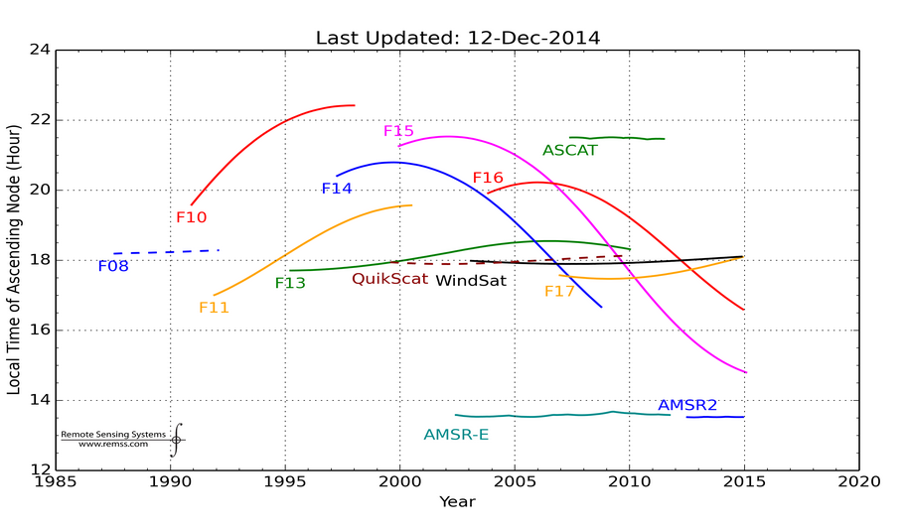
Figure 1: Local ascending crossing times for each microwave radiometer showing the change over the lifetime of the sensor. The SSM/I and SSMIS sensors are distinguished using the name of the DMSP satellite. F08 to F15 have the SSM/I and F16 and F17 have SSMIS. This plot is continually updated and available at www.remss.com/support/crossing-times. Though the plot represents all imaging radiometer data processed by RSS, only the SSM/I, SSMIS, AMSR2, and WindSat data are used in this merged product.

- In creating this merged product, there were 3 satellite-months that did not meet the data production requirements stated above. We require that the average time of the calculated monthly mean fall within 6 days of the center of the month. This was not the case for the following satellites/months: F08 in Jan 1988, F08 in Oct 1990 and F10 in Dec 1991 when the sensors operating at that time had data outages. In each case, the month values were needed for consistency of the time series so an exception is made and the data are included despite the poor sampling. These exceptions are early within the time-series and one can avoid any bias that may result by starting analysis in 1992.

Inhomogeneous Sampling:
The quality of the wind speed product is dependent on the number of data that are averaged into each grid cell. Sampling by polar-orbiting microwave sensors is not homogeneous. For a given day of measurement, polar-orbiting sensors measure some regions with greater coverage and some regions without any coverage. In the Arctic, there are an extremely high number of observations due to overlapping measurement swaths by multiple sensors. In areas where the first and last orbits for a day overlap, a greater sampling exists. Other regions have fewer values in the mean.
Land and ice proximity reduces data sampling as radiometers suffer from side lobe interference that prevents obtaining wind speed values near land. Due to variations in sensor resolution, look angle, geographic conditions and spatial footprints, some pixels near land have more observations than others. This results in varying numbers of observations for a given grid cell and poorer quality averages near coastlines and along ice edges.
Due to the effect of rain on wind speeds derived from microwave observations, we use an extended rain flag when developing this wind speed product. The removal of rain-affected or potentially rain-affected wind speeds reduces the number of values used to calculate the mean in rainy tropical regions.
We account for sampling differences when constructing the product by requiring a minimum number of values for a mean to be calculated in any grid cell. We tested a variety of minimum observation requirements. We found that only along the coastlines and ice edges did the number of values drop below a threshold and poor quality data enter into the product. We experimented to see how different thresholds affected the resulting trends and determined little difference once a minimum threshold of 160 counts per cell per month was met. This is therefore the requirement used in constructing the merged product.
Ice Effect:
Ice is likely to exist more at one end of a month than another (with the exception of floating icebergs) and ice removal is necessary to obtain a quality product. A mean-day-of-month quality calculation is used to remove ice edge grid cells where the amount of ice increases or decreases throughout the month during seasonal changes. To handle icebergs which move between grid cells, we use the number of ice observations within a grid cell during the month to exclude when too much ice exists (number of ice observations must be <= 30). Even though these requirements are applied, it is still possible that some small ice effects remain in the product.
Rain Effects:
Rain affects ocean wind speed values measured by microwave radiometers. The removal of values measured in rainy conditions can have adverse effects on the product. For the wind speed product, grid points adjacent to rain need to be removed to ensure the highest quality. However, exclusion of data adjacent to rain creates a geographic sampling problem by removing data from primarily rainy, tropical areas. Despite these complications, we feel it necessary to exclude any rain-affected data from the mean calculation and therefore use an extended rain flag during construction that consists of checking nearby data (within the 0.25 degree grid cells adjacent to the grid cell in question) and omitting those for which rain is present.
Accounting for Small Differences between Sensors:
Even after our best efforts to intercalibrate the satellites at the brightness temperature level, small wind speed biases exist that are typically less than 0.1 m/s for the various satellites. These are characterized and removed via comparison to the TMI V7 sensor wind speeds (Wentz, 2015) which arenot used in this product. In Figure 2, we show monthly-mean time series of the differences (satellite minus TMI) between collocated measurements made by each of the satellites used in the merged product and TMI. To be considered to be collocated, the observations must be in the same 0.25 degree grid cell, and separated in observation time by less than 30 minutes. The DMSP F14, F15, and F16 sensors all exhibited periods of anomalous performance (shown in red) that are excluded from further processing. Ignoring these red regions, the mean differences shown here are used to adjust the values for each of the satellites prior to merging. The biases applied to each satellite are shown in Table 1 below.
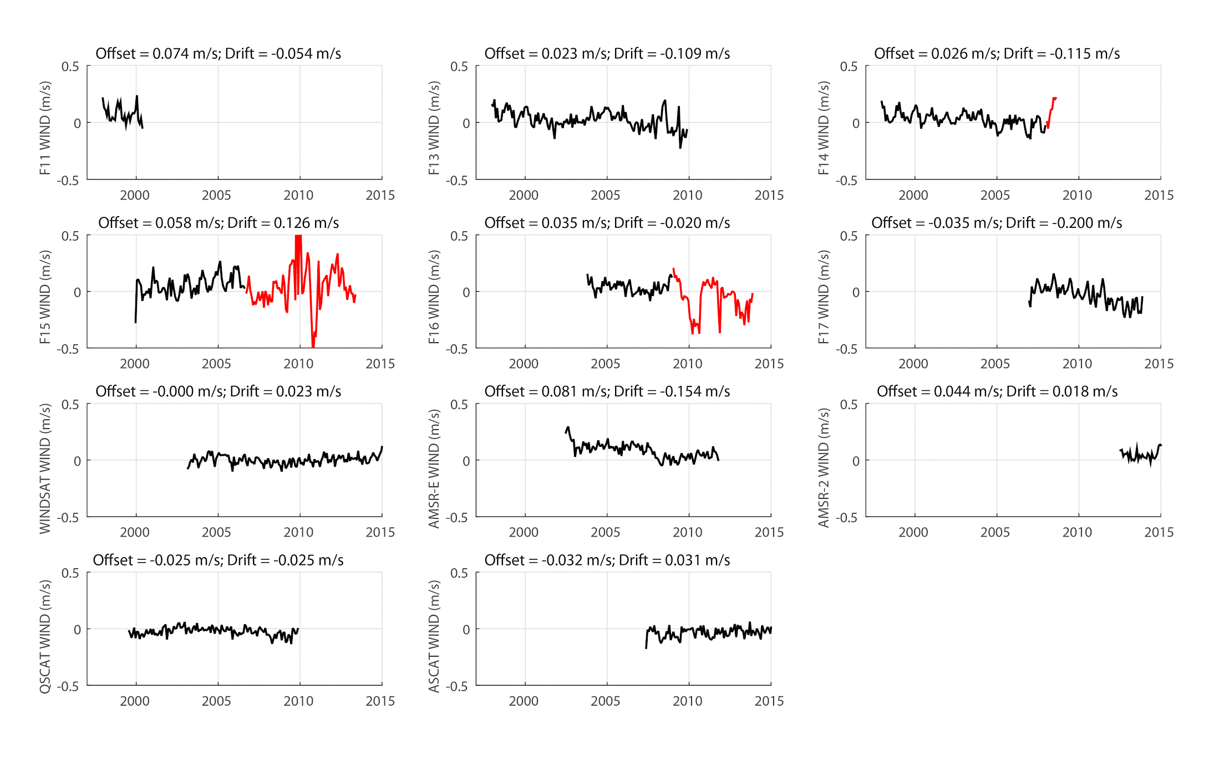
Figure 2. Time Series of monthly-mean differences (satellite minus TMI) of collocated measurements between each of the sensors used in in our data product and TMI. Note that TMI, AMSR-E, and AMSR2 are not used in the merged product. The F14, F15, and F16 sensors show periods of anomalous performance (red) and data from these periods are not used in making the merged wind product.

Table 1. Adjustments Applied to Sensor Data Prior to Merging
Satellite | Adjustment (m/s)
F08 | 0.000
F10 | 0.000
F11 | -0.074
F13 | -0.023
F14 | -0.026
F15 | -0.058
F16 | -0.035
F17 | 0.035
WindSat | 0.000
AMSR2 | -0.044

To test the success of these adjustments, the mean wind speed difference between each satellite sensor and TMI for the latitude range 38.0S to 38.0N (roughly the extent of the TMI measurements) is shown in Figure 3. Any bias or drift in a single sensor would be seen as an offset or slope in these time series. No large biases or drifts exist. There is a slight downward drift in the F17 wind speed values. This has been determined to be due to changes in the F17 wind speeds over time.
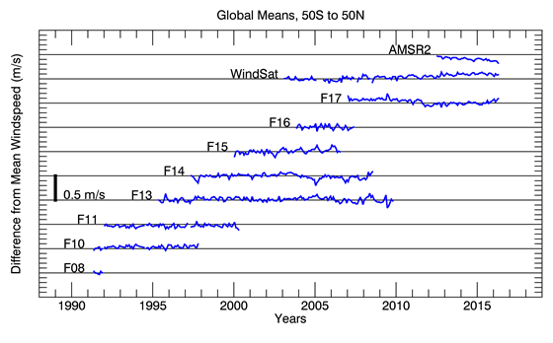
Figure 3. Monthly mean time series for each satellite relative to the mean of all satellites operating at the given time. The distance between tick marks on the y-axis is 0.5 m/s. The early part of the F08 mission is not shown, because the plot is only meaningful when 2 or more satellites are operating at the same time.

Requirements for Ancillary Data Sets:
No ancillary data are needed for this merged wind speed product. For the RSS microwave radiometer data processing there are minimal requirements for ancillary data sets. Since wind direction, in relationship to satellite look angle can impact the emissivity; wind direction is needed for the microwave sensor retrieval algorithm. Wind directions from the NCEP GDAS analysis [Derber et al., 1991] are used (obtained daily from NOAA). Any error in wind direction specification has little effect on subsequent wind speed retrieval errors.

References:
Derber, J.C., D.F. Parrish, and S.J. Lord, 1991: The New Global Operational Analysis System at the National Meteorological Center. Weather Forecasting, 6, 538–547.
Gaiser, P. W., et al. (2004), The WindSat spaceborne polarimetric microwave radiometer: Sensor description and early orbit performance, IEEE Transactions on Geoscience and Remote Sensing, 42(11), 2347-2361.
Hilburn, K. A., F. J. Wentz, C. A. Mears, T. Meissner, and D. K. Smith (2010), Description of Remote Sensing Systems version-7 geophysical retrievals, in 17th Conference on Satellite Meteorology and Oceanography and 17th Conference on Air-Sea Interaction, Annapolis, MD.
Hollinger, J., J. L. Peirce, and G. Poe (1990), SSM/I instrument evaluation, IEEE Transactions on Geoscience and Remote Sensing, 28(5), 781-790.
Kunkee, D. B., G. A. Poe, D. J. Boucher, S. D. Swadley, Y. Hong, J. E. Wessel, and E. A. Uliana (2008), Design and evaluation of the first Special Sensor Microwave Imager/Sounder, IEEE Transactions on Geoscience and Remote Sensing, 46(4), 863-883.
Mears, C. A., D. K. Smith, and F. J. Wentz (2001), Comparison of Special Sensor Microwave Imager and buoy-measured wind speeds from 1987 - 1997, Journal of Geophysical Research, 106(C6), 11719-11729.
Meissner, T., D. K. Smith, and F. J. Wentz (2001), A 10-year intercomparison between collocated Special Sensor Microwave Imager oceanic surface wind speed retrievals and global analyses, Journal of Geophysical Research, 106(C6), 11731-11742.
Meissner, T., and F. J. Wentz (2004), The complex dielectric constant of pure and sea water from microwave satellite observations, IEEE Transactions on Geoscience and Remote Sensing, 42(9), 1836-1849.
Meissner, T., and F. J. Wentz (2009), Wind vector retrievals under rain with passive satellite microwave radiometers, IEEE Transactions on Geoscience and Remote Sensing, 47(9), 3065-3083.
Meissner, T., and F. J. Wentz (2012), The emissivity of the ocean surface between 6 - 90 GHz over a large range of wind speeds and Earth incidence angles, IEEE Transactions on Geoscience and Remote Sensing, 50(8), 3004-3026.
Wentz, F. J. (2013), SSM/I Version-7 Calibration Report, Technical Report Rep., 46 pp, Santa Rosa, CA.
Wentz, F. J. (2015) A 17-Year Climate Record of Environmental Parameters Derived from the Tropical Rainfall Measuring Mission (TRMM) Microwave Imager, Journal of Climate, 28, 6882-6902.
Wentz, F. J., and R. W. Spencer (1998), SSM/I rain retrievals within a unified all-weather ocean algorithm, Journal of the Atmospheric Sciences, 55(9), 1613-1627.

A publication on this data product is in production. Several presentations are available online that describe the process. The best discusses the TPW data product, but the methodology is the same for the wind speed product:

Smith, Deborah K., Mears, Carl A., Hilburn, Kyle A., Ricciardulli, Lucrezia, and Wentz, Frank J., 2012, Contribution of data set construction methodology to data set uncertainties, presented at 2012 AGU Fall Meeting, San Francisco, CA., http://images.remss.com/papers/rssconf/smith_AGUFall_2012_vapor_product_method.pdf

Smith, Deborah K., Mears, Carl, Hilburn, Kyle A., and Ricciardulli, Lucrezia, 2013, A 25-year satellite microwave mean total precipitable water data set for use in climate study, presented at 2013 EUMETSAT Meteorological Satellite Conference, Vienna, Austria., http://images.remss.com/papers/rssconf/Smith_EUMETSAT_2013_TPW.pdf

