High-resolution Precipitation and Wind Measurements from Passive Aquatic Listeners (PALs)

Elizabeth J. Thompson (1), Haonan Chen (1)(2), and Jie Yang (3)

(1) NOAA Physical Sciences Laboratory, Boulder, CO 80305; (2) Colorado State University, Fort Collins, CO 80523; (3) Applied Physics Laboratory, University of Washington, Seattle, WA 98105

27 October 2022

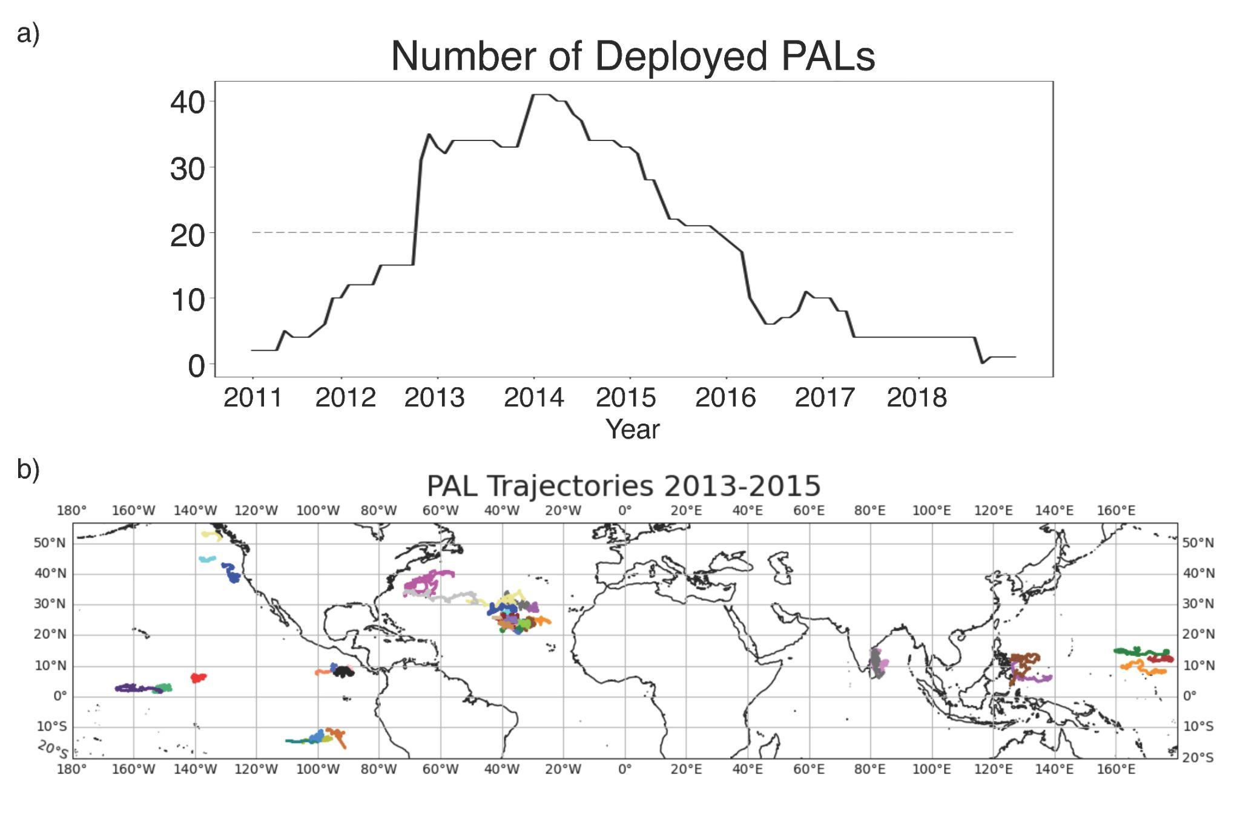
[Janice’s GRL paper - Fig. 1]

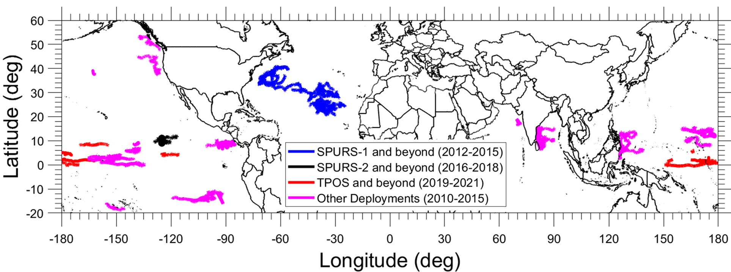

- abstract from Janice’s paper

- a photo about the PAL (Jie’s paper )

The irregular rain and wind measurements from the Passive Acoustic Listeners (PALs) during SPURS-1, SPURS-2, TPOS project, and other deployments are reprocessed to regular time steps. The data are provided as netCDF files following the Climate and Forecast conventions.

- PAL data from Argo floats deployed for the SPURS-2 field experiment (7 platforms):
- Argo float 8435
- Argo float 8444
- Argo float 9302
- Argo float 12360
- SPURS-2 central mooring (500m)
- SPURS-2 central mooring (1000m)
- SPURS-2 south mooring (650m)

- PAL data from Argo floats deployed for the SPURS-1 field experiment (18 platforms):
- Argo float 6923
- Argo float 7547
- Argo float 7569
- Argo float 7572
- Argo float 7582
- Argo float 7587
- Argo float 7607
- Argo float 7635
- Argo float 7660
- Argo float 7681
- Argo float 7699
- Argo float 7574
- Argo float 7595
- Argo float 7598
- Argo float 7599
- Argo float 7605
- Argo float 7611
- Argo float 7585

- PAL data from Argo floats deployed for the Tropical Pacific Observing System (TPOS) project (7 platforms):
- Argo float 17350
- Argo float 12780
- Argo float 12792
- Argo float 19644
- Argo float 19090
- Argo float 19412
- Argo float 19017

- PAL data from Argo floats for other deployments (26 platforms):
- Argo float 6862
- Argo float 6872
- Argo float 6874
- Argo float 6877
- Argo float 6879
- Argo float 6915
- Argo float 6918
- Argo float 6919
- Argo float 6920
- Argo float 6921
- Argo float 6922
- Argo float 7543
- Argo float 7548
- Argo float 7576
- Argo float 7586
- Argo float 7589
- Argo float 7600
- Argo float 7606
- Argo float 7609
- Argo float 7610
- Argo float 7612
- Argo float 7648
- Argo float 7650
- Argo float 7695
- Argo float 7704
- Argo float 8469
Header information of an example NetCDF file (PAL_precip_wind_SPURS2_Argo_float8435_v1.nc) is given below:

PAL_precip_wind_SPURS2_Argo_float_8435_v1 {
dimensions:
time = 1033921 ;
variables:
double time(time) ;
time:standard_name = "time" ;
time:units = "seconds since 1970-01-01 00:00:00UTC" ;
time:cdm_data_type = "coordinate" ;
time:comment = "original irregular 2-9 min samplings are resampled to regular 1-min intervals" ;
int year(time) ;
year:long_name = "year" ;
int month(time) ;
month:long_name = "month" ;
int day(time) ;
day:long_name = "day" ;
int hour(time) ;
hour:long_name = "hour" ;
int minute(time) ;
minute:long_name = "minute" ;
double lat(time) ;
lat:standard_name = "latitude" ;
lat:long_name = "PAL latitude" ;
lat:units = "degrees_north" ;
lat:cdm_data_type = "coordinate" ;
lat:method = "Interpolated position between GPS fixes when float comes to the surface, which happens about every 9.5 days. Float drifts slowly with 1 km depth ocean currents between vertical profiles and GPS fixes." ;
double lon(time) ;
lon:standard_name = "longitude" ;
lon:long_name = "PAL longitude" ;
lon:units = "degrees_west" ;
lon:cdm_data_type = "coordinate" ;
lon:method = "Interpolated position between GPS fixes when float comes to the surface, which happens about every 9.5 days. Float drifts slowly with 1 km depth ocean currents between vertical profiles and GPS fixes." ;
double rain_rate(time) ;
rain_rate:_FillValue = -9999. ;
rain_rate:long_name = "instantaneous rain rate" ;
rain_rate:altitude = "surface" ;
rain_rate:units = "mm/hr" ;
rain_rate:cdm_data_type = "modelResult" ;
rain_rate:surface_area = "5 km; circular diameter listening area of PAL is about 5 times as wide as the instrument depth during listening periods, which is 1 km for this Argo float." ;
rain_rate:method = "measured sound pressure levels at different frequencies are used to estimate surface rain rate and wind speed using a regionally-tuned algorithm tested extensively with in-situ data." ;
rain_rate:comment = "The fillvalue of -9999 are missing data because these are times when the PAL was not listening during float descent, ascent, and when telemetering data at the ocean surface. This occurs for a few hours at a time about every 9.5 days." ;
double wind_speed(time) ;
wind_speed:_FillValue = -9999. ;
wind_speed:long_name = "wind speed" ;
wind_speed:altitude = "surface" ;
wind_speed:units = "m/s" ;
wind_speed:cdm_data_type = "modelResult" ;
wind_speed:surface_area = "5 km; circular diameter listening area of PAL is about 5 times as wide as the instrument depth during listening periods, which is 1 km for Argo float. (and etc. recalculated and with different numbers for other PALs at different depths." ;
wind_speed:method = "measured sound pressure levels at different frequencies are used to estimate surface rain rate and wind speed using regionally-tuned algorithm tested extensively with in-situ data." ;
wind_speed:comment = "No wind data are recorded during rainy periods, so are marked with fillvalue -9999. Additionally, the fillvalue of -9999 is also used to denote missing data when the PAL was not listening during float descent, ascent, and when telemetering data at the ocean surface. This occurs for a few hours at a time about every 9.5 days." ;

// global attributes:
:date_created = "29-Sep-2022 13:08:31" ;
:date_issued = "29-Sep-2022 13:08:31" ;
:date_metadata_modified = "29-Sep-2022 13:08:31" ;
:date_modified = "29-Sep-2022 13:08:31" ;
:product_version = "v1: first release" ;
:geospatial_lat_min = "8.927" ;
:geospatial_lat_max = "10.355" ;
:geospatial_lon_min = "-129.131" ;
:geospatial_lon_max = "-122.151" ;
:geospatial_lat_bounds = "POLYGON [-129.131, -122.151, 8.927, 10.355]" ;
:time_coverage_start = "2016-08-31 00:00:00UTC" ;
:time_coverage_end = "2018-08-19 00:00:00UTC" ;
:time_coverage_duration = "718.000 days" ;
:acknowledgement = "Dataset collected and processed by Jie Yang with funding from the NASA Ocean Salinity Science Team and the NASA Precipitation Measurement Mission. Dataset archived and managed by Elizabeth Thompson and Haonan Chen with support from the NASA Precipitation Measurement Mission." ;
:cdm_data_type = "Trajectory" ;
:comment = "Corrections" ;
:conventions = "CF-1.6 ACCD-1.3" ;
:coverage_content_type = "modelResult, coordinate" ;
:creator_email = "elizabeth.thompson@noaa.gov, haonan.chen@colostate.edu, jieyang@apl.washington.edu" ;
:creator_institution = "(1) NOAA Physical Sciences Laboratory (PSL); (2) CIRA Cooperative Institute for Research of the Atmosphere at the Colorado State University in partnership with NOAA PSL, (3) Applied Physics Laboratory at University of Washington" ;
:creator_name = "Elizabeth J. Thompson (1), Haonan Chen (2), Jie Yang (3)" ;
:creator_type = "group" ;
:geospatial_lat_units = "degrees_north" ;
:geospatial_lon_units = "degrees_east" ;
:history = "v0: original data, v1: first release, v2: reformatted second release" ;
:id = "doi = not yet assigned" ;
:instrument = "Passive Aquatic Listener (PAL) hydrophone" ;
:instrument_vocabulary = "GCMD Version 12.3" ;
:keywords_library = "GCMD Version 12.3" ;
:license = "Please use these global attributes when acknowledging and using these data: acknowledgement, creator_name, creator_institution. These data may be redistributed and used without restriction." ;
:naming_authority = "gov.noaa.ncei" ;
:platform = "PAL Argo float 8435" ;
:platform_vocabulary = "GCMD Version 12.3" ;
:processing_level = "processed and quality controlled" ;
:program = "Funding agencies: NASA Ocean Salinity Science Team, NASA Precipitation Measurement Mission." ;
:project = "NASA Salinity Processes in the Upper Ocean Regional Study (SPURS-2)" ;
:references = "Bytheway, J., Thompson, E. J., Yang, J., and Chen, H. (2022): Evaluating Satellite Precipitation Estimates over Oceans Using Passive Aquatic Listeners, Geophysical Research Letters, (in progress)."; "Yang, J., Riser, S.C., Nystuen, J.A., Asher, W.E., and Jessup, A.T. (2015). Regional Rainfall Measurements Using the Passive Aquatic Listener During the SPURS Field Campaign, Oceanography 28(1), 124–133, doi: 10.5670/oceanog.2015.10."; "Riser, S.C., Yang, J., and Drucker, R. (2019). Observations of Large-Scale Rainfall, Wind, and Sea Surface Salinity Variability in the Eastern Tropical Pacific, Oceanography, 32 (2), 42-49, doi: 10.5670/oceanog.2019.211." ;
:source = "observations from Passive Aquatic Listener hydrophones whose sound pressure levels are used in an algorithm to produce a time series of surface rain rate and wind speed. The algorithm has been adjusted for each ocean basin using extensive in-situ data for validation." ;
:standard_name_vocabulary = "CF Standard Name Table, Version 77, 19 January 2021, https://cfconventions.org/Data/cf-standard-names/77/build/cf-standard-name-table.html" ;
:summary = "Data collected from this instrument is critical for supporting the study of physical oceanography, air-sea interaction, meteorology, as well as global weather and climate variability and predictability. This includes improvement to our fundamental understanding of precipitation and wind processes over the ocean and their influence around the globe including the Continental United States." ;
:title = "Acoustic rain rate and wind speed measurements from Passive Aquatic Listener on Argo float 1236 during SPURS-2 2016-2017 experiment." ;
:sea_name = "Eastern Pacific Ocean" ;
:ncei_template_version = "netCDF_single_trajectory_v2.0" ;
:keywords = "Earth Science > Atmosphere > Atmospheric Winds > Surface Winds; Earth Science > Oceans > Ocean Winds > Surface Winds > Wind Speed; Earth Science > Atmosphere > Precipitation > Precipitation Rate; Earth Science > Oceans > Ocean Volume Budget > Precipitation; Earth Science > Oceans > Salinity/Density > Ocean Salinity Budget > Precipitation" ;
}

Table 1. List of platforms that were equipped with PAL to produce rain and wind measurements.
PAL Argo float # | Field Campaign | Start Year | Start Day | Start Time | End Year | End Day | End Time
Argo float 6923 | SPURS-1 | 2012 | 261.5 | 2012-09-17 1200UTC | 2015 | 1431 | 2015-12-01 0000UTC
Argo float 7547 | SPURS-1 | 2012 | 260.5 | 2012-09-16 1200UTC | 2016 | 1543 | 2016-03-22 0000UTC
Argo float 7569 | SPURS-1 | 2012 | 263 | 2012-09-19 0000UTC | 2016 | 1462 | 2016-01-01 0000UTC
Argo float 7572 | SPURS-1 | 2012 | 261.5 | 2012-09-17 1200UTC | 2016 | 1563 | 2016-04-11 0000UTC
Argo float 7582 | SPURS-1 | 2012 | 260.5 | 2012-09-16 1200UTC | 2016 | 1533 | 2016-03-12 0000UTC
Argo float 7587 | SPURS-1 | 2012 | 262.5 | 2012-09-18 1200UTC | 2016 | 1546 | 2016-03-25 0000UTC
Argo float 7607 | SPURS-1 | 2012 | 262.5 | 2012-09-18 1200UTC | 2016 | 1592 | 2016-05-10 0000UTC
Argo float 7635 | SPURS-1 | 2012 | 263 | 2012-09-19 0000UTC | 2015 | 1224 | 2015-05-18 0000UTC
Argo float 7660 | SPURS-1 | 2012 | 261.5 | 2012-09-17 1200UTC | 2016 | 1562 | 2016-04-10 0000UTC
Argo float 7681 | SPURS-1 | 2012 | 263 | 2012-09-19 0000UTC | 2016 | 1587 | 2016-05-05 0000UTC
Argo float 7699 | SPURS-1 | 2012 | 262.5 | 2012-09-18 1200UTC | 2015 | 1413 | 2015-11-13 0000UTC
Argo float 7574 | SPURS-1 | 2012 | 281 | 2012-10-07 0000UTC | 2016 | 1547 | 2016-03-26 0000UTC
Argo float 7595 | SPURS-1 | 2012 | 280.5 | 2012-10-06 1200UTC | 2016 | 1518 | 2016-02-26 0000UTC
Argo float 7598 | SPURS-1 | 2012 | 281.5 | 2012-10-07 1200UTC | 2016 | 1547 | 2016-03-26 0000UTC
Argo float 7599 | SPURS-1 | 2012 | 280 | 2012-10-06 0000UTC | 2016 | 1547 | 2016-03-26 0000UTC
Argo float 7605 | SPURS-1 | 2012 | 256.5 | 2012-09-12 1200UTC | 2016 | 1547 | 2016-03-26 0000UTC
Argo float 7611 | SPURS-1 | 2012 | 255.5 | 2012-09-11 1200UTC | 2016 | 1547 | 2016-03-26 0000UTC
Argo float 7585 | SPURS-1 | 2012 | 253 | 2012-09-09 0000UTC | 2015 | 1133.5 | 2015-02-06 1200UTC
Argo float 8435 | SPURS-2 | 2016 | 244 | 2016-08-31 0000UTC | 2018 | 962 | 2018-08-19 0000UTC
Argo float 8444 | SPURS-2 | 2016 | 252 | 2016-09-08 0000UTC | 2018 | 962 | 2018-08-19 0000UTC
Argo float 9302 | SPURS-2 | 2016 | 250 | 2016-09-06 0000UTC | 2018 | 964 | 2018-08-21 0000UTC
Argo float 12360 | SPURS-2 | 2016 | 250 | 2016-09-06 0000UTC | 2018 | 963 | 2018-08-20 0000UTC
SPURS-2 central mooring (500m) | SPURS-2 | 2016 | 238 | 2016-08-25 0000UTC | 2017 | 538 | 2017-06-21 0000UTC
SPURS-2 south mooring (650m) | SPURS-2 | 2016 | 238 | 2016-08-25 0000UTC | 2017 | 486 | 2017-04-30 0000UTC
SPURS-2 central mooring (1000m) | SPURS-2 | 2016 | 238 | 2016-08-25 0000UTC | 2017 | 538 | 2017-06-21 0000UTC
Argo float 17350 | TPOS | 2019 | 301 | 2019-10-28 0000UTC | 2021 | 940 | 2021-07-28 0000UTC
Argo float 12780 | TPOS | 2018 | 228.5 | 2018-08-16 1200UTC | 2021 | 1303 | 2021-07-26 0000UTC
Argo float 12792 | TPOS | 2019 | 248 | 2019-09-05 0000UTC | 2021 | 929.5 | 2021-07-17 1200UTC
Argo float 19644 | TPOS | 2020 | 259.5 | 2020-09-15 1200UTC | 2021 | 487.5 | 2021-05-01 1200UTC
Argo float 19090 | TPOS | 2020 | 244.5 | 2020-08-31 1200UTC | 2021 | 487.5 | 2021-05-01 1200UTC
Argo float 19412 | TPOS | 2020 | 245.5 | 2020-09-01 1200UTC | 2021 | 496 | 2021-05-10 0000UTC
Argo float 19017 | TPOS | 2020 | 258 | 2020-09-14 0000UTC | 2021 | 496.5 | 2021-05-10 1200UTC
Argo float 6862 | Others | 2011 | 110.5 | 2011-04-20 1200UTC | 2014 | 1273 | 2014-06-26 0000UTC
Argo float 6872 | Others | 2010 | 291 | 2010-10-18 0000UTC | 2014 | 1778 | 2014-11-13 0000UTC
Argo float 6874 | Others | 2011 | 111.5 | 2011-04-21 1200UTC | 2014 | 1304 | 2014-07-27 0000UTC
Argo float 6877 | Others | 2011 | 112.5 | 2011-04-22 1200UTC | 2014 | 1288 | 2014-07-11 0000UTC
Argo float 6879 | Others | 2011 | 300.5 | 2011-10-27 1200UTC | 2015 | 1555 | 2015-04-04 0000UTC
Argo float 6915 | Others | 2010 | 332.5 | 2010-11-28 1200UTC | 2011 | 523 | 2011-06-07 0000UTC
Argo float 6918 | Others | 2011 | 353.5 | 2011-12-19 1200UTC | 2014 | 1424.5 | 2014-11-24 1200UTC
Argo float 6919 | Others | 2013 | 293 | 2013-10-20 0000UTC | 2014 | 491.5 | 2014-05-06 1200UTC
Argo float 6920 | Others | 2011 | 244 | 2011-09-01 0000UTC | 2015 | 1624.5 | 2015-06-12 1200UTC
Argo float 6921 | Others | 2011 | 301 | 2011-10-28 0000UTC | 2015 | 1497 | 2015-02-05 0000UTC
Argo float 6922 | Others | 2011 | 248 | 2011-09-05 0000UTC | 2015 | 1605 | 2015-05-24 0000UTC
Argo float 7543 | Others | 2014 | 0 | 2014-01-01 0000UTC | 2017 | 1205 | 2017-04-19 0000UTC
Argo float 7548 | Others | 2012 | 104.5 | 2012-04-13 1200UTC | 2015 | 1293.5 | 2015-07-16 1200UTC
Argo float 7576 | Others | 2013 | 293 | 2013-10-20 0000UTC | 2014 | 490.5 | 2014-05-05 1200UTC
Argo float 7586 | Others | 2012 | 105.5 | 2012-04-14 1200UTC | 2014 | 920 | 2014-07-08 0000UTC
Argo float 7589 | Others | 2012 | 108 | 2012-04-17 0000UTC | 2015 | 1209 | 2015-04-23 0000UTC
Argo float 7600 | Others | 2013 | 317.5 | 2013-11-13 1200UTC | 2017 | 1570.5 | 2017-04-19 1200UTC
Argo float 7606 | Others | 2013 | 314.5 | 2013-11-10 1200UTC | 2016 | 1421.5 | 2016-11-21 1200UTC
Argo float 7609 | Others | 2013 | 320 | 2013-11-16 0000UTC | 2017 | 1573.5 | 2017-04-22 1200UTC
Argo float 7610 | Others | 2013 | 1259.5 | 2016-06-12 1200UTC | 2017 | 1574.5 | 2017-04-23 1200UTC
Argo float 7612 | Others | 2013 | 293.5 | 2013-10-20 1200UTC | 2017 | 1496 | 2017-02-04 0000UTC
Argo float 7648 | Others | 2012 | 347.5 | 2012-12-12 1200UTC | 2014 | 960.5 | 2014-08-17 1200UTC
Argo float 7650 | Others | 2012 | 348 | 2012-12-13 0000UTC | 2016 | 1588.5 | 2016-05-06 1200UTC
Argo float 7695 | Others | 2013 | 293.5 | 2013-10-20 1200UTC | 2017 | 1503 | 2017-02-11 0000UTC
Argo float 7704 | Others | 2013 | 319.5 | 2013-11-15 1200UTC | 2017 | 1572 | 2017-04-21 0000UTC
Argo float 8469 | Others | 2015 | 33 | 2015-02-02 0000UTC | 2015 | 204 | 2015-07-23 0000UTC

