USDA-ARS
South Fork Experimental Watershed
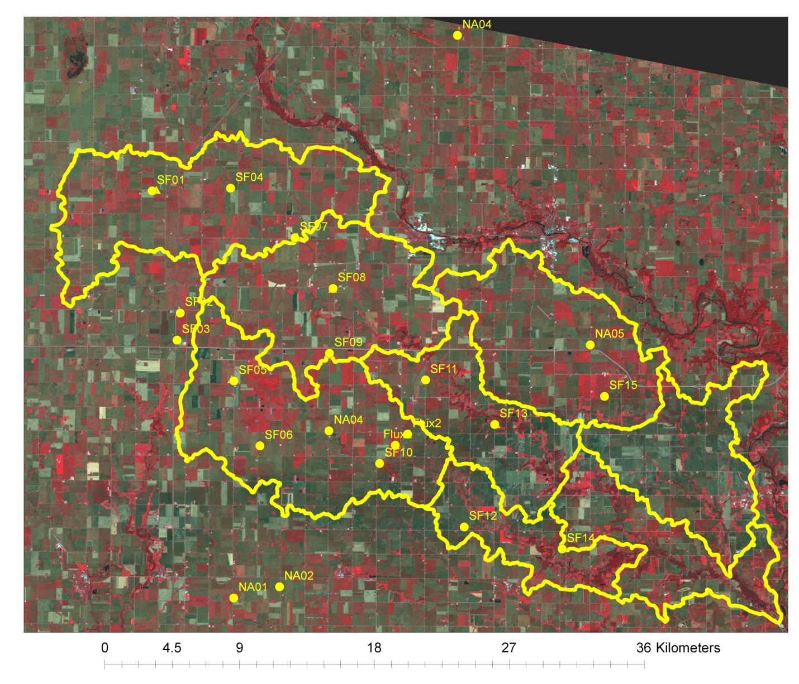
Summary
A total of 15 stations are deployed in and around the South Fork River in North Central Iowa. An additional 5 stations are operated by NASA in cooperation with the University of Iowa. This summary addresses the ARS stations specifically and the NASA station information can be found at http://ifis.iowafloodcenter.org.
Equipment
There are 4 Stevens Water Hydra Probes installed at each station in profile with the center of each sensor located at 5, 10, 20, and 50 cm. There are 2 precipitation gages located at each site as well, a Texas Electronics 525 (TE525) and a MetOne 380. The soil moisture probes record hourly instantaneous measurements of the real dielectric, soil temperature and volumetric soil moisture.

File Formats
There are three files for each station. They are organized in Daily, Hourly, and Rainfall-only.
File Name: SF##_Daily.xlsx is the daily file for station ##.
SF##_Hourly.xlsx is the hourly file for station ##.
SF##_Rain.xlsx is the rainfall file for station ## in second increments.

*some stations have an alternate designation of A, B, C, or D which is an old naming convention for 4 longer term sites. These are represented in the file names as well.

SF##_Daily and SF##_Hourly file formats.
Columns: TimeStamp: in Central Standard Time
Record: record number
Site ID
VWC_1: Volumetric Water Content at 5 cm depth
VWC_2: Volumetric Water Content at 10 cm depth
VWC_3: Volumetric Water Content at 20 cm depth
VWC_4: Volumetric Water Content at 50 cm depth
Rain_TE_Tot: precipitation in mm from the TE525 tipping bucket raingage
Rain_Met_Tot: precipitation in mm from the MetOne 380.
Temp_1: Soil Temperature at 5 cm depth
Temp_2: Soil Temperature at 10 cm depth
Temp_3: Soil Temperature at 20 cm depth
Temp_4: Soil Temperature at 50 cm depth
Batt_Volt: battery voltage in volts

***2 stations have additional measurements as follows.
AirTC_Min: Minimum air temperature during the day of record in Celsius
AirTC_Max: Maximum air temperature during the day of record in Celsius
AirTC_Avg: Average air temperature in Celsius
RH_avg: Average relative humidity in %
e_sat: saturation vapor pressure
e_act: actual vapor pression
e_sat_Avg: Average Saturation Vapor Pressure
e_act_avg: Average Actual Vapor Pressure
WindSpeed_Mean: Mean wind speed in meter/sec
WindDir_Mean: Mean wind direction in degrees (0 North)
WindDir_SD: Standard deviation of the wind direction in degrees
SLR_MJ_Tot: Total Solar Radiation in MegaJoules/m2.
SLR_W_Avg: Solar Radiation in W/m2

SF##_Rain file format
Columns: TimeStamp: in Central Standard Time, nearest second
Record: record number
Site ID
Rain_TE_Tot: precipitation in mm from the TE525 tipping bucket raingage
Rain_Met_Tot: precipitation in mm from the MetOne 380.

Figure 1: Map of the South Fork Experimental Watershed
Table 1: ARS and NASA soil moisture and raingage stations in and around the South Fork Experimental Watershed.
Site ID | Latitude | Longitude
SF01 | 42.542620 | -93.589060
SF02 | 42.469300 | -93.565450
SF03 | 42.452960 | -93.567970
SF04 | 42.544590 | -93.525270
SF05 | 42.428570 | -93.521580
SF06 | 42.389600 | -93.500130
SF07 | 42.515010 | -93.472710
SF08 | 42.484630 | -93.441490
SF09 | 42.445560 | -93.444050
SF10 | 42.379370 | -93.402930
SF11 | 42.429750 | -93.365960
SF12 | 42.341400 | -93.334220
SF13 | 42.403180 | -93.309710
SF14 | 42.328310 | -93.254860
SF15 | 42.420340 | -93.220770
NA01 | 42.297846 | -93.520643
NA02 | 42.304850 | -93.483616
NA04 | 42.398868 | -93.444281
NA04 | 42.637269 | -93.341192
NA05 | 42.451260 | -93.232442

