For the IPHEX campaign we received three boxes with equipment for soil moisture field measurements sent from the USDA on Thursday, 23 April 2014. Jing Tao and Lauren Lowman took inventory of their contents after receipt of the packages. The contents of these boxes are described below:

- DATA LOGGER (3) and THETA PROBE (3) (Note: only 1 has a protective case)

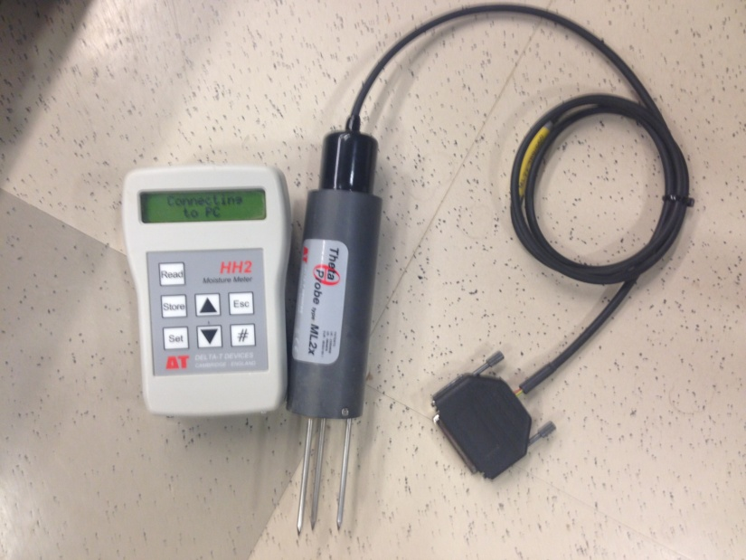

- LARGE AND SMALL SPATULAS (3 ea.)
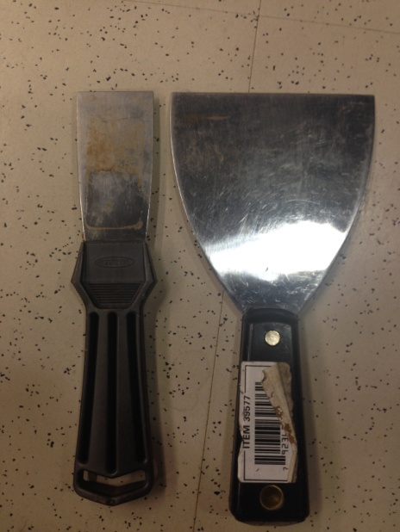

- HANDHELD INFRARED THERMOMETER (w/ protective case) (3)
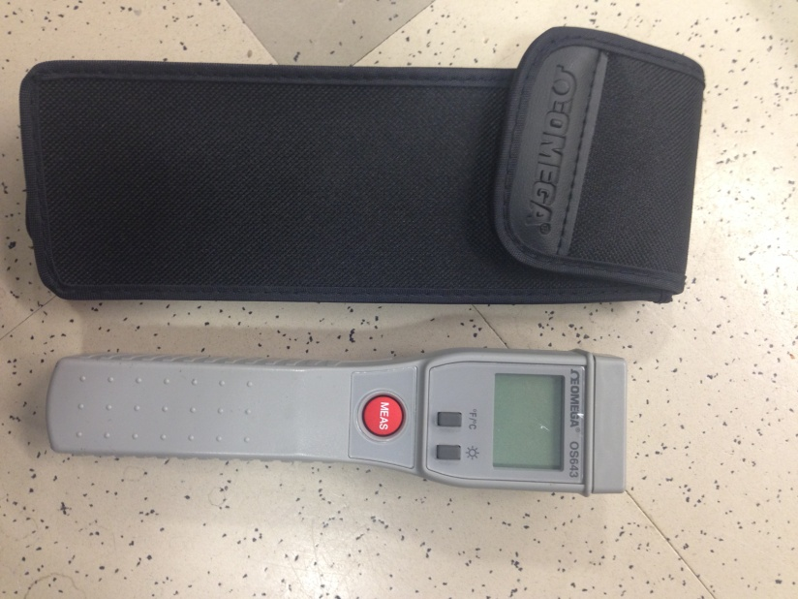

- SOIL THERMOMETER PROBE (3)
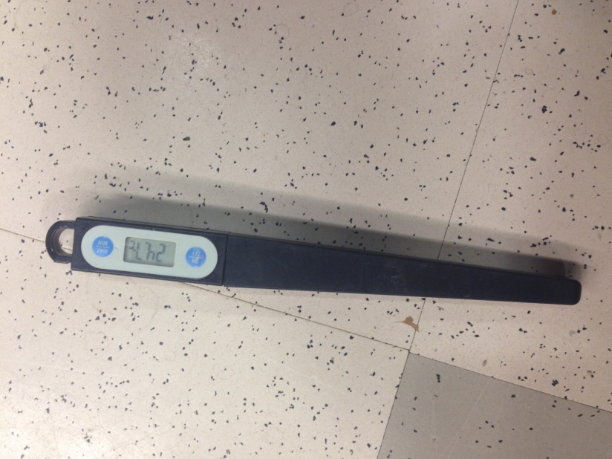

- BRUSH (3)
(not shown)

- BLUE PIPES (3) AND CONNECTORS (6)
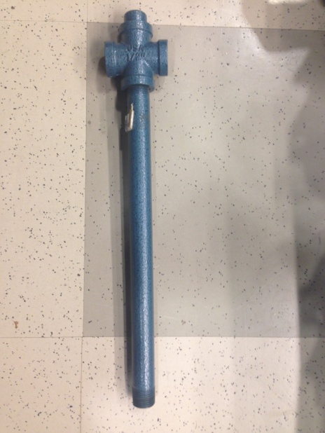
(Note: Connectors not shown)

- METAL BASE (3)
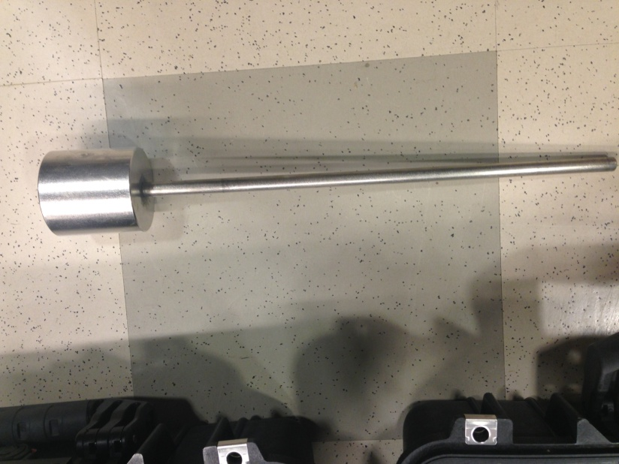

- METAL RING HOLDER (W/ RINGS INSIDE) (3)
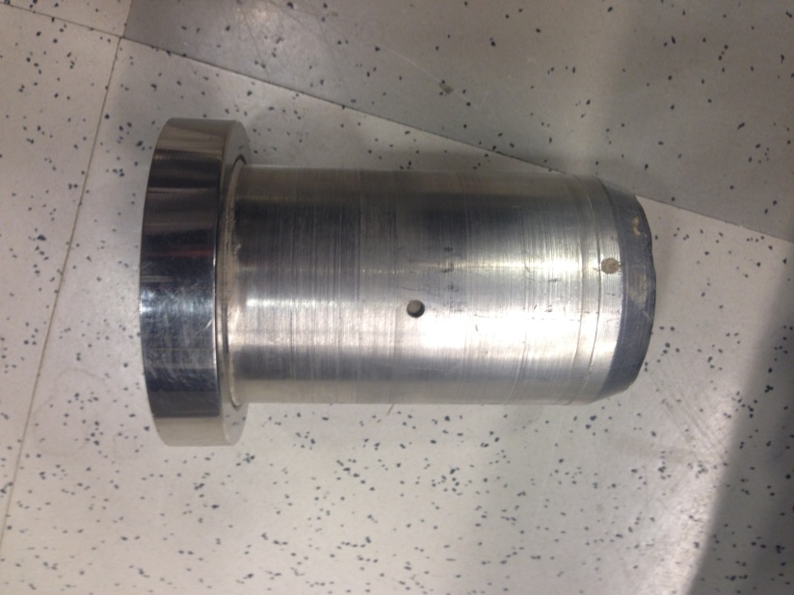

- BOWL (2)
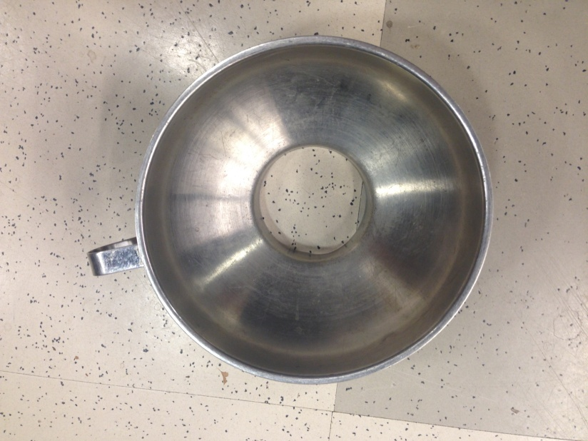

- EXTRA RINGS (7)
