Summary of Calibration for Theta Probe (TP)
Last updated on Aug. 12, 2014 by Jing Tao
The Theta Probe (TP) provides volumetric soil moisture (VSM) readings (m³/m³) converted from the generalized equation given default coefficients a0 and a1 (1.6 and 8.4 respectively) provided by the manufacture. The in-situ VSM readings then will need to be calibrated for each field site based on true VSM observations measured through soil samples.
There are two methods for calibrating VSM readings from TP. The first method (Method 1) is a conventional calibration approach based on the calibration equation (1) (Cosh et al., 2005).
$$θ=\frac{\left[1.07+6.4V-6.4V^{2}+4.7V^{3}\right]-a0}{a1}$$
The key procedures of Method 1 are listed as follows:
  - Solve voltage ($V$) given the VSM ($θ$) readings from TP based on equation (1) with default a0 and a1 using Levenberg-Marquardt algorithm.
  - Process the soil bulk density samples and obtain gravimetric soil moisture (GSM) and bulk density (BD), to obtain the VSM (=GSM*BD) measurement which is the true VSM observation corresponding to each TP reading.
  - Find the optimal coefficients a0 and a1 that can give the minimum total RMSE between the calculated VSM ($θ_{i}^{TP}$) and the VSM observations ($θ_{i}^{obs}$) at locations that bulk density were known,$RMSE=\sqrt{\frac{\sum_{i=1}^{i=n}{{\left(θ_{i}^{TP}-θ_{i}^{obs}\right)}^{2}}}{n}}$ , which is to solve a nonlinear least-squares problem. Again, the Levenberg-Marquardt method is used for searching the minimum and deriving coefficients a0 and a1.
The derived coefficient a0 and a1 for each field site is listed in Table 1. These coefficients will then be used to calibrate all TP readings collected during IPHEx-IOP soil moisture experiment.
The second calibration method (Method 2) seeks the linear relationship between the VSM readings from TP ($θ_{BD}^{TP}$) and the VSM measurements ($θ_{BD}^{obs}$) at locations that soil samples and bulk density were collected. Then, the linear regression equation will be used to calibrate each VSM reading ($θ_{i}^{TP}$) during the campaign to obtain the true VSM measurement ($θ_{i}^{obs}$), as illustrated by the equation (2) and (3).
$$θ_{BD}^{obs}=p1×θ_{BD}^{TP}+p2$$
$$θ_{i}^{obs}=p1×θ_{i}^{TP}+p2$$
The derived coefficient p1 and p2 for each field site is listed in Table 1.

Table 1 Derived coefficients from two calibration methods for each site.
Method 1: | Site | a0 | a1
 | 16 | 0.00 | 17.34
 | 21 | 0.85 | 10.20
 | 22 | 0.76 | 12.00
 | 23 | 0.00 | 13.59
 | 26 | 1.24 | 10.22
Method 2: | Site | p1 | p2
 | 16 | 0.38 | 11.16
 | 21 | 0.82 | 7.31
 | 22 | 0.70 | 7.01
 | 23 | 0.52 | 13.68
 | 26 | 0.82 | 3.55

Although the two methods use completely different approaches, they result in very identical results, as can be seen from the RMSE summary given in Table 2 and figures below.
Table 2 The Root Mean Square of Error (RMSE) of VSM before and after calibration against measurements at locations the bulk density were measured.
Site | RMSE(m³/m³)  (Before Calibration) | RMSE(m³/m³)  (Calibrated by Method 1) | RMSE(m³/m³)  (Calibrated By Method 2)
16 | 0.038 | 0.030 | 0.029
21 | 0.079 | 0.073 | 0.073
22 | 0.052 | 0.041 | 0.041
23 | 0.066 | 0.045 | 0.045
26 | 0.024 | 0.020 | 0.020

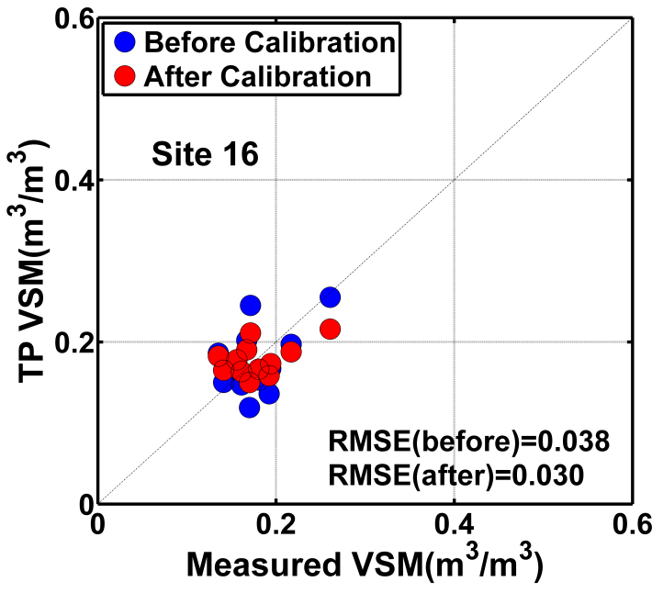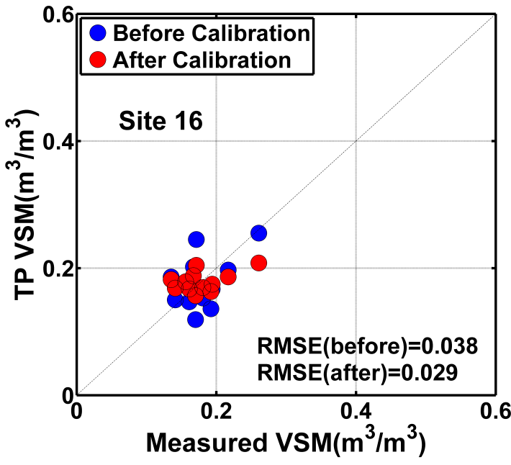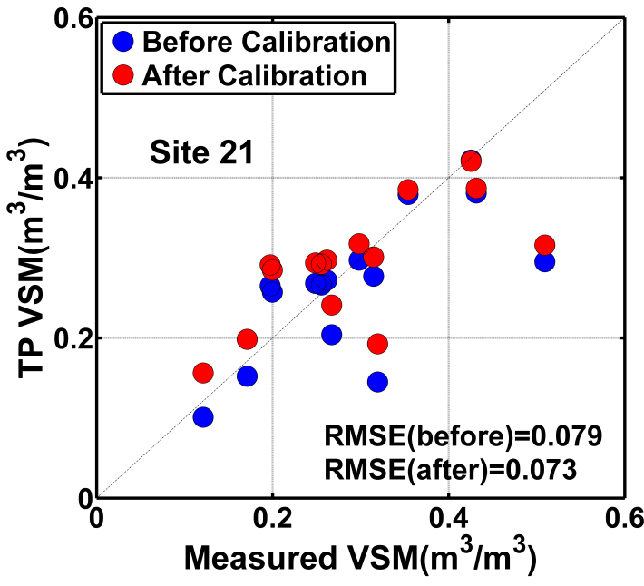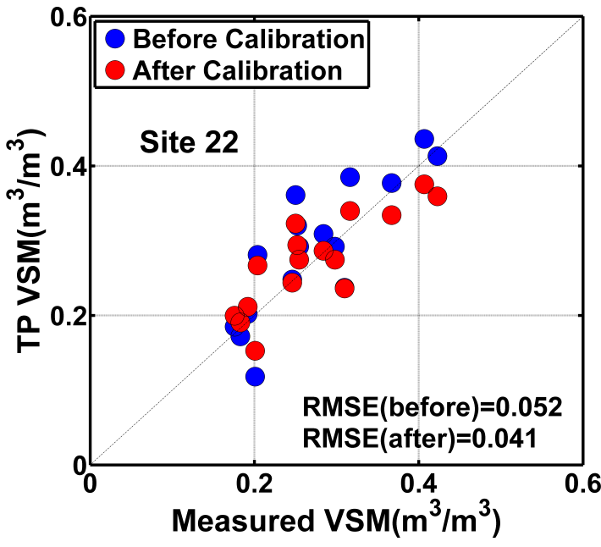
Method 1
Method 2
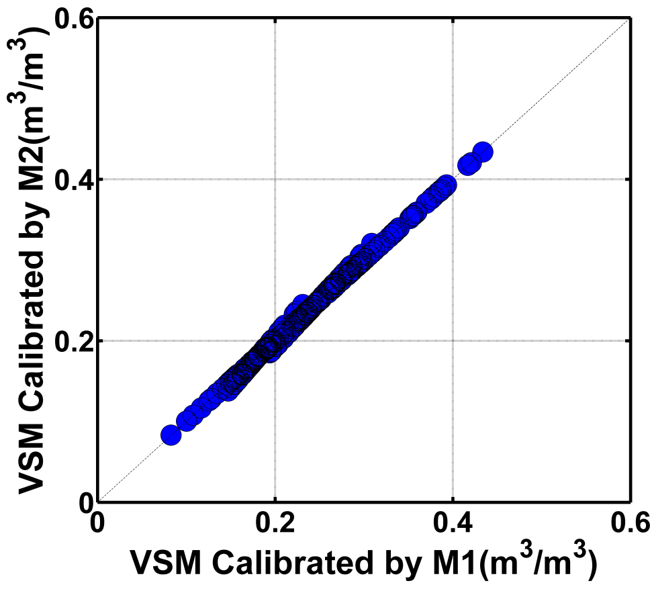
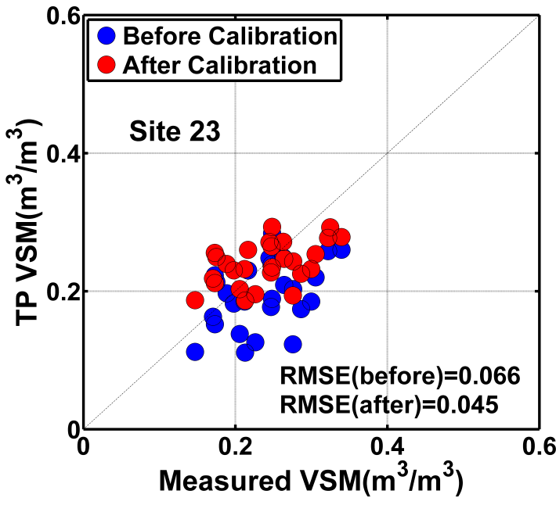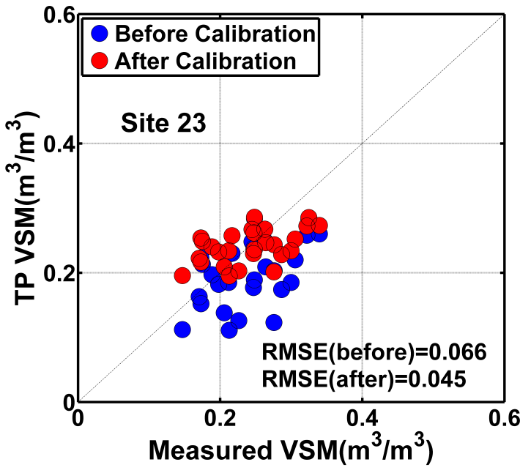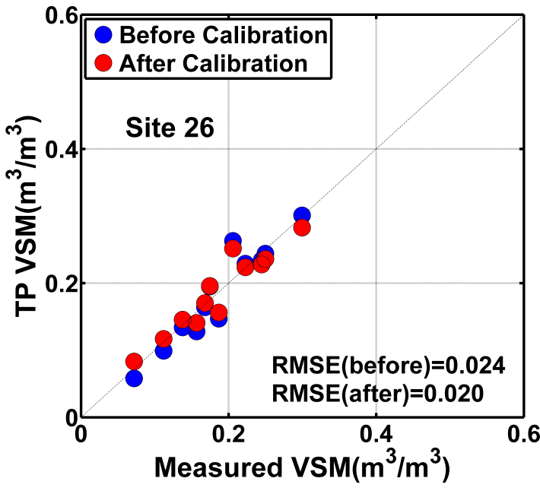
All Data
Method 1
Method 2

Cosh MH, Jackson TJ, Bindlish R, Famiglietti JS, Ryu D. 2005. Calibration of an impedance probe for estimation of surface soil water content over large regions. J. Hydrol., 311: 49-58. DOI: DOI 10.1016/j.jhydrol.2005.01.003.

