P1 – Marshall Ridge

Sept. 26, 2013
Time: ~2:30 PM
Weather: Mostly Sunny
We ended up installing a rain gauge platform and the knob (~50’ from house) close to the current gauge. The Pelican case used is “NASA0031”, “A” rain gauge is “N12507”, and “B” rain gauge is “N12506”. I was able to get a GPS lock and the cellular service was great, so data will be sent to NASA. Talked to Greg Wilson about the installation of a P1 and he was okay with us digging a whole for concrete to be applied to the base.
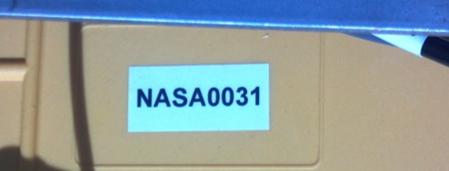
Gauge A Gauge B
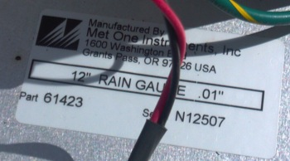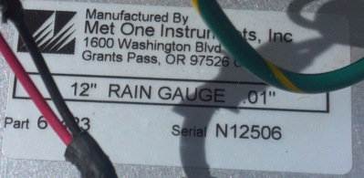
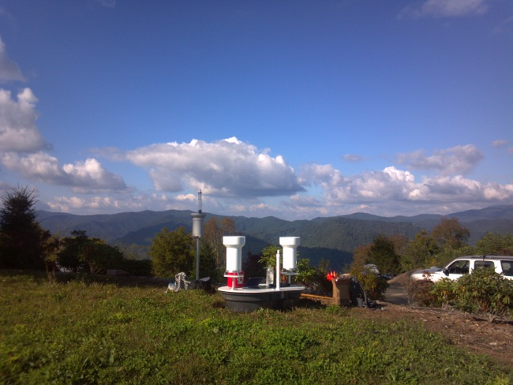
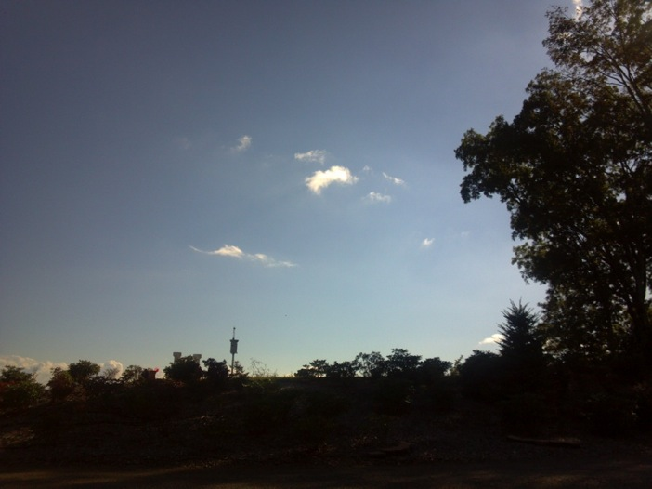

11/24/13
Time: ~11 AM (Greg, Marta, Anna)
Weather: Mostly Clear
Dug a hole ~1.5’ deep by 1’ foot deep and poured a 50lb bag of concrete into the hole with the Parsivel pole set in the concrete. Ran extension cord from their garage to the Parsivel beside the gauges and buried the cord across their driveway. Although we did not plug in the Parsivel, it was still set up so when the Parsivels were fixed, it could easily be turned on.
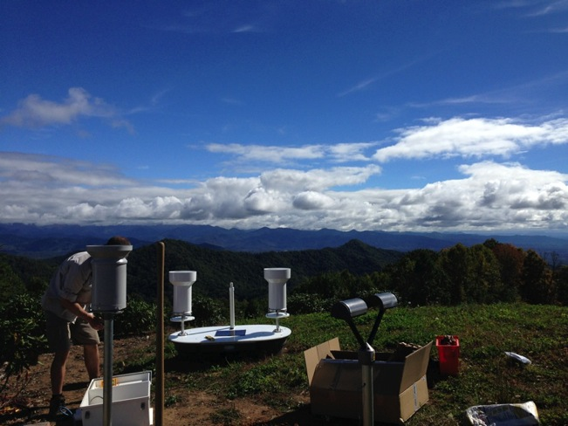
12/13/13
Time: 11:00 AM
Weather: Clear
Very little debris in both platform gauges, of which were cleaned out. Gauge “A” was level and gauge “B” was only slightly un-level and then leveled. Artilla for P1 was blinking every 10 seconds. Downloaded data from P1 and made sure the Artilla was blinking again after power was connected.

Installed JWD on cinder block by the other instruments. The junction box where two signal cables connect was not sealed like the other JWD’s I have installed, so I placed the junction box in the enclosure to ensure the cable connection stayed dried. JWD has Scotch Brite pad and was zipped tied down to the cinder block. Data wire was run under their driveway and processor/laptop was placed in their garage. This JWD did not contain a GPS, so one will need to be installed to ensure the correct laptop time.

Gauge B Level
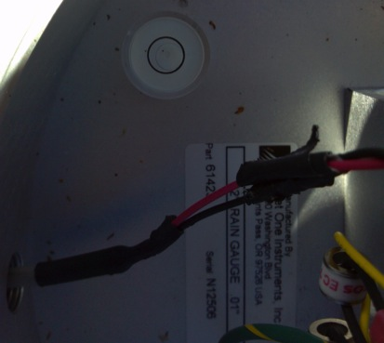
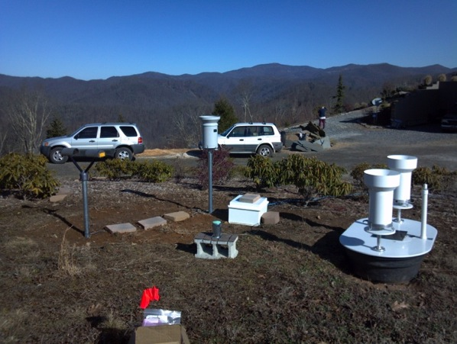
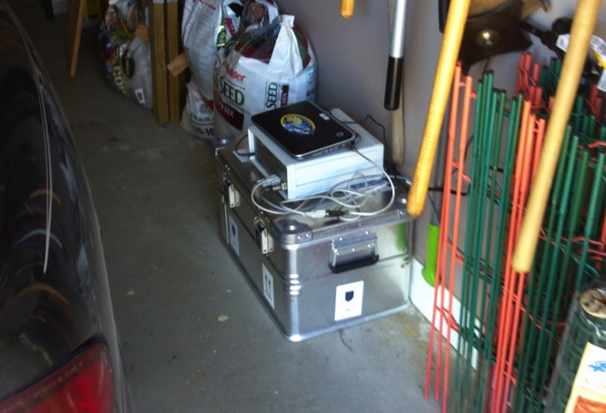

1/13/14
Time: ~3PM
Weather: Clear
Both gauges were level and clean. The Parsivel was not working correctly and the Parsivel was uninstalled. Copied the JWD data from laptop to send to Matt.

2/27/14
Time: ~3:35 PM Local
Weather: Clear
Installed new P1. No debris in either gauge with gauge “A” level touching circle, leveled. While checking battery voltage, program said “A” is “not installed”. Battery voltage 9.1 and new battery is 12.8V. Afterwards gauge “A” was “installed”. Removed temp sensor from the back of the platform and installed the soil moisture and temperature sensor ~2” below the surface.
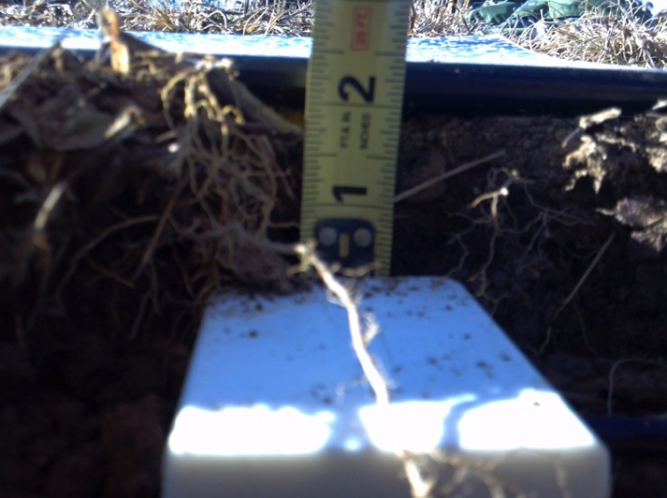

4/23/14
Time: ~3:00 PM Local
Weather: Clear (Greg)
No debris in gauges, gauges level P1 working normally, downloaded JW data. JW is “02”.

4/23/14
Time: ~3:00 PM Local
Weather: Clear (Greg, Anna)
Gauges level and clean.

5/21/14
Time: ~6:30 PM Local
Weather: Partly cloudy (Greg, Anna, Marta)
Gauges level and clean. Checked P1 and JWD

5/24/14
Time: ~afternoon (Anna)
Weather: unknown
Very little debris in gauges. Gauges cleaned out.

6/11/14
Time: ~1300 EDT (Greg)
Weather: unknown
Removed Parsivel after finding it stopped working. Gauges clean and level. Found that the soil temperature sensor had been cut and put the wires together. Took soil samples.
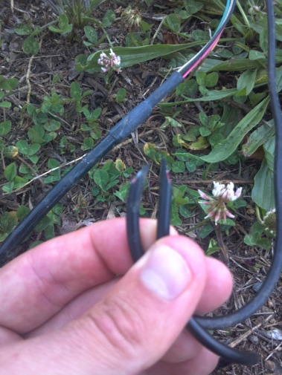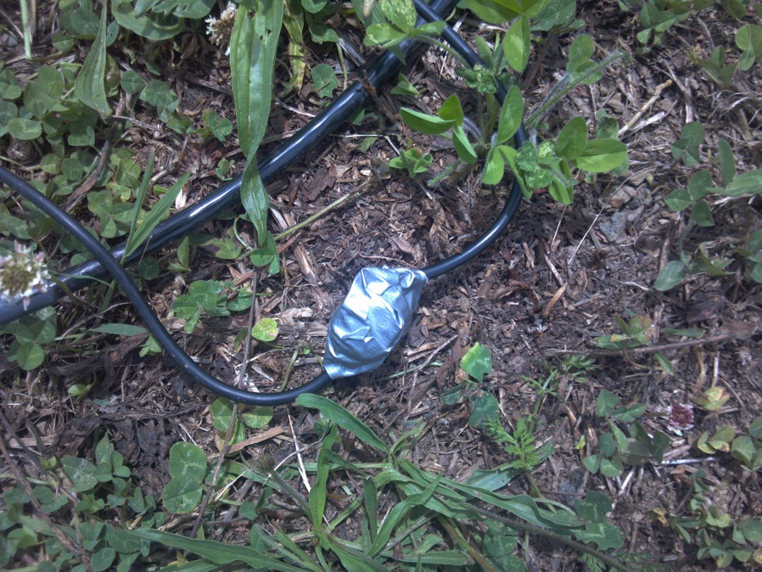

6/27/14
Time: ~1100 EDT (Greg)
Weather: Overcast
Gauges level and clean, JW cone tight and not touching metal, placed extra temp/soil in base of gauge, soil temperature appears to be working correctly. Took soil samples.

7/8/14
Time: 1130 EDT (Greg)
Weather: Mostly Cloudy
Gauges clean and JWD good. Took soil samples.

7/22/14
Time: 1230 EDT (Greg)
Weather: Mostly Cloudy
Took soil samples. Removed P1 enclosure, cell antenna, and power cords. Found that the JWD and MRR cable had been chewed on in some spots reaching the braided outer metal (possible ground). Placed duct tape over the chewed wire. Found a lot of ants inside JW enclosure and was it out. Placed silicon around it and put outside of Parsivel enclosure.

7/28/14
Time: 1010 EDT (Greg)
Weather: Overcast
Took soil samples, gauges clean, slightly tightened JW cone.

9/2/14
Time: 1215 EDT (Greg)
Weather: Cloudy
Gauge with minor debris, cleaned filter/funnel, both levels touching circle, leveled both gauges, MRR level, JW cone tight, MRR and JWD laptop OK, re-buried wire under rock driveway and flowerbed.

10/1/14
Time: 1145 EDT (Greg)
Weather: Party Cloudy
Gauges level and clean, JWD cone tight/clean, MRR level.

10/13/14
Time: 1600 EDT (Greg, Matt, Piotr)
Weather: Party Cloudy
MRR level, NASA JWD, and dual rain gauges level and removed.

12/5/14
Time: 1300 EDT (Greg)
Weather: Overcast/fog
Removed MRR

