P15 – NC Wildlife Maintenance Yard

9/11/13

I arrived at the NC Wildlife Commissions at ~3:45 PM with cloudy skies. A past volunteer, Michael Keiser, was able to help me get the APU and solar panels out of the back of the suburban since I could not find a student to help me. Due to a broken elevator at UNCA, I was unable to get the solar panel base that allows the panels to be free standing. For the time being, I had to prop the solar panel against the enclosure until the next time I visit the site.

The pelican box is “NASA0033” with the “A” rain gauge is N12533 and “B” rain gauge is N12534. Like at P-20, I was unable to connect to the NASA server, so data is currently not “live” and being stored. The APU installed at P-15 is “APU08”.

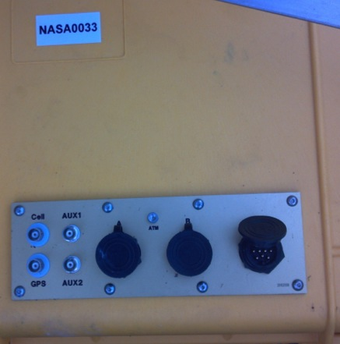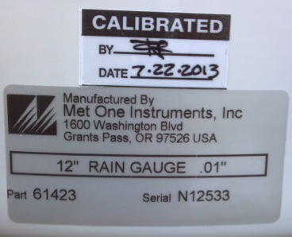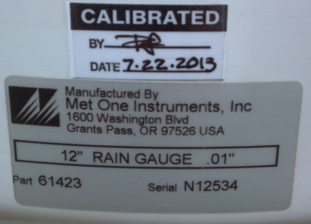
For my next visit, I need to put silicon under the GPS and tighten the plastic screws underneath the rain gauges and around the grounding rod.
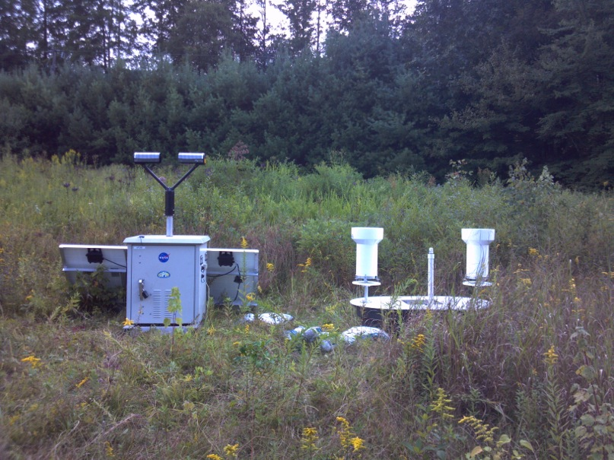

10/03/13
Time: 7:00 AM
Weather: Mostly Sunny

Since the initial setup, the solar panels were leaning against the APU enclosure because the stand was not accessible the day of installation. Today I setup the solar panels with the normal guy wire and rocks holding down the stand and the excess solar wire covered with plastic tubing. While opening the platform, a tip was caused on gauge “B” at ~7:58 and gauge “A” at ~8:04 (both buckets must have been full). After connecting to the PC, I learned bucket “A” was “not connected”. While this was not reported at the initial installation, it was probably due to that gauge not having a resistor at installation. A resister was installed and the gauge was then working correctly.

APU was running correctly, downloaded the data, and obtained the MAC address (00:D0:69:42:DF:9A) for the embedded PC.

10/31/13
Time: 3:30 PM (Greg, Matt Wingo)
Weather: Overcast

Matt retrieved APU data, updated APU program, and connected 3rd solar panel for the winter season. The APU time was off by a few minutes. Matt has a printscreen of the exact time the APU is off. Gauges were level and had very little debris in the gauge, which was cleaned.

1/15/14
Time: 3:30 PM (Greg, Matt, Marta)
Weather: Light snow
Matt installed a cell mode. Could not tell if debris was in gauge due to snow in funnel, but did not see any large objects under the snow. Gauge “A” was touching level circle (leveled), gauge “B” was OK.

2/22/14
Time: 4:15 PM (Greg, Anna)
Weather: Overcast
Both rain gauges clean and level, gauge “B” tipped ~2115 UTC. Cycled APU08 as requested by Matt.

4/21/14
Time: 1 PM (Greg, Matt)
Weather: Clear
Both rain gauges clean and level. Installed soil and temperature sensor ~2” below the surface. The temperature sensor was NOT outside of the platform prior to installation. Matt changed HD since the APU was not correctly uploading data to the server.
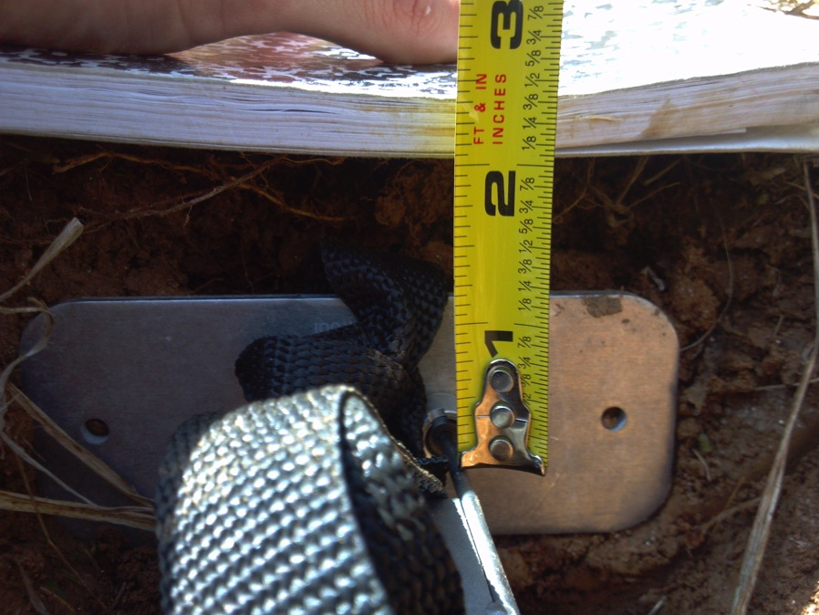

6/6/14
Time: 5 PM (Greg)
Weather: Partly Cloudy
Both rain gauges clean and level. APU artilla was not blinking, so cycled power and APU started to work correctly. Saw two small garden snakes on battery side of APU.

7/7/14
Time: 1415 EDT (Greg)
Weather: Cloudy
Parsivel had minor cobwebs between heads, Parsivel level, downloaded uncompressed data, gauges level with minor debris infilter and on tipping buckets, cleaned filter and tipping buckets. Took soil samples.

7/11/14
Time: 0830 EDT (Greg)
Weather: Unknown
Pasrsivel clean, but there was no power to the APU unit. After some test, it was determined that something was wrong with the solar controller. Took soil samples.

7/17/14
Time: 0730 EDT (Greg)
Weather: Mostly Cloudy
Parsivel and gauges clean, replaced regulator and worked correctly, ADAM converter and cell modem working. Took soil samples.

7/24/14
Time: 0700 EDT (Greg)
Weather: light/moderate rain
Gauges and Parsivel clean, ADAM converter and controller working. Took soil samples.

8/26/14
Time: 0930-1030 EDT (Greg)
Weather: Clear
APU working correctly, tweaked Parsivel level, Parsivel clean, download all data from July 17 to today, replaced flash card with new one Matt sent. Gauges level with some bugs in filter, funnel dirty. Cleaned funnel/filter/tipping buckets.

9/10/14
Time: 0900 EDT (Greg)
Weather: Low clouds overcast
APU working normally, Parsivel clean, very minor debris in gauges, cleaned gauge tipping buckets/filter/funnel, both level.

10/2/14
Time: 0900 EDT (Greg)
Weather: Clear
Gauges clean and level, P2 clean, downloaded data from 8/26 to today.

10/17/14
Time: ~1300 EDT (Greg)
Weather: Clear
Gauges level and removed. APU working and removed.

