Glad Mountain Rain Gauge Platform

12/15/13
Time: 3:00 PM
Weather: Mostly Sunny

Meet Mr. Allan Stellers at his house, which borders the Canton Watershed. He showed me the location he had in mind, which was suitable since we could run power to a Parsivel and there were no objects overhead that would affect the drop zone. While the ground was fairly level, I still needed to use a piece of wood to support one end and allow me to level the gauges. The platform ID is “NASA0037” and the rain gauge A is “N12494” and B is “N12513”. Tested tipping buckets, GPS, cellular modem, and all worked.
Gauge A Gauge B
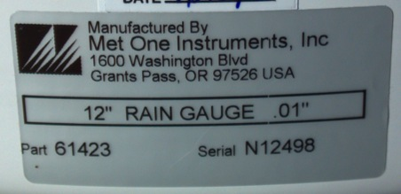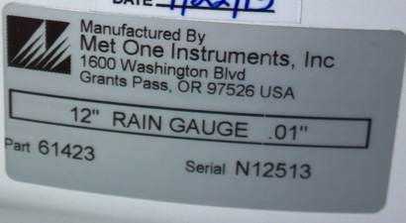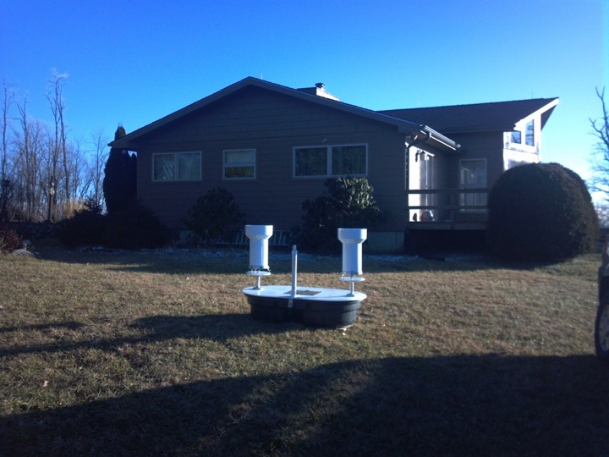
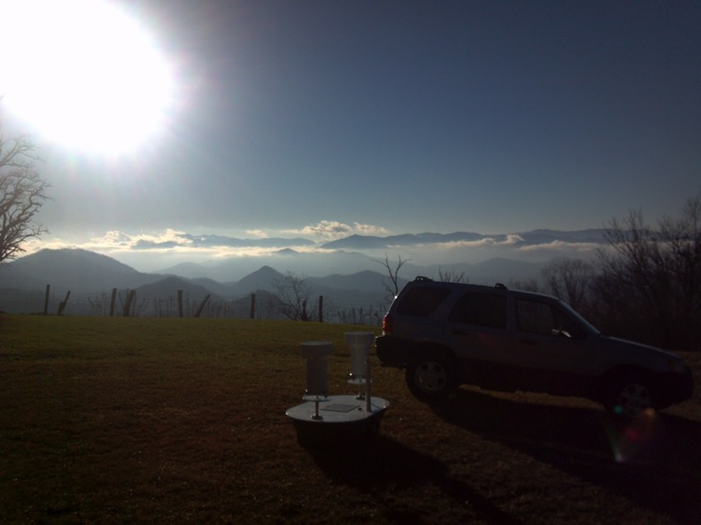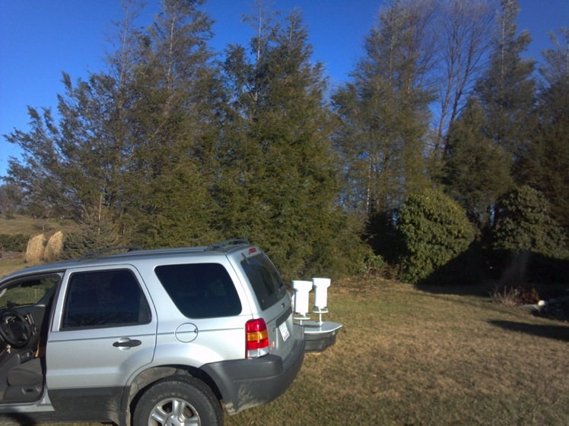

12/23/13
Time: Noon (Greg)
Weather: on/off fog

Gauges clean, platform settled and gauges slightly un level, but not touching circle. Leveled gauges, took off rubber band that was holding gauge “B” from tipping and stuck out temperature sensor.

2/7/14
Time: 12:30 (Greg)
Weather: clear

No debris in gauge with some ice on top of small filter, gauge “B” level was slightly outside of circle (leveled), gauge “A” was level, gauge “A” tipped while taking off top (very full).

3/11/14
Time: 5:00 PM (Greg)
Weather: clear

Both gauges clear and level. Although the land owner looked at the rain gauge, I found that rain gauge A still had a rubber band on it from the last time it was visited on Feb 7th. The temperature sensor was removed from the back and both soil moisture/temperature sensor was installed ~2” below the surface.
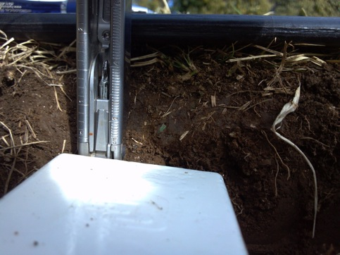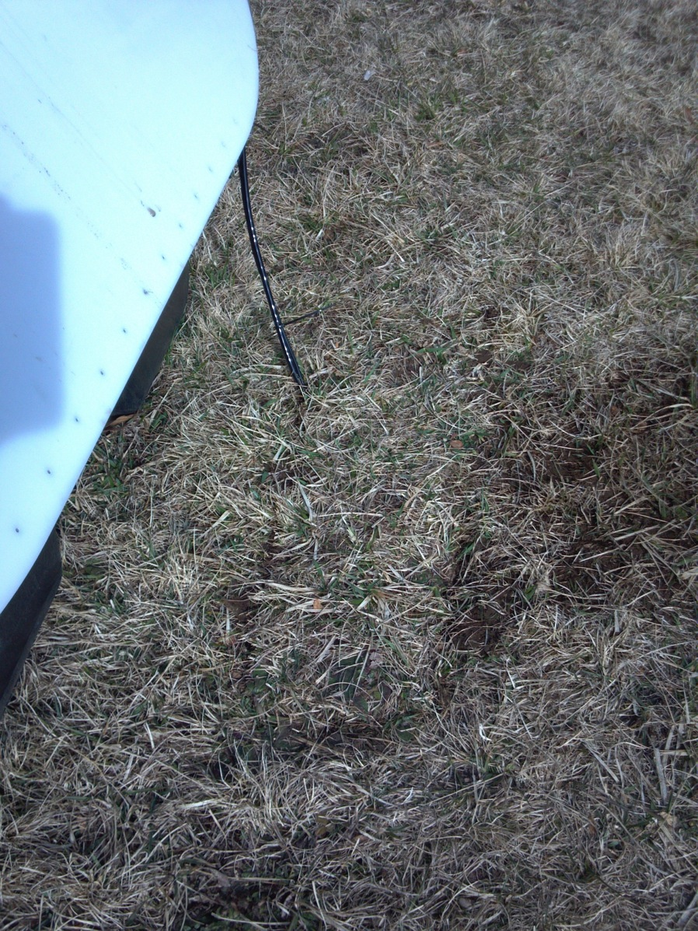

6/2/14
Time: 2:00 PM (Greg)
Weather: Party Cloudy

Both gauges clean and level, cleaned out little debris in funnel and filters, wiped down tipping buckets of pollen **B TIPPED AT 1820 UTC (no water loss)**
6/21/14
Time: 1330 PM (Greg)
Weather: Mostly clear
Gauges level and clean, took soil samples.

7/31/14
Time: 1845 EDT (Greg)
Weather: Overcast
Gauges clean and level, saw nearby trees were cut down, took soil samples.

8/3/14
Time: 1420 EDT (Greg)
Weather: Mostly Clear
Gauges clean, took soil samples.

9/10/14
Time: 1945 EDT (Greg)
Weather: Mostly Cloudy
Gauges level with very minor debris, cleaned filter/funnel, found cobweb had made “B” bucket stuck in middle of tip, removed all cobweb and conducted many tips **TEST TIP ~2340-2345 UTC**

10/14/14
Time: ~0900 EDT (Greg)
Weather: Overcast
Gauges clean and removed.

