P7 - Cosby

10/30/13
Time: ~3:30 PM (Greg, Duncan Belew)
Weather: Clear

Travelled to Cosby Campground with Paul and a UNCA student. Since we needed to get power from a maintenance yard, we needed to meet with the supervisor of the maintenance yard. We were able to get power and needed to use two 100’ extension cords to reach site for the P1. We were not able to finish the P1 installation, but the student was able to get over half of the extension cord buried. The supervisor said they were done cutting grass for the year, so we do not have to worry about them hitting the cord that is left on top of the ground. I left everything at the site except for the P1 and cinder block.

The rain gauge platform was installed and cellular connection was made. Although it is weak, it is strong enough to occasionally upload the data.

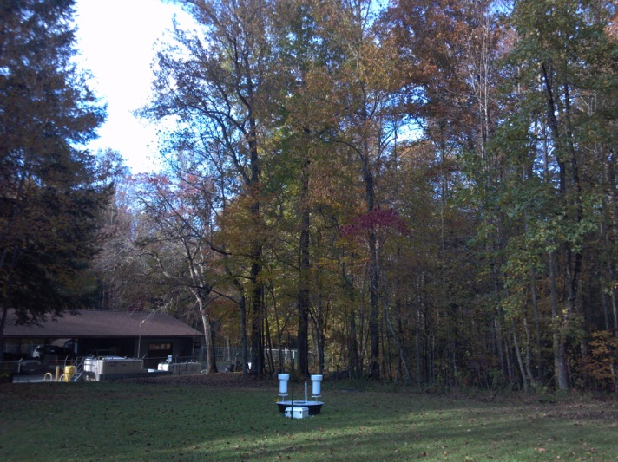

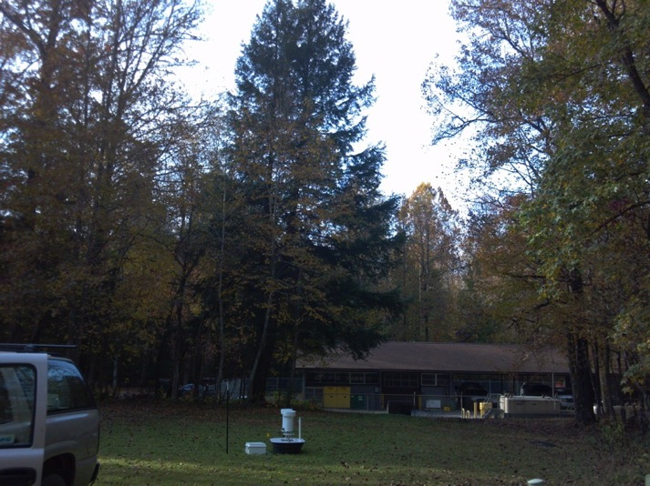

11/23/13
Time: ~Noon (Greg, Marta)
Weather: Overcast

Mounted Parsivel to pipe, which was attached to a driven down T-post. Parsivel was set up perpendicular to the SW. Half of the extension cord was buried, so we needed to finish burrowing the cord. Used silicon, then electrical putty, then electrical tape, then duct tape over the extension cord connections. Parsivel was measuring and recording data.

There was minor debris in the gauges, which was cleaned out. GAUGE B TIPPED AT 1:12 (VERY FULL), GAUGE A TIPPED AT 1:15 LOCAL TIME (ONLY ~1/4 FULL)

Gauge A
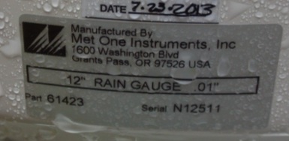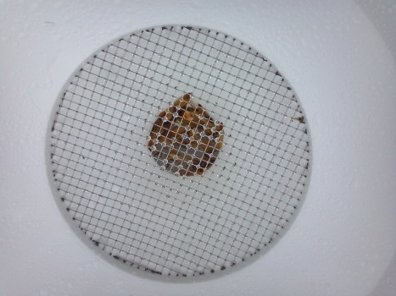

Gauge B
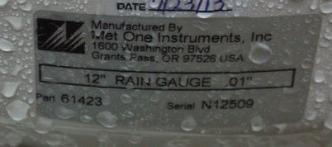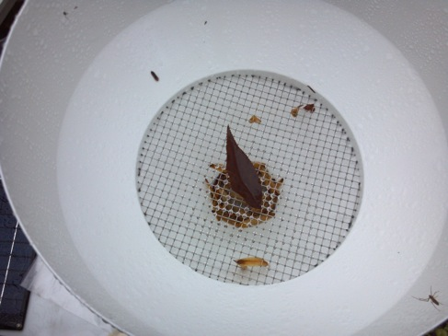
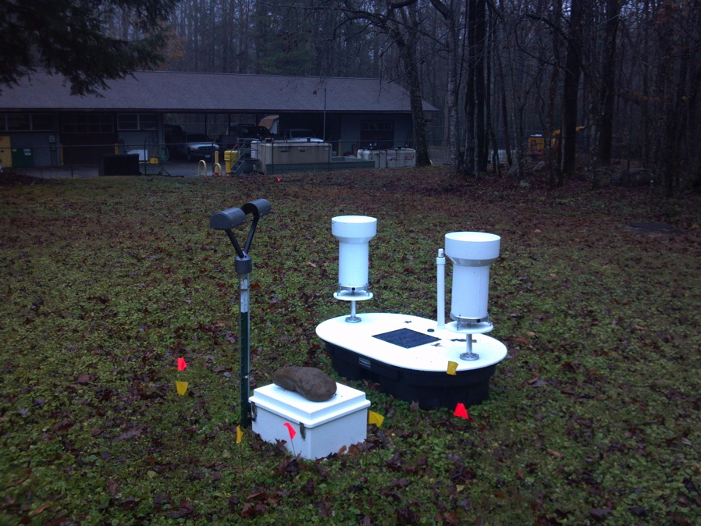

1/14/14
Time: 5 PM (Greg, Marta, Matt)
Weather: Clear

Gauge A was level just touching circle (leveled), gauge B was level, changed out battery since it only had 8.3 volts with new battery that had 12.7 volts. Gauge “A” lost ~5mL of water and gauge “B” tipped.

Installed 23 Nov. 2013.
Working perfectly from that time till 11.Jan 2014 13h utc time. Apparently it lost the power connection somehow. We tried to reconnected again and started storing data perfectly fine, therefore we have 2 days of no data, it stopped while it was raining. Matt suggested that the explanation could be that when there is moisture sometimes affect the power connectivity and we lose power contact.
I updated the scripts and connected the Cloud Gate telecommunication system.
I made sure everything worked and a telegram is recorded every 10 seconds, we can communicate by ssh. Ron tested while we were in the field.
We are currently archiving the data in Lunda every night and also locally in the USB.

3/6/14
Time: 2:15 PM (Greg, Marta)
Weather: Stratus cumulus

Both gauges clean and level, gauge “B” tipped ~1915UTC while taking off top (very full). Marta updated P1 configuration.

3/20/14
Time: 8:15 AM (Greg, Marta, Jing)
Weather: Clear

Both gauges clean and level. Marta downloaded data from the P1 USB.

4/13/14
Time: 10 AM (Greg, Bobby Taylor)
Weather: Clear

Both gauges clean and level, installed soil moisture sensor ~2” below the surface, removed Power from Parsivel cellular modem and downloaded data from P1.

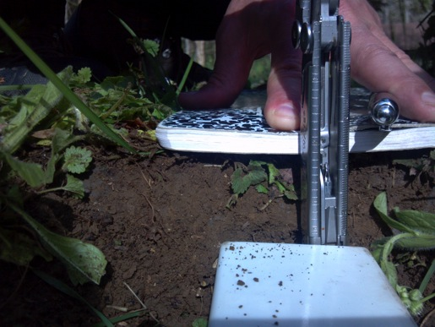
5/1/14
Time: 10 AM (Greg, Marta)
Weather: Overcast

Minor debris in funnels, cleaned funnels, gauges bubble not touching inner circle, but tweaked level. Pulled up some tall grass in the area. Marta downloaded data.

Gauge A Gauge B
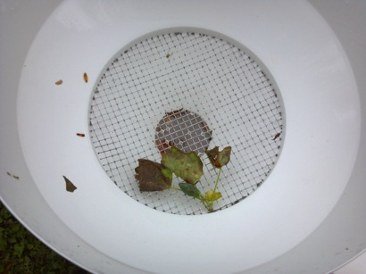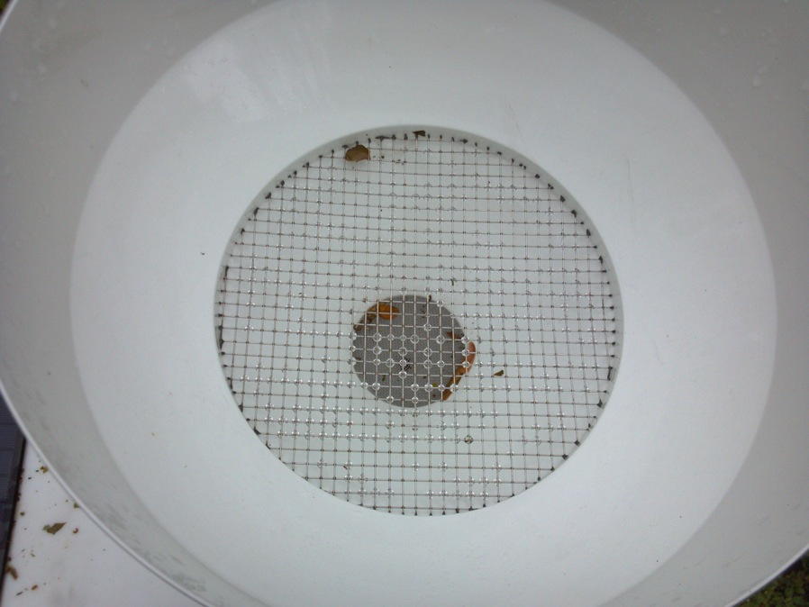

5/13/14
Time: 1200 (Greg, Marta)
Weather: Mostly Clear

Both gauges level and very small amount of debris, cleaned both gauges, **GAUGE B TIPPED AT 1612 UTC (saved water)**

6/24/14
Time: 1800 (Greg)
Weather: Clear

Some debris in both gauges, both gauges cleaned, gauges level, **GAUGE B TIPPED AT ~1805 EDT (NO WATER LOSS)**, downloaded Parsivel data, changed time, rebooted artilla. Took soil samples.

6/30/14
Time: 1530 (Greg)
Weather: Overcast

No debris in gauges or Parsivel. Took soil samples.

7/4/14
Time: 1415 EDT
Weather: Clear
Gauges clean, Parsivel on, but not communicating with Artilla, stopped recording on 29th at 20Z, took out signals and put back in, cycled power for Artilla and Parsivel. Sprayed di-electric spray in connections and placed putty around connections, put connect on top of Damprid, downloaded data, deleted up to July 2nd. Took soil samples.

7/11/14
Time: 1530 EDT
Weather: Partly Cloudy
Parsivel and gauges clean, Artilla is working correctly, changed time, downloaded data, rebooted Artilla. Took soil samples.

7/17/14
Time: 1430 EDT
Weather: Clear
Parsivel and gauges clean, Artilla working correctly, and took soil samples.

7/24/14
Time: 1446 EDT
Weather: Overcast
Gauges and P1 clean, Artilla working correctly, Artilla 30 seconds slow, changed time, rebooted Artilla, downloaded data and deleted data to July 21st. Took soil samples.

7/31/14
Time: 1600 EDT
Weather: Overcast
Spider web between Parsivel heads, gauges clean, gauge “A” outer level outside of circle, gauge “B” touching circle, leveled both gauges, **May have caused tips ~2005 UTC (no water loss)**, changed Artilla time, downloaded data, deleted to July 29th, rebooted Artilla.

8/11/14
Time: 1645 EDT (Anna, Greg, Lauren)
Weather: Partly cloudy, recently rained, thunderstorm in vicinity
Cleaned out gauges, level ok, **both gauges tipped during visit (very full) 2045 UTC** but it was the action of putting the tops on/off. Cobwebs between Parsivel heads removed, downloaded data and deleted to 1 August.

8/18/14
Time: 1245 EDT (Greg)
Weather: Overcast/light rain
Some cobwebs between Parsivel heads, cleaned, gauges clean, Parsivel working correctly, changed time, downloaded data, deleted to Aug 16th, rebooted Artilla.

8/26/14
Time: 1600 EDT (Greg)
Weather: Mostly Clear
Small web in between Parsivel heads, could possibly affect laser, gauges clean, ARtilla working normally, changed time, rebooted Artilla, download data and deleted to Aug 25

9/3/14
Time: 1400 EDT (Greg)
Weather: Overcast/light rain
Parsivel and gauges clean, Artilla working normally, downloaded data, set time, rebooted.

9/10/14
Time: 1640 EDT (Greg)
Weather: Overcast
Minor debris in filter and debris on funnels, cleaned both filter/funnels, both levels touching circle, level both, Artilla working normally, downloaded and deleted data to 8th, changed time, rebooted Artilla.

9/17/14
Time: 1400 EDT (Greg)
Weather: Cloudy
Gauges clean, coweb between Parsivel that could have affected laser, P1/Artilla working correctly, set time, downloaded data, deleted data through 16th, rebooted.

9/24/14
Time: 1515 EDT (Greg)
Weather: Clear
Cobweb on Parsivel but not obstructing laser, cleaned Parsivel, Artilla working, changed time, downloaded data.

10/2/14
Time: 1330 EDT (Greg)
Weather: Partly Cloudy
Parsivel clean and operating normally, minor tree and bug debris in filters, cleaned filter/funnel, gauges level, changed Artilla time, downloaded data, deleted through Oct. 1st, rebooted.

10/9/14
Time: 1530 EDT (Greg)
Weather: light rain/overcast
**MAY HAVE TIPPED GAUGES AT 1930Z**, Parsivel working, changed time, downloaded data, deleted to 8th, rebooted Artilla.

10/15/14
Time: 1415 EDT (Greg)
Weather: light rain/overcast
Gauges level and removed. P1 working, downloaded data and deleted to Oct. 13, changed time, rebooted.

10/31/14
Time: 1545 EDT (Greg)
Weather: Clear
Cobwebs between Parsivel heads that may have obstructed laser, Artilla working normally, P1 level, changed time, downloaded data, deleted data through 30th, rebooted.

11/20/14
Time: 1700 EDT (Greg)
Weather: Clear
P1 clean and level, Artilla and P1 working normally, changed time, downloaded data, deleted data through 19th, rebooted.

12/11/14
Time: 1000 EDT (Greg)
Weather: Overcast
P1 clean and working, checked date/time diff, downloaded all USB data, removed instruments.

