P6- Elkmont

10/23/13
Time: 11:30 AM (Greg, Marta, Jim)
Weather: Overcast

We meet Jim at Elkmont and loaded up most of the equipment in his Jeep so he could carry it to the field site. With Jim’s help we installed a P1 and rain gauge platform. The P1 was installed on a fence post that was driven into the ground almost 3’. Jim wanted the Parsivel close to the rain gauge setup to make the footprint smaller for workers to cut grass around the instruments. To do this, we needed to make the Parsivel close to the level to the rain gauges so water would not drip into the rain gauges.

The rain gauge was setup the day before at UNCA, so it could be quickly installed in the field. The Pelican case used is “NASA0040”, “A” rain gauge is “N12501”, and “B” rain gauge is “N12536”. Unfortunately there is no cellular service in this area so the data will manually have to be downloaded from the rain gauge. The P1 serial number is “237569”. The new laptops did not have the correct driver for the USB and was not able to connect to the Parsivel, so we had to return after installing the instruments at Twin Creek to get everything working correctly.

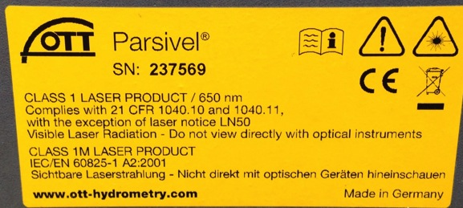

Gauge A Gauge B
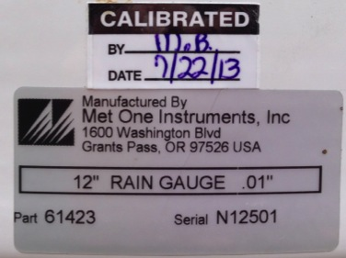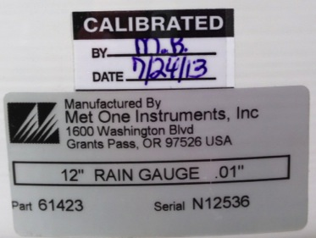

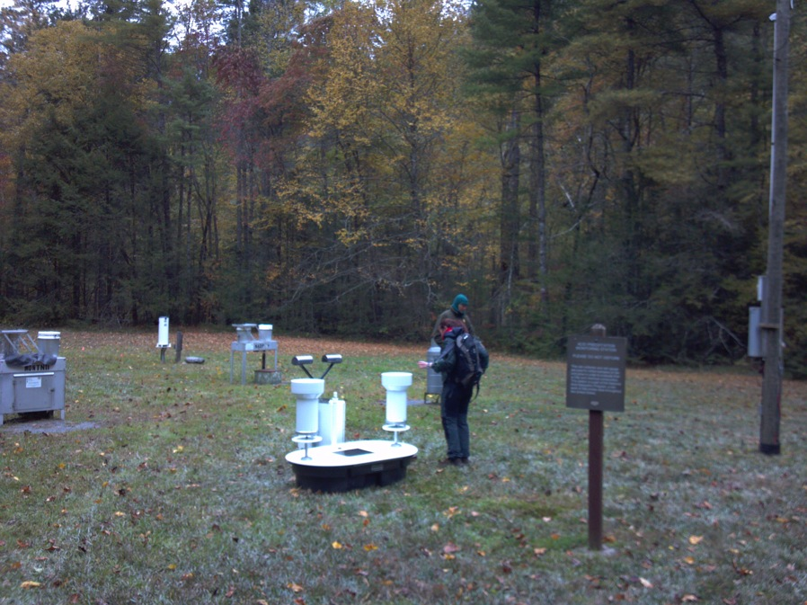

1/14/14
Time: 3:30 PM (Greg, Marta, Matt)
Weather: Clear

Gauges are clean of debris, gauges are level, battery only had 8.3 volts and replaced with new battery of 12.7 volts. While opening the platform, gauge A lost ~5mL of water and “B” tipped. Downloaded data from onboard SD card.

Installed 23 October 2013.
The analysis of the data shows some data recorded that day when it was installed and then nothing. Apparently all the time though there has been power it hasn´t worked with the laptop.
I substitute the laptop for the Artila.
I made sure everything worked and a telegram is recorded every 10 seconds.
We are currently archiving the data locally in the USB.
Static ip to access with Ethernet cable; 192.168.2.127
Psswd: Barros2014

3/6/14
Time: Noon (Greg, Marta)
Weather: Stratus Overcast

Caused tips in “A” and “B” ~1500 UTC, but saved water. Both gauges clean and level. Battery voltage 9.0, copied data from MicroSD to “P6” folder on desktop. Marta updated P1 to include new configuration. P1 was not on when we arrived, but working when we left.

3/20/14
Time: 9AM (Greg, Marta, Jing)
Weather: Clear

Both gauges clean and level. Gauge “B” tipped ~13:15 while removing the water from the tipping bucket. Battery at 10.5V, but placed new battery in platform (12.8V) and left the old battery in case it would be needed in the future. Downloaded all data from microSD card.

5/1/14
Time: 1200 (Greg, Marta)
Weather: Clear

Gauges level and very little debris in funnel, cleaned funnel and cleaned tipping buckets to get pollen off, **CAUSED TIPS AT ~1615UTC AT BOTH GAUGES (saved water)**, removed temperature sensor from back and installed soil moisture temperature sensor at ~2” below surface (picture). Electrical taped cords and put flag by cords.

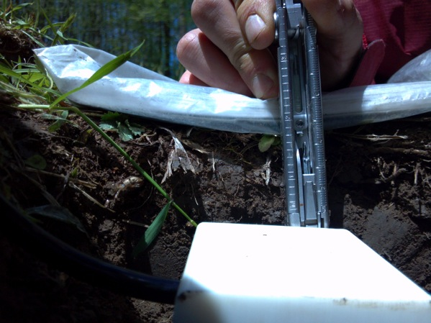

5/13/14
Time: 10:30AM (Greg, Marta)
Weather: Mostly Clear

Rain gauges level, little debris in filter (cleaned), BV 13.1, downloaded data, **CAUSED TIPS ~1430UTC (saved water)

6/24/14
Time: 3:15 PM (Greg)
Weather: Mostly Clear, just finished raining

Parsivel not communicating, fixed Parsivel, added di-electric spray and putty around connections, also added putty on the back side of power cord entrance in the enclosure, damprid is going away faster than it should be. Gauge clean and level, whipped down dirt on tipping buckets, heard tip while fixing Parsivel, downloaded data, battery voltage at 13.2V, took soil samples.

7/4/14
Time: 1130 EDT
Weather: Cloudy
Gauges level and clean. Parsivel light on, Parsivel clean, P1 light blinking, downloaded data, changed time, rebooted Artilla, deleted data from Artilla up to July 2nd. Took soil samples.

7/11/14
Time: 1245 EDT
Weather: Mostly clear
Gauges clean and level, **Tips at both gauges ~1450 UTC**, downloaded data from gauges, looks good, but still could not connect to PC, Parsivel lost connection, stopped July 8th. Took soil samples.

7/17/14
Time: 1220 EDT
Weather: Mostly clear
Gauges and Parsivel clean, Artilla working normally, re-sprayed the connections with di-electric spray, placed di-electric liquid on Parsivel connectors. Took soil samples.

7/24/14
Time: 1200 EDT
Weather: Partly Cloudy
Took soil samples. Gauges and Parsivel clean, Parsivel on but not communicating, took out connections and added more di-electric spray and liquid to the Artilla connection side, cycled power, ARtilla working correctly, logger 41 seconds slow, changed time, rebooted, downloaded data and deleted data to July 21st.

7/31/14
Time: 1400 EDT
Weather: Cloudy
Gauges and Parsivels clean and level, found no power to the Parsivel, took out connections and sprayed with di-electrics spray and convered with putty (did not have di-electric liquid), downloaded data, stopped on 28th 0000Z, changed time and rebooted Artilla, sprayed di-electric spray on data and power connections.

8/11/14
Time: 1445-1530 EDT
Weather: Cloudy
Parsivel lost power connection on 10 august, took out connections and placed di-electric grease on both, left Parsivel working normally and downloaded Parsivel data, deleted to August 1, changed time.

Cleaned very minor debris from gauges and did minor re-leveling and rain during maintenance period. Some water in buckets removed ruing rain even. Initial false tips ~1847 UTC. Remove all tips until ~1920 UTC. Downloaded rain gauge data, confirmed gauges were operating normally afterwards.

8/18/14
Time: 1425 EDT
Weather: Overcast
Parsivel and gauges clean, Parsivel on but not communicating, fox comm issue and added more di-electric grease, downloaded data, deleted to the 17th, Artilla stopping on 12th, changed time, rebooted Artilla.

8/26/14
Time: 1430 EDT
Weather: Clear
Gauges and Parsivel clean, Artilla working correctly, added putty around both connectors after adding di-electric spray, deleted data to 25th, changed time, rebooted Artilla.

9/3/14
Time: ??? EDT
Weather: Partly cloudy
Parsivel and gauges clean, Parsivel on and Artilla working correctly, added damprid, changed time, downloaded data, rebooted Artilla.

9/10/14
Time: 1445 EDT
Weather: Partly cloudy
Minor debris in gauges, “A” level touching circle, cleaned filter/funnel, leveled gauge “A”, downloaded data, **CAUSED TIP AT 1852 UTC (no water loss)**, small cobweb between Parsivel but not obstructing laser, Artilla and Parsivel working normally, downloaded data, changed time, deleted data through 8th, rebooted Artilla.

9/17/14
Time: 1230 EDT
Weather: Overcast
Gauges and Parsivel clean, Parsivel and Artilla working normally, set time, downloaded data, deleted data through 16th, rebooted Artilla.

9/24/14
Time: 1400 EDT
Weather: Partly cloudy
Parsivel and gauges clean, Parsivel and Artilla working, changed time, downloaded data.

10/2/14
Time: 1200 EDT
Weather: Partly cloudy
Gauges clean, small spider web in front of Parsivel head, changed time, downloaded data, deleted through 1st, rebooted Artilla.

10/9/14
Time: 1350 EDT
Weather: Overcast
Spider webs around Parsivel, but not obstructing laser, Parsivel working correctly, some debris in gauge, cleaned gauges, gauges clevel, changed Artilla time, downloaded data, deleted to 8th, rebooted Artilla.

10/15/14
Time: 1145 EDT
Weather: Mostly cloudy
Gauges level, removed gauges and downloaded data, P1 working, time OK, downloaded Artilla data and deleted to Oct. 13.

10/30/14
Time: 1400 EDT
Weather: Clear
Spider webs on Parsivel, but not obstructing laser. Parsivel level, Artilla and P1 working normally, changed time, downloaded data, deleted through 29th, rebooted Artilla.

11/20/14
Time: 1330 EDT
Weather: Clear
Parsivel clean and level, P1 and Artilla working, downloaded data, deleted data through Nov. 19, rebooted.

12/11/14
Time: 1150 EDT
Weather: Clear
Parsivel clean and working normally, checked time diff, downloaded USB data, removed instruments.

