Station: P5 – Cherokee orchard rd.  City, County, State: Gatlinburg, Sevier County, TN  Latitude: 35.686108 Longitude: -83.500819 Elevation: 595 m  Climate division:  River Basin: Huc 6 French Broad, Huc 8 Lower French Broad  Supported by: Duke University - UNCA  Date of first observation:  Instrumentation: Disdrometers Parsivel 1 | 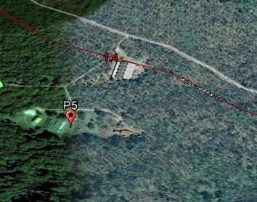

Visiting the locations prior the installation:

Visiting day: 19 April 2013  General comments about the day of the visit:  The place is secured with a locked fence. It is a clear spot not disturbed by trees. Installation will be made at 4-6 meters to the power supply pole. We will dig a hole in the ground and put concrete. All mounting supplies can be purchased from the local hardware store. | 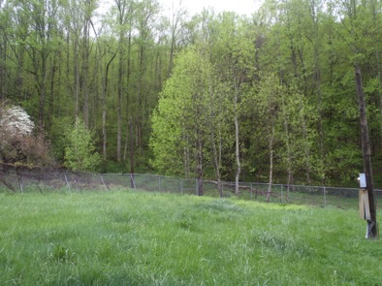
Installation specifications(mark with a circle): Phase 1
Power supply: YES | Comments: Cable of 5-7 m
Accessible by car: YES
Cell phone service: YES  Internet supply: YES with our wireless-wifi device | Comments: The installation place belongs to the Great Smoky Mountains National Park that allows us to install our sensor. There they supply electricity
Can we keep the laptop inside the building?: NO | We need a proper enclosure from Campbell Sci. During the measurement mission check if the laptop resists properly.
Any other comments we might think on: Jim said he could check our laptop and desdrometer status a couple times a week.

