Description of WISPER data set for IMPACTS 2020
Darin Toohey, University of Colorado Boulder
November 2021
Revised December 17, 2021 (see text in red)

Instrument Description
Water Isotope System for Precipitation and Entrainment Research (WISPER) primarily obtains in situ measurements of condensed water contents and the isotope ratios D/H and ¹⁸O/¹⁶O. For IMPACTS, WISPER uses two inlets. The primary inlet is a counterflow virtual impactor (CVI) of similar design to that described in Noone et al. (1988) and Twohy et al. (1997) and that has been deployed frequently on the NCAR G-V and C-130 aircraft for cloud-related studies (e.g., Twohy et al. 2021). To ensure that air is sampled from the free stream, the inlet is mounted on an extension similar to the one used on the NCAR C-130 aircraft. The inlet as flown on the NASA P-3 in January and February of 2020 is pictured in Figure 1.

Figure 1: Photo of CVI inlet as deployed on the NASA P-3 for IMPACTS 2020. The front of the NASA P-3 aircraft is to the left in the photo. The CVI inlet faces forward, above which is a backward facing tube that was used for attempting to measure water vapor in and out of clouds. See text for additional details of both inlets.

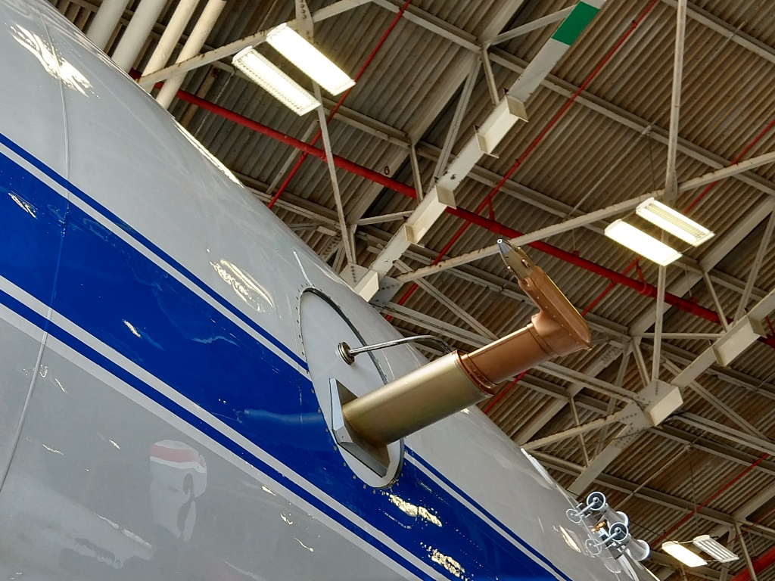

A second inlet, facing backwards, was intended to measure water vapor both in and out of clouds. Unfortunately, during IMPACTS 2020 there was insufficient heating of that inlet and too slow of flow of air through the inlet to ensure that there was no contribution to that measurement by water condensing on surfaces near the tip of the inlet, and therefore those results are all considered suspect for the campaign (discussed later in the document). However, the measurements of condensed water contents are of high quality for most of the campaign.

Picarro cavity ringdown laser spectrometers (CRDS, models L-2120fxi and L-2120i) are used to measure condensed water and water vapor, respectively. The L-2120fxi operates at a fixed mass flow rate of 350 cm³min⁻¹, ensuring that the optical cavity is refreshed at a rate faster than the native measurement rate of 5 Hz. The L-2120i operates at a fixed flow rate of 25 cm³ min⁻¹, which results in a much slower effective data rate. However, because the tip of the back-facing inlet was often contaminated by condensed water (as diagnosed by analyses of water isotopologues, which are a sensitive indicator of condensation and evaporation), this aspect of the measurements of water vapor for IMPACTS 2020 is unimportant.

The CVI inlet operates by continuously pulling air at a flow rate of ~3-18 liters per minute (LPM) down a sample line connected to the probe tip. A porous tube ~4 inches long and ~1/4” in diameter is inserted directly behind the tip, and dry air from a cylinder on the aircraft is pushed through the porous tube at a rate that is in slight excess of the sample rate. This excess (called the “excess counterflow”) ensures that no ambient air or particles larger than about 5 microns in diameter penetrate into the air that is then sampled downstream of the probe tip. Particles (including hydrometeors) larger than 5 microns in diameter are then heated rapidly to ~45 ºC (a process that takes less than 1 second under most conditions) in a ~12” long segment of tubing in the inlet, and this air then passes through a box that contains multiple heater controllers and flow controllers, a computer for operating a feedback control loop and recording signals necessary for calculating condensed water contents, and that air is finally exhausted out of the aircraft through a venturi mounted to the fuselage downstream of the inlet. A small fraction of the total sample flow is picked off by the Picarro L-2120fxi for measuring the water vapor mixing ratio and isotopic ratios D/H and ¹⁸O/¹⁶O produced by the evaporated hydrometeors. Under normal conditions, the response time of the measurements of condensed water is less than 1 second. However, in cold clouds (especially in the presence of supercooled water), there is some hysteresis due to icing and condensation and subsequent slow evaporation on inner surfaces of the inlet. This unavoidable situation is most noticeable as a slow dropoff of water vapor (hence, inferred condensed water contents) which can last tens of seconds and longer when exiting some clouds. Although there is no simple way to correct for these situations, it is estimated that the error in condensed water during these occasions is less than 15%, so this is the uncertainty quoted for the measurements reported here.

More information can be found in the following publication by Henze, et al., (2021):
https://doi.org/10.5194/essd-2021-238 and at https://ghrc.nsstc.nasa.gov/home/micro-articles/instrument-water-isotope-system-precipitation-and-entrainment-research-wisper

Data File Format
The data files presently submitted to the archive for analysis by other investigators are in the ICARTT V1.1 format (see https://www-air.larc.nasa.gov/missions/etc/IcarttDataFormat.htm). The following values are reported once each second, when available. Missing or bad data are indicated by -9999.

Start_UTC, seconds, seconds since start of day of record
CWC, g/(m^3), condensed water concentration (ice + liquid water)
H2O_VAP, ppm, water vapor mixing ratio
DELTAD_C, permil, HDO/H2(16)O ratio in condensed water
DELTAO18_C, permil, H2(18)O/H2(16)O ratio in condensed water
DELTAD_V, permil, HDO/H2(16)O ratio in water vapor
DELTAO18_V, permil, H2(18)O/H2(16)O ratio in water vapor

These variables are described in more detail next.

Condensed Water Contents
Condensed water contents (or CWC) are calculated in units of grams H₂O per kg* meter³ of air at ambient temperature and pressure using a geometric ratio of the impact rate of hydrometeors onto the cross sectional plane of the trip of the sample tube (or πR² x V, where R is the inner radius of the inlet and V is the forward velocity of the aircraft perpendicular to that cross section) to the mass flow rate of air sampled by the inlet. This ratio is often expressed as a product of an “enhancement factor” that accounts for sub-isokinetic nature of the inlet and the amount of condensed water. Enhancement factors employed during IMPACTS 2020 ranged from ~10-30, resulting in observed water vapor mixing ratios typically less than to < 40,000 ppm in most situations, ensuring that there was no condensation in the sample lines for the temperatures at which the inlet and sample lines were heated. However, there were some occasions when heavy precipitation was encountered, resulting in temporary condensation within the sample lines. This condition was diagnosed with isotopologue ratios, which are sensitive indicators of condensation and evaporation. To the extent they are evident in the isotopologue data, these occasions have been removed from this data release, and the results are replaced with -9999.

*Note added December 17, 2021: This is not the usual format for the CVI, so in the next release they will be converted to ambient units (P and T at flight altitudes). Until then, to convert from the values in the R0 release to ambient using the following formula:

CWC (g/m³ ambient) = CWC(R0 release) x (1/2.86) x P(hPa)/T(K)

As part of the normal operation of the CVI inlet, and usually only when outside of clouds, the counterflow of dry air can be turned off, allowing for measurements of water vapor in ambient air. If, on occasion, this mode of operation is employed while in clouds, the resulting measurement is called “enhanced total water”, and the measurement represents a sum of the ambient water vapor and the product of the condensed water and the enhancement factor. This mode, although potentially useful under some conditions, was not used extensively during IMPACTS 2020, although it was used on occasion to diagnose performance issues that help with data QA/QC. In the Rev_0 release of data, these periods have not been flagged or removed, so investigators should proceed with caution when discovering periods when WISPER is reporting appreciable condensed water contents when clearly outside of clouds.

Water Vapor Measurements
Water vapor was detected by sampling from a backward facing, unheated inlet near the CVI probe. Unfortunately, for most of the IMPACTS 2020 campaign, small amounts of water vapor condensed on surface of the inlet, probably by impaction of hydrometeors on the tubing that extended into the airstream. This condensed water then acted as a source of saturated water in air at the pressure and temperature conditions at the first point of contact of ambient air with the inlet. Consequently, water vapor appears supersaturated with respect to free stream conditions due to a reduction in pressure due to suction at the entrance of the back-facing inlet. Investigators who wish to use these data should proceed with extreme caution, and they should contact the PI for the latest knowledge regarding the quality of the measurements, which will be undergoing additional analysis to determine whether or not accurate values can be retrieved. At the time of this writing, however, it is felt that the accurate water vapor measurements from IMPACTS 2020 may be irretrievable from WISPER. New in-flight diagnostics will be performed during IMPACTS 2022 to determine what values, if any, from the 2020 field campaign may be useful for scientific investigations.

Water Isotopologue Measurements in Condensed Water
Water isotopologues are useful for diagnosing performance of the instrument (e.g., as noted in the previous section, when icing, condensation, or evaporation is occurring on the inlet or in the transfer lines). Scientifically, they are useful for examining origins of airmasses and elucidating important microphysical processes, entrainment and detrainment, and precipitation. As of the writing of this document, the Rev-0 data are believed to be accurate, and investigators are encouraged to use them in their analyses. However, it is highly recommended that the PI be contacted prior to extensive use of the isotopologue data because ongoing laboratory work and in-flight diagnostics planned for the IMPACTS 2022 field campaign will be used to refine the results, as needed. It is likely that some data will eventually be flagged as suspicious if instances of icing, condensation, or evaporation are suspected in the results.

Water Isotopologue Measurements in Water Vapor
At the time of this writing, it is believed that the water isotopologue measurements in water vapor are not accurate for scientific analyses, at least when flying in cloud and for at least 10-15 minutes after exiting clouds. These measurements are useful for CWC data QA/QC purposes, and therefore they are included in the R0 exchange files. In future releases a flag will be incorporated to specify if and when these results are accurate for scientific analyses.

References
Noone, K. J., Ogren, J. A., Heintzenberg, J., Charlson, R. J., and Covert, D. S.: Design and calibration of a counterflow virtual impactor for sampling of atmospheric fog and cloud droplets, Aerosol Sci. Tech., 8:3, 235- 244, DOI:10.1080/02786828808959186, 1988.
Twohy, C., Schanot, A., and Cooper, W. A.: Measurement of condensed water content in liquid and ice clouds using an airborne counterflow virtual impactor, J. Atmos. Oceanic Technol., 14, 197-202, 1997.

Twohy, C.H., P.J. DeMott, L.M. Russell, D.W. Toohey, B. Rainwater, R. Geiss, K.J. Sanchez, S. Lewis, G. Roberts, R.S. Humphries, C.S. McCluskey, K.A. Moore, P.W. Selleck, M.D. Keywood, J.P. Ward, I.M. McRobert (2021), Cloud-Nucleating Particles over the Southern Ocean in a Changing Climate, Earth’s Future. doi: 10.1029/2020EF001673

